**Possible Ecodesign and Energy Labelling**

**requirements for electronic displays**

**EXPLANATORY NOTES**

# Context of the proposal

## Legal framework

The Ecodesign Framework Directive 2009/125/EC establishes a framework for laying down ecodesign requirements for energy-related products. It is a key instrument of EU policy for improving the energy efficiency and other aspects of the environmental performance of products in the internal market. Article 16 of the Ecodesign Directive lists products identified by the Council and the European Parliament as priorities for the Commission for implementation, including consumer electronics, office equipment and domestic appliances. Electronic displays therefore belong to the priority product groups considered for implementing measures under the Ecodesign Directive.

The application of the Ecodesign Directive is complemented by the Energy Labelling Directive 2010/30/EU, which establishes a framework for developing Delegated Regulations which lay down energy labelling schemes for the priority product groups. The labelling requirements ensure that consumers make well informed purchase decisions, provide a dynamic incentive for manufacturers to improve energy efficiency of their products and accelerate the market take-up of energy-efficient models.

The application of ecodesign and energy labelling requirements is complementary, i.e. ecodesign pushes the market and energy labelling pulls the market. In this context, a proposal for an ecodesign Regulation on a specific product group is often (provided that there is a positive outcome of the Impact Assessment) accompanied by a proposal for a Delegated Regulation laying down energy labelling requirements for that product group.

## Grounds for and objectives of the proposal

Televisions ('TVs') and other electronic displays, such as computer monitors, are widely used in European households. In 2010 the EU stock of TVs and computer monitors amounted to 576 million units. The annual sales of televisions peaked in 2010 and then started gradually to decline. Approximately 60-62 million TVs and 16-17 million computer monitors were sold in 2011 in the EU-27. The electricity consumption of electronic displays reached 75 TWh in 2011.

Factors that have contributed to the significant increase in sales to peak in 2010 were (i) the gradual switch across Europe from analogue to digital broadcast, (ii) the change in size ratio from 4:3 to 16:9, (iii) the move from a resolution of 576 lines to HD (1208x720 pixels) and soon after to full HD (1920x1080) and (iv) the introduction of flat-screens, with smaller-footprint, less weight and better perceived image quality displays. This technology evolution is continuing, e.g. with a move to UHD for televisions and even beyond for displays used for graphics or video editing.

In contrast to the rise and fall of television sales between 2007 and 2013, over this same time period, there was a steady increase (Figure 1) in the demand for larger screen-sizes with a drop of small televisions (e.g. <20”) that may reflect the end-user shifting to watch video content on laptops or tablets. Figure 2 provides an alternative perspective showing the trend towards bigger displays.

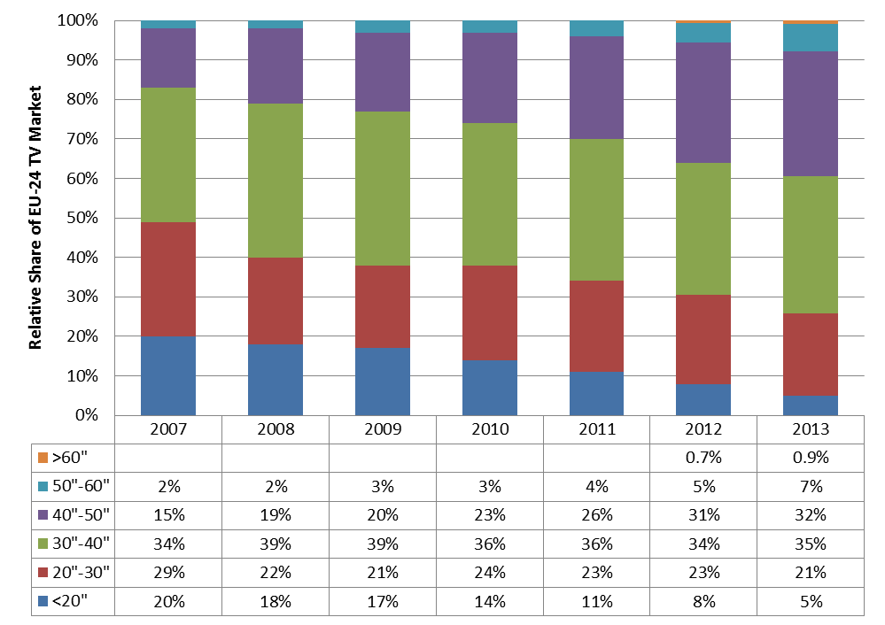

Figure 1: Increasing screen size market share for televisions (EU-24, GfK data referred to by CLASP, 2014)

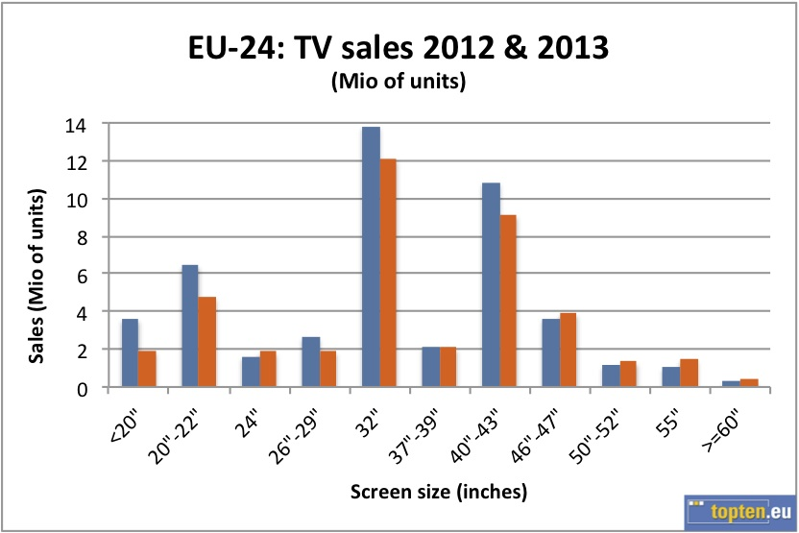

Figure 2: Most popular: 32” and 40” – 43”: large TVs are increasingly popular (Topten)

So far, of all electronic displays, only TVs have been subject to a mandatory ecodesign requirements (laid down by Commission Regulation 642/2009) and an energy labelling scheme (set up under Commission Delegated Regulation 1062/2010). In 2012, the Commission undertook a review study of the two television regulations and presented its conclusions to stakeholders at the meeting of the Consultation Forum (CF, held on 8 October 2012) established under Article 18 of the Ecodesign Directive 2009/125/EC. The review showed that regulatory gaps and market failures, preventing the full realisation of the identified energy savings potential, existed, including:

* Insufficiently stringent minimum ecodesign and energy labelling requirements applying to TVs that had been exceeded by an unpredicted industry-led technological change;
* Rapidly progressing functional convergence between electronic displays, such as televisions, computer monitors and digital photo frames, creating a possible regulatory loophole. TVs have been increasingly enabled for web browsing and other displays, mainly computer monitors have been used to watch content traditionally viewed on TVs. It is more and more difficult to distinguish between different product categories;
* Lack of requirements on new energy-intensive features, such as network connectivity;
* Lack of requirements on resources efficiency aspects that have a significant environmental impact (e.g. no requirements aiming at recovery of rare, precious and critical raw materials), or of requirements on recyclability of common metals and plastics to recover embodied energy and carbon.

The Commission is willing to correct existing market and regulatory failures and to contribute to realising the cost-effective potential for reducing electricity consumption and consequently GHG emissions and saving natural resource.

The aim of these proposed ecodesign regulations for electronic displays is, to strengthen the existing regulatory framework by introducing a new set of requirements that will more appropriately reflect recent technology developments in the electronic displays sector, to extend the application of the requirements to electronic displays other than televisions (and thus to remove possible regulatory loopholes), to address new energy-intensive features, such as networked standby and to tackle resource efficiency aspects having significant impact.

## Existing provisions in the area of the proposal

The following Regulations are relevant to the energy and environmental aspects of the electronic display products placed on the EU market:

* Commission Regulation (EC) No 1275/2008 of 17 December 2008 implementing Directive 2005/32/EC of the European Parliament and of the Council with regard to ecodesign requirements for standby and off mode, and networked standby, electric power consumption of electrical and electronic household and office equipment[1].
* Commission Regulation (EC) No 278/2009 of 6 April 2009 implementing Directive 2005/32/EC of the European Parliament and of the Council with regard to ecodesign requirements for no-load condition electric power consumption and average active efficiency of external power supplies[2]
* Commission Regulation (EC) No 642/2009 of 22 July 2009 implementing Directive 2005/32/EC of the European Parliament and of the Council with regard to ecodesign requirements for televisions[3]
* Commission Regulation (EC) No 617/2013 of 26 June 2013 implementing Directive 2009/125/EC of the European Parliament and of the Council with regard to ecodesign requirements for computers and computer servers[4]
* Commission Regulation (EU) No 801/2013 of 22 August 2013 amending Regulation (EC) No 1275/2008 with regard to ecodesign requirements for standby, off mode electric power consumption of electrical and electronic household and office equipment, and amending Regulation (EC) No 642/2009 with regard to ecodesign requirements for televisions[5]
* Commission Delegated Regulation (EU) No 1062/2010[6] of 28 September 2010 supplementing Directive 2010/30/EU of the European Parliament and of the Council with regard to energy labelling of televisions.

Additionally, the resource-efficiency requirements in this proposed measure are in line with the provisions of the Directive 2012/19/EU of 4 July 2012 on waste electrical and electronic equipment (WEEE). Finally Directive 2011/65/EU of 8 June 2011 on the restriction of the use of certain hazardous substances in electrical and electronic equipment (RoHS) is relevant in electronic equipment production.

# Consultation of interested parties and impact assessment

## Consultations

European and international stakeholders and Member States' experts have participated in the process from the beginning.

A first proposal for ecodesign was already discussed, together with potential energy labelling requirements, on 8 October 2012 in the ecodesign CF that comprises Member States' experts and other stakeholders, including the representatives of manufacturers, environmental non-governmental organisations ('NGOs') and consumer organisations.

Following this meeting, at which the Commission presented the proposals for ecodesign requirements and an energy labelling scheme, stakeholders were given an additional thirty days for submitting written comments that were subsequently published on the CIRCA website.

Furthermore, the initiative was discussed between Commission staff of different services and various stakeholders at several bilateral and multilateral post-CF meetings held in 2013.

*Main organisations/experts consulted*

The process of preparing the proposed regulation was conducted in an open process, taking into account input from all relevant stakeholders, including the representatives of national authorities, manufacturers and their associations, environmental NGOs, consumer organisations and technical experts.

*Input from scientific expertise*

In addition to the consultation process mentioned above, the Commission acquired external expertise to support the proposed measure on ecodesign (and associated energy labelling) measure. The expertise was gathered mainly through a review study that was carried out (with a full involvement of stakeholders) in 2012, before the CF meeting. The review study provided the Commission with technical and market data used to evaluate the existing television regulations and to support the development of the new ecodesign and energy labelling proposals for electronic displays. Furthermore, market and technical data was acquired through several bilateral and multilateral meetings with stakeholders held in 2013.

*Industry data*

The Commission established a dataset containing information about the environmental performance of electronic displays to support the development of the proposed ecodesign and energy labelling measures. The dataset was created to ensure that the proposed requirements have a proper ambition level and that they reflect recent technology developments.

*Results of the CF of 2012*

In principle, the proposed ecodesign requirements for electronic displays were supported by Member States and stakeholders.

An overwhelming majority of Member States and NGOs agreed on a proposed extension of the requirements to electronic displays other than televisions, including but not limited to computer monitors and digital photo frames. Manufacturers requested exceptions for specialised displays with distinct characteristics, such as signage (public) displays, medical monitors and broadcast monitor as well as for plasma displays (PDP) and displays using emerging technologies, i.e. ultra-high definition displays (UHD) and organic light emitting diode displays (OLED). Furthermore, following the extension of the scope, several stakeholders requested the EC to amend mandate 477 and to ensure that CENELEC develops one standard that would provide proper measurement methods for all displays covered by the scope of the proposed measure.

The majority of stakeholders accepted the proposed approach for regulating on-mode power demand of electronic displays and was in favour of a proposal that was based on a logarithmic regression line[7].

A majority of stakeholders was in favour of including in the proposal the requirements on non-energy related aspects, including recyclability. At the same time they noted a need for proper measurement methods and pointed at the enforceability of requirements.

The proposed measure (presented in a greater detail in section 3 of this explanatory memorandum) fully incorporates comments expressed by Member States and stakeholders at and after the CF meeting of 8 October 2012 (and thus differs on a number of aspects from the EC's original proposal prepared for the consultation process).

*International stakeholders*

Finally, the initially proposed regulation was notified to the World Trade Organisation in accordance with the Agreement on Technical Trade Barriers.

## Impact assessment

An impact assessment of the possible policy measures was carried out pursuant to Article 15(4)(b) of Directive 2009/125/EC. Several policy options for achieving a market transformation fulfilling the appropriate level of ambition were considered, including: no new EU action (‘business-as-usual’ case; option 1), termination of the existing television regulations (option 2), a self-regulation measure concluded by industry (option 3), and revision of the existing television regulations (option 4).

Given that the eligibility criteria laid down in the Ecodesign Directive (i.e. economic significance, significant environmental impact and significant savings potential) were still fully met and because the industry had not submitted any proposal for a valid self-regulation measure, options 2 and 3 were discarded and the analysis concentrated on the revision of the existing ecodesign and energy labelling television regulations.

The impacts of a policy option comprising an introduction of the new ecodesign requirements for televisions and other electronic displays together with a new energy label were assessed against the ‘business as usual’ scenario. Two different, in terms of the stringency of requirements, proposals for revised ecodesign and energy labelling measures were analysed, including: the first proposal presented before the consultation process (including before the CF meeting of 8 October 2012) and the second proposal prepared after the said CF meeting that incorporates stakeholders'' comments.

Based on an assessment of costs and benefits, a combination of ecodesign requirements for electronic displays and of energy labelling emerged as a preferred option to address regulatory and market failures existing in the electronic displays sector.

This combination of ecodesign requirements and energy labelling has the following results:

* the ecodesign requirements achieve potential for cost-effective improvements in the energy efficiency of electronic displays;
* the labelling scheme creates market transparency for consumers and provides incentives for manufacturers to innovate/invest in energy efficiency;
* the life-cycle environmental impact of electronic displays related to the use-phase energy consumption and resources efficiency is significantly reduced;
* a clear legal framework is created which ensures fair competition;
* there will be positive impacts on the competitiveness of industry;
* requirements for the placing on the EU market of electronic displays are harmonised, leading to the lowest possible administrative burdens and costs for economic operators;
* no disproportionate burdens or significant additional costs for manufacturers will result from the proposed measure. Re-design cycles and the pace of innovation have been fully taken into account.

## Review of the measures

The proposal was not brought forward as expected. Because of the quick technology and market evolution, the Commission decided to update the technology and market analysis with an update of the review study and, as requested by the industry representatives, to run an additional consultation of technical experts. A second dataset has been created with updated market data from 2014, combining data from industry associations and from single companies. This data has been used to review the appropriateness of the curves previously devised and a first analysis suggested the identification of an improved function description, more in line with other labelling schemes, such as the US EnergyStar and the Super-Efficient Equipment and Appliance Deployment (SEAD) initiative[8]. Performing the analysis, the Commission has been supported by a recognised international expert, by industry, by CLASP and by the Joint Research Centre (JRC), in collaboration with DG Environment.

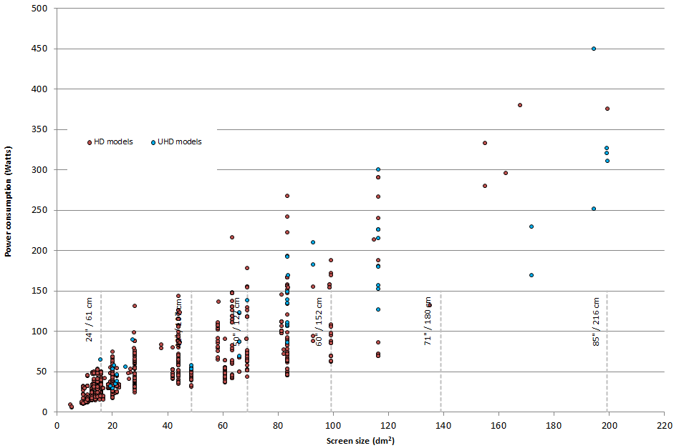

Figure 3: Scatter plot for energy use in respect to screen size (2014 dataset): UHD/4k displays are in blue.

The review has focused on UHD televisions and in general on displays with resolution above HD. UHD/4k televisions are already widely available in the market with increasingly affordable prices[9] and new models are offering resolutions even beyond 4k[10]. The updated data analysis has highlighted that already several models of 4k televisions are in energy A class and there is no objective reason not to include these displays in the scope of the proposed measures (Figure 3).

Figure 4 shows the power consumption levels of electronic display models from the model database, compared with the requirements currently in force (Tier 2, red lower line): the graph clearly shows how the efficiency levels for the biggest displays are abundantly below the current requirements.

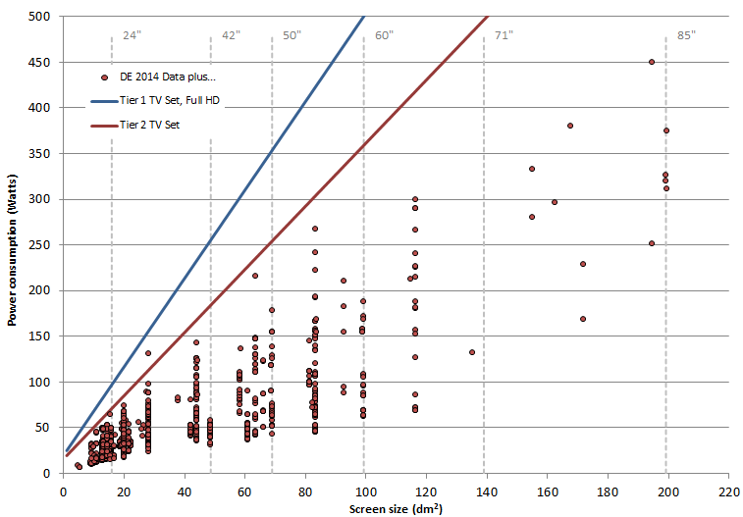

Figure 4: Comparison between the data on display models data and requirements included in Tier1 and Tier 2 of the current ED regulation 642/2009 (CLASP, 2014)

Furthermore, when comparing the improvements of power consumption in big and in small displays over time, the big improvement in the largest displays becomes even more evident. A linear regression curve appears not appropriate anymore and an innovative approach is required.

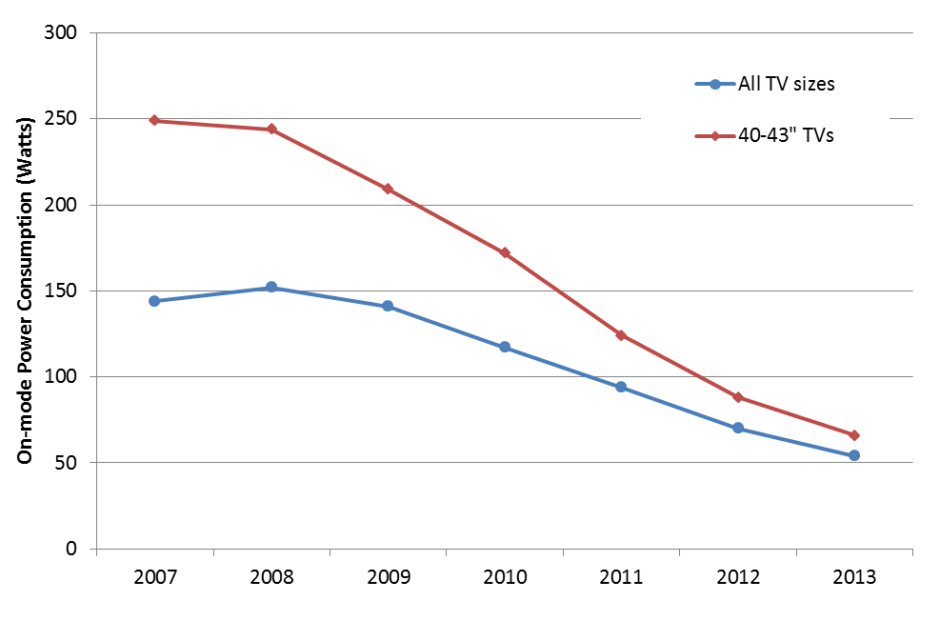

Figure 5: Average energy consumption trend 2007-1014 comparing 40-43" TVs with all sizes (CLASP, on Topten data).

With respect to labelling aspects, a television in E class in 2010 was already in A class in 2012 for a comparable life-cycle cost (Figure 6).

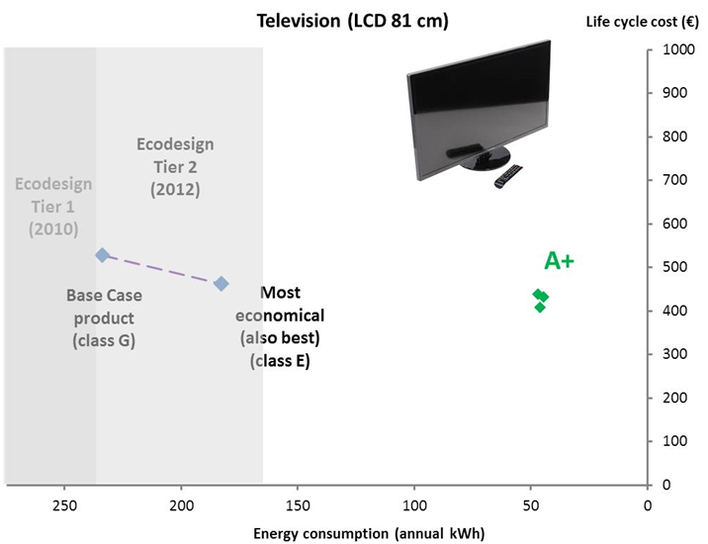

Figure 6: Energy class evolution of televisions for comparable life-cycle cost (Topten presentation[11])

Although the 2014 dataset includes displays and television models in the classes C and D, when analysing the market share by energy class, inefficient displays reveal a negligible market penetration from 2014, as the market data study from GfK suggests (Figure 7 for the Belgian market).

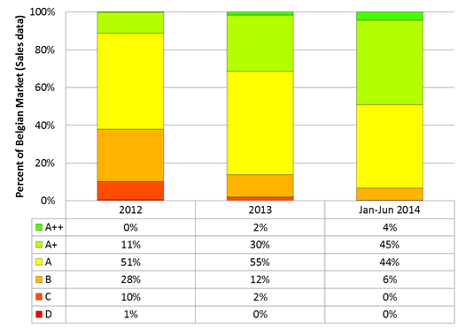

Figure 7: Market share evolution of sales data for televisions in Belgium (GfK, 2014)

According to the Regulation 1062/2010, the labels can already indicate the 7 classes A+++ to D that had been originally foreseen by 1/1/2020 and an overcrowding of the top classes can be expected soon (Figure 8).

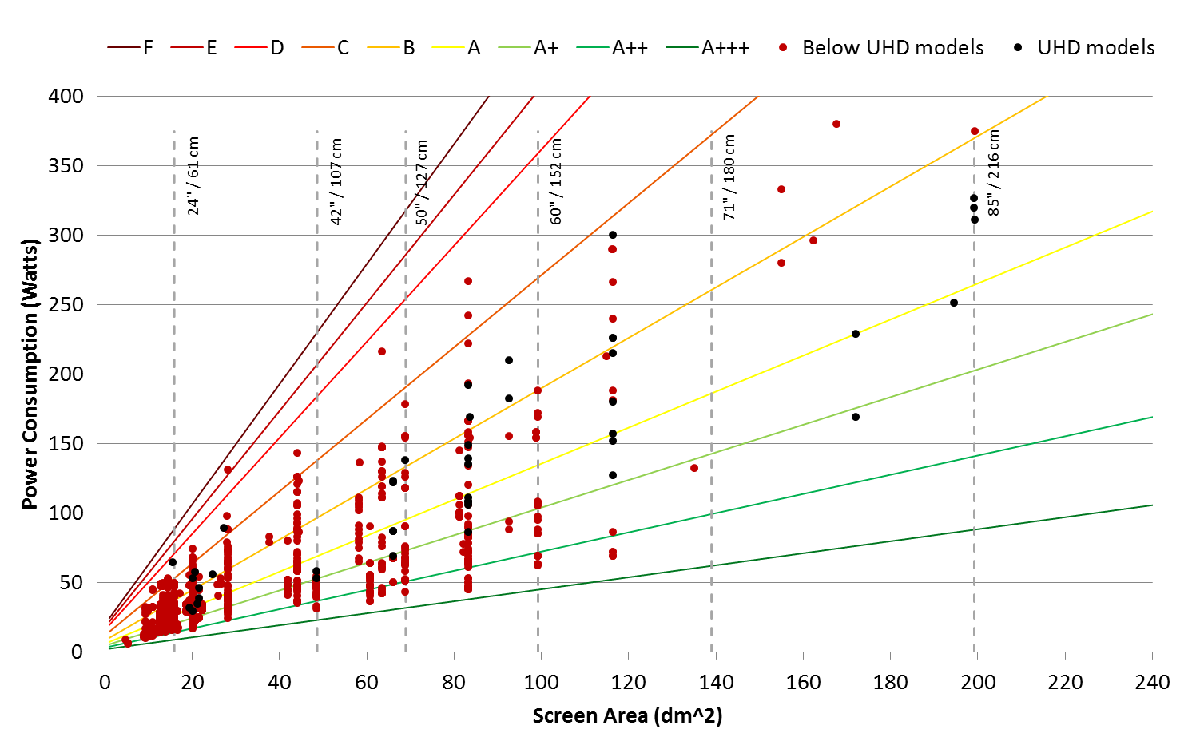

Figure 8: The 2014 models dataset compared with the current energy classes.

## Resource efficiency aspects

Electronics manufacturing is highly resource and energy-intensive. Using recycled plastics is one way of “closing the loop”, facilitating a more circular economy and ensuring that resources recovered from waste products are partially used in new products. Embedded energy and carbon from manufacturing is lost when e-waste is dumped, and resources are wasted that are far more energy intensive to extract as raw materials as they are to recycle. Some companies report on their use of post-consumer content (PCC) recycled plastic as a way of reducing waste, saving energy used for raw materials processing and moving towards a circular production cycle. Recycling is more difficult and less efficient if waste plastics are contaminated with hazardous substances. Therefore there is a clear need to design them out and ensure minimal residual contamination of products.

According to a recent study[12], the share of TVs observed at the recycling plant containing Brominated Flame Retardants (BFR) plastics in the housings is around 18% (i.e. relevant but not dominant). As discussed in the paper, it was found that a substantial share of the analysed TVs had a plastic marking not corresponding with the plastic composition. Some automated techniques for sorting BFR containing plastics have been developed, but their efficiency and feasibility is still unknown. Miscibility of plastics is an issue (Figure 9). “X-ray fluorescence spectral analysis” seems actually the most efficient technology for sorting dark plastics used in TVs.

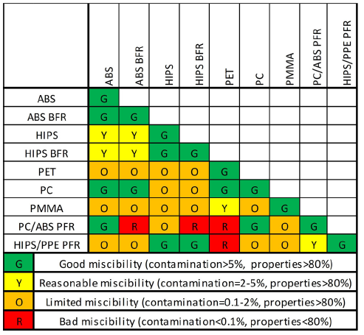

Figure 9: Miscibility preference scheme for plastics commonly used in LCD TVs (source Peeters et a., 2014)

Electronic displays using LCD-CCFL technology include a fluorescent lamp containing mercury (Hg) vapour that is extremely fragile and should be removed with care (depollution phase, as required by the WEEE Directive) if the displays is recycled using shredding techniques. A clear indication of the absence of such a lamp could dramatically speed up recycling procedures.

## Environmental significance

The impact assessment undertaken in 2013 had estimated the annual electricity consumption related to electronic displays in the EU at about 55 TWh in 2020 and 66 TWh in 2030, corresponding to 21 and 25 Mt CO2 emissions respectively. The savings potential for the two revised regulations, with their scopes extended to ‘electronic displays’ that are primarily intended for use in households and/or offices and digital photo frames, were estimated at 32 TWh electricity (by 2020), 12 Mt CO2 equivalent and 8 billion euros in lowering the consumer energy bill. The savings potential in 2030, was estimated to reach 35 TWh, 13 Mt CO2 equivalent and almost 13 billion euros. Additional benefits can be expected from measures promoting a higher recovery rate of rare and precious material resources.

An update of the previous impact assessment will be undertaken after the Consultation Forum.

## Currently covered products

The current Regulations, as mentioned, cover televisions and television monitors (ENER Lot 5). Computer displays (ENER Lot 3) are not currently covered by any regulation, with the exception of displays integrated into computers (integrated desktop computers) for which the total mercury content has to be declared[13]. Article 9 of Regulation 642/2013 mentions the "potential to address energy consumption of integrated displays" in a future revision of the computer regulation itself.

## International legislation

US-EPA EnergyStar covers both televisions[14] and computer[15] displays. Annex C of the EU-US EnergyStar agreement includes exclusively the displays[16]. The European Commission is involved in the preparation of new specifications for EnergyStar, as well as in the SEAD initiative.

# Proposed measures

The preparatory study has shown that significant energy savings can be achieved by implementing a number of policy options which are explained in this chapter. An overview of the projected savings can be found below.

## Ecodesign

The 2012 proposal applied a best-fit linear curve for small displays and a natural log function for large displays. This same approach, tested with the new 2014 database was not considered satisfactory anymore.

The proposal from CLASP was retained as better responding to the technology evolution, as emerged by the new 2014 model database and having an approach more in line with Energy Star and SEAD:

$${Power}_{max}=A × \left[B×\tanh\left(0,02+D×\left(Area-11\right)\right)+4\right]+6$$

Where *Area* is the display area in dm2, A, B and D have different values for three different tiers, as detailed in the draft ecodesign proposed measure.

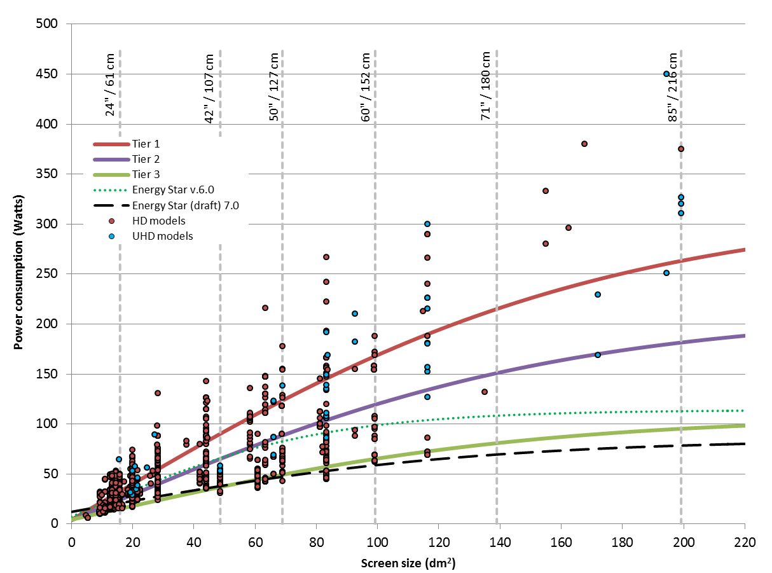

Figure 10: Proposed curves compared with the 2014 database for all displays, compared with EnergyStar and distinguishing UHD displays.

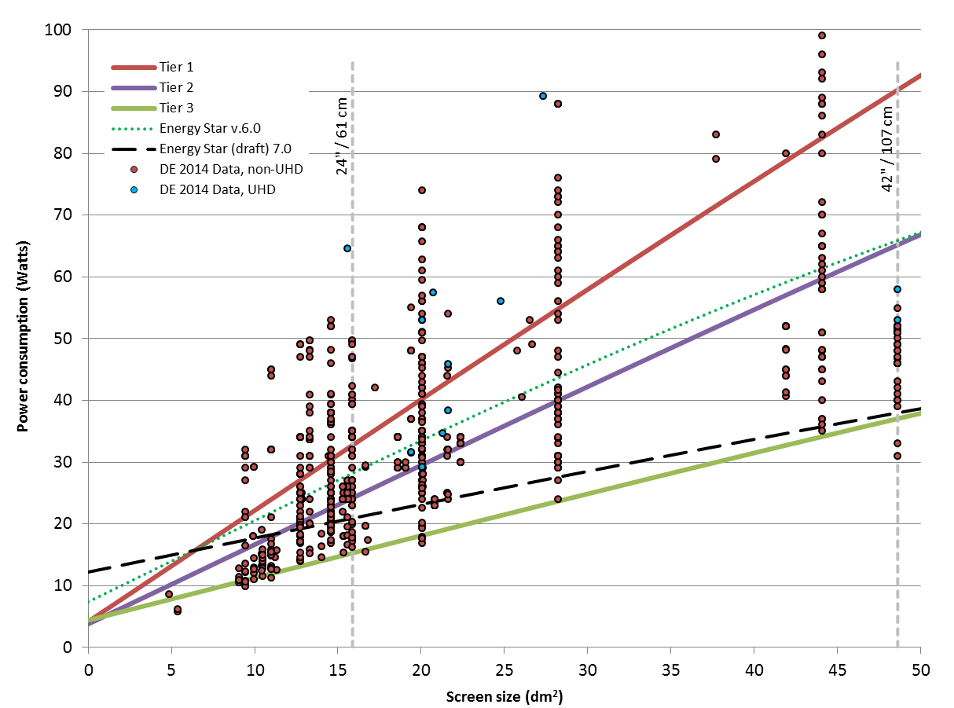

Figure 11: Proposed curves compared with the 2014 database for small displays, compared with EnergyStar

### Resource-efficiency requirements

The proposed measure sets specific requirements for manufacturers to (1) disclose information relevant for disassembly, recycling and/or recovery at end-of-life, (2) mark plastic parts, (3) declare the recyclability rate of plastic parts, and (4) label for mercury and BFR presence.

These requirements are devised to help recyclers to better comply with the WEEE Directive (2012/19/EU) by providing information relevant for the depollution, disassembling and/or shredding operations.

These requirements are in line with the approach taken in the Ecodesign regulations that were adopted so far and with the Commission Communication "Towards a circular economy: a zero waste programme for Europe" aimed at establishing a common and coherent EU framework to promote the circular economy. The proposed requirements should result in marginal costs to manufacturers with possibly relevant cost reduction and improved efficiency for the recycling industry.

User information requirements include a requirement for information on the advantages of power management.

## Labelling

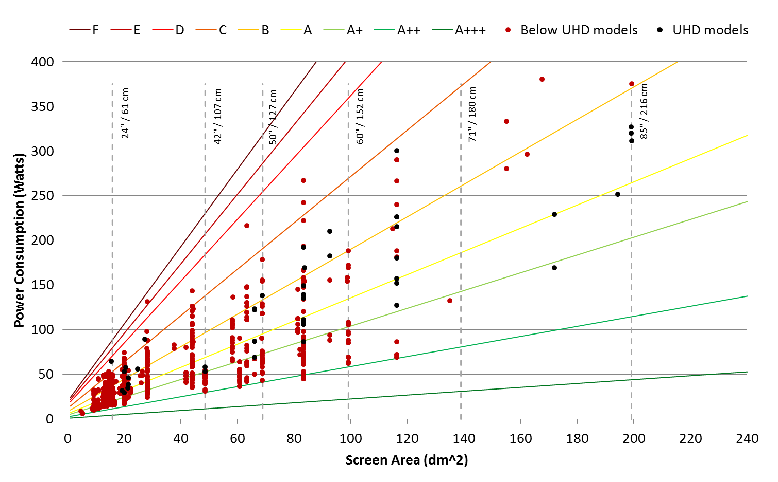

Figure 12: Rarefaction of display models in the two best energy classes by increasing the ambition

The analysis of the 2014 database has highlighted that 41 models are already in the A++ class, whilst the introduction of the label ranging between A++ and E was only foreseen from 1 January 2017.

A partial rescaling in respect to what was established in the Regulation 1062/2010 of "future" thresholds of the 3 top EEI classes may extend the useful life of the energy label (Figure 12), until a new label will be adopted.

The following table summarises the proposed changes in respect to Articles 3(c) and 3(d) of the current labelling regulation and Annex I, Table 1 of the same regulation. According to the 2014 dataset, such a modification would reclassify 33 of the 41 models currently in the EU market, would reduce the number of A++ displays already in the market and would avoid an overcrowding of the 3-4 top classes A-A+++ , permitting an extension of the lifetime of the label, maintaining its appeal for consumers.

|  |  |  |  |
| --- | --- | --- | --- |
| EEI | range (1062/2010) | start date | new range proposed |
| A+ | 0,16 ≤ *EEI* < 0,23 | 1/1/2014 | 0,13 ≤ *EEI* < 0,23 |
| A++ | 0,10 ≤ *EEI* < 0,16 | 1/1/2017 | *0,05* ≤ *EEI* 0,13 |
| A+++ | EEI< 0,10 | 1/1/2020 | EEI *< 0,05* |

Such a change in the three highest classes would be accompanied by the anticipation to the date of entry into force of the Regulation of the Label foreseen from 1 January 2020, thus simplifying the compliance obligations.

The same equation in the provisions of the current Regulation (although not ideal) is proposed until after the overall label update is completed as it may be considered disproportionate for the industry to undertake a full reclassification of the energy classes at this moment in time.

## Exclusions

Televisions, computer monitors for home/office use and picture frames are in the scope of the proposed Regulations.

Displays in game-consoles, signage displays and projectors already included in other ecodesign measures or voluntary agreements are out of scope.

Displays integrated into mobile devices are out of scope because the efficiency requirements of such devices (due to a clear need for increasing battery lifetime) mean that a specific ecodesign measure would have limited added value.

Displays integrated into equipment for the professional or business-to-business market, such as industrial processing or laboratory testing, are out of scope due to their particular characteristics.

A number of displays for use in specific and professional market are only covered by the resource efficiency (end of life) requirements.

# Possible overlap with other Ecodesign measures

Horizontal measures including Regulation 1275/2009 on stand-by, Regulation 801/2013 on networked stand-by and Regulation 278/2009 on external power supplies have been considered in the drafting of this measure for the possible overlap of specific articles or specific aspects.

Inclusion of computer displays in an Ecodesign regulation may provide the opportunity of excluding, in future, displays from the EU EnergyStar agreement to avoid an overlap of measures and confusing consumers.

# Review of Regulation 642/2009

According to Article 6 of the Commission Regulation (EC) No 642/2009 of 22 July 2009 implementing Directive 2005/32/EC of the European Parliament and of the Council with regard to ecodesign requirements for televisions[17], the Commission shall review this Regulation in the light of technological progress within 3 years after entry into force[18] and shall present the results of this reviews to the Ecodesign Consultation Forum. The proposed Ecodesign measure would repeal the Regulation 642/2009.

## Review of Regulation 1062/2010

Similarly, according to Article 7 of the Commission Delegated Regulation (EU) No 1062/2010 of 28 September 2010, supplementing Directive 2010/30/EU of the European Parliament and of the Council with regard to energy labelling of televisions[19], the Commission shall review this Regulation in within 5 years after entry into force[20]. The proposed Energy labelling measure would repeal the Regulation 1062/2010.

# Form of implementing measures

The implementing measure will take the form of a Regulation setting minimum ecodesign requirements directly applicable in all Member States.

The ecodesign requirements relate to the energy efficiency of the products within the scope of the Regulation. In addition there are ecodesign requirements on the provision of supplementary product information and information related to resource efficiency aspects.

# Measurements and calculations

Measurements and calculations of the relevant product parameters should be performed using harmonised standards established in accordance with Article 10 of Directive 2009/125/EC, the reference numbers of which have been published in the *Official Journal of the European Union,* or using other reliable, accurate and reproducible methods which take into accountthe generally recognised state-of-the-art and produce results deemed to be of low uncertainty. Requirements for calculation and measurement methods are specified in Annex IV to the proposed Ecodesign measure and in annex IX of the Labelling measure. Following the extension of the scope, the Commission should amend mandate 477 to ensure that CENELEC develops one single standard that would provide proper measurement methods for all displays covered by the scope of the proposed measures.

# Conformity assessment

When performing the market surveillance checks referred to in Article 3 (2) of Directive 2009/125/EC, the authorities of the Member States shall apply the verification procedure for the requirements set out for the Ecodesign and the labelling measure respectively in Annex V and in Annex X.

The verification tolerances set out in the Annexes relate only to the verification of the measured parameters by Member States authorities and shall not be used by the manufacturer or importer as an allowed tolerance to establish the values in the technical documentation.

# Benchmarks

The following indicative benchmarks are identified for the purpose of part 3, point 2 of Annex I to Directive 2009/125/EC and refer to the best available technology at the time of drafting this document for electronic displays on the market:

55,9 cm / 22 inch diagonal of viewing area: 14.5 Watts

81,3 cm / 32 inch diagonal of viewing area: 24 Watts

106,7 cm / 42 inch diagonal of viewing area: 31 Watts

139,7 cm / 55 inch diagonal of viewing area: 45 Watts

# REFERENCES

Chen Jian, Hartlove Jason, Yurek Jeff, Lee Ernie, Gensler Steve (2014), High efficiency LCDs using Quantum Dot Films, Nanosys, Inc., Milpitas, CA.

CLASP (2014), Review of the Ecodesign and Energy Labelling Regulations for televisions and draft Regulation on electronic displays: Discussion Paper. Online:  
 <http://clasponline.org/en/Resources/Resources/PublicationLibrary/2014/EU-Ecodesign-and-Energy-Labeling-of-Electronic-Displays.aspx#files>

1. OJ L 339, 18.12.2008, p. 45
2. OJ L 93, 7.4.2009, p. 3
3. OJ L 191, 23.07.2009, p. 42
4. OJ L 175, 27.6.2013, p. 13
5. OJ L 225, 23.8.2013, p. 1
6. OJ L 314, 30.11.2010, p. 64
7. Requirements laid down in Regulation 642/2009 were based on linear regression line
8. <http://www.superefficient.org/>
9. Or, conversely, with fall in prices for displays and televisions with lower resolution.
10. Apple has placed on the market an integrated desktop computer with a 5k display and other companies start now proposing 5K displays.
11. International trends in Ecodesign and Energy Labelling, Brussels, 21 February 2014, WS 2)
12. Peeters et a., Closed loop recycling of plastics containing Flame Retardants, Resources, Conservation and Recycling 84 (2014) 35–43
13. Annex II, point 7.1.1(y)
14. Current revision version 6.1 effective from 06/01/2013 with version 7.0 in preparation with the involvement of the Commission.
15. Current Version 6.0 effective from 06/01/2013.
16. Commission Decision (2014/202/EU) of 20 March 2014.
17. OJ L 191, 23.07.2009, p. 42
18. According to Article 8, 20 days from publication on OJ L191, Vol 2, 23 July 2009, i.e. within 13 August 2012
19. OJ L314, 30.11.2010, p.64
20. According to Article 9, 20 days from publication on OJ L314, Vol 53, 30 November 2010, i.e. within 20 December 2015