Guidelines accompanying Commission Regulation
(EU) No 801/2013 of 22 August 2013
amending Regulation (EC) No 1275/2008 with regard to ecodesign requirements for standby, off
mode electric power consumption of electrical and electronic household and office equipment, and
amending Regulation (EC) No 642/2009 with regard to ecodesign requirements for televisions

November 2014

Table of Contents
1. Purpose of the guidelines and disclaimer 3
2. Introduction 4

3. Scope of the Amended Regulation 5
Single functional unit 5
Intended for the end-user 5
Product types covered by the Regulation 5
Energy input from the mains power up to 250 V 6
Scope decision tree 6
4. Definitions and scope of the amendments 8
Networked equipment 8
Network 9
Network port 10
Networked standby 11
Other terms used 13
Networked equipment decision tree 14
Examples 15
5. Ecodesign requirements for networked equipment 16
Availability of off and/or standby modes and maximum power levels
in off and standby modes 16
Power management for networked standby 16
Power levels 18
Deactivation of wireless network connections 19
Specific requirements for standby and off for networked equipment 20
Changes as of 1 January 2017 22
6. Exemption of requirement if inappropriate for the intended use 24
Decision tree for inappropriate requirements for intended use 24
7. Timing 27
As from 7 January 2010 27
As from 7 January 2013 27
As from 12 September 2013 27
As from 1 January 2015 27
As from 1 January 2017 27
As from 1 January 2019 28
8. Tests for networked standby 29
9. Information to be provided 31
Public product information 31
On the manufacturers’ website 31
In user manuals 31
Information to be provided in the technical documentation 32
Declaration of Conformity 34

Purpose of the guidelines and disclaimer

Ecodesign Regulation (EC) No 801/2013 is an amending regulation introducing requirements for networked standby to the existing Regulation (EC) No 1275/2008 with regard to ecodesign requirements for standby, off mode electric power consumption of electrical and electronic household and office equipment, and to Regulation (EC) No 642/2009 with regard to ecodesign requirements for televisions.

These guidelines aim to help relevant stakeholders, including industry and public authorities, to implement the Regulation and its requirements in practice. They summarise the main elements from the regulations to give SMEs an introduction to the subject matter and answer the most common questions.

The guidelines are intended to be used only for facilitating the implementation of the Regulation. They are not intended to replace the Regulation or to provide “interpretation” beyond its intent.

The guidelines have been drawn up by the European Commission services and were extensively discussed with Member State and stakeholder experts. The guidelines only reflect the opinion of the Commission services and are not legally binding. A finally binding legal interpretation of EU legislation may only be provided by the European Court of Justice. The guidelines are without prejudice to the position the Commission might take should an issue arise in a procedure before the European Court of Justice.

This guide should be read in conjunction with the already published guide for SMEs to regulation 1275/2008 (http://ec.europa.eu/energy/efficiency/ecodesign/doc/legislation/guidelines_for_smes_1275_2008_okt_09.pdf).

For convenience, an unofficial consolidated version of the amended Regulation can be downloaded here: http://eur-lex.europa.eu/LexUriServ/LexUriServ.do?uri=CONSLEG:2008R1275:20130912:EN:PDF.

Introduction

The standby regulation was amended to include specific requirements for networked equipment, which so far were not addressed and were developed in a separate Ecodesign process.

These guidelines describe the specific networked standby requirements and which products are subject to these requirements.

Section 3, "Scope of the amended regulation", describes the overall criteria for products to be within or outside the scope of the amended Regulation (EC) No 1275/2008;

Section 4, "Definitions", explains and illustrates the definitions being relevant for networked standby.

Section 5 specifies and explains in more detail the requirements for networked equipment.

Section 6 describes the background and use of the clause "inappropriate for the intended use".

Section 7 gives an overview of the timing of the various requirements.

Section 8 describes the test procedure.

Section 9 describes the information to be provided on the web sites, the user manuals and in the technical documentation.

Italic text (e.g. written like this) is text directly from the amended Regulation.

Scope of the amended Regulation (EC) No 1275/2008

This section describes the most relevant criteria for determining if equipment is subject to Regulation (EC) 1275/2008 and in particular with respect to the provisions that were amended.

Equipment covered by the Regulation is equipment which fulfils all the criteria set out in Article 2.1. as follows:

Single functional unit and intended for the end-user
The amended Regulation applies to equipment which is made commercially available as a single functional unit.

A single functional unit is similar to the concept of an "apparatus" in the EMC directive 2004/108. The EMC Directive defines ‘apparatus’ as any finished appliance, or combination thereof made commercially available (i.e. placed on the market) as a single functional unit, intended for the end-user, and liable to generate electromagnetic disturbance, or the performance of which is liable to be affected by such a disturbance. The apparatus must be accompanied with a Declaration of Conformity. Components that are inside equipment in the scope or in another way are an integrated part of the equipment and that do not have their own CE marking and Declaration of Conformity are no single functional units.

A television with a remote control is a single functional unit. Even though the remote control connects to the television, the connection between these two is not considered to be a network connection.

The equipment should also be intended for the end-user. This is equipment, which can be used by individuals directly. In particular, the end-user has direct control over activation and deactivation of the product.

Equipment listed in Annex I
Equipment in scope of the Regulation is listed in Annex I, which includes household appliances, information technology equipment, consumer equipment and toys, leisure and sports equipment. Specific product types are mentioned under each of these product groups.

Lighting and lamp control gear and devices are not covered. Therefore, smart lamps and devices installed between the mains and the lamp, which can be controlled by e.g. a smart phone over a network connection, are not covered. These are covered by the regulation (EU) 1194/2012.

Computers (with exception of some sub-categories) and televisions are exempted from Regulation (EC) No 1275/2008 and therefore not subject to the requirements stipulated in the amended regulation. The reason is that they are subject to product-specific regulations that include provisions for standby and networked standby ((EC) 617/2013 for computers and (EC) 642/2009 for televisions)).

In the case of computers, the networked standby mode is covered by the Wake-on-Lan (WoL) functionality in (EC) 617/2013. In the case of televisions, Amending Regulation (EC) 801/2013 introduced specific network standby requirements to Regulation (EC) No 642/2009 (Article 2 of the Amending Regulation).

Voluntary Agreements do not have the same status as regulations. Provisions in regulations that regulate certain aspects (like standby operating mode) of products for which a Voluntary Agreement is in place do apply.

Regarding information technology equipment, the requirements of Regulation (EC) No 1275/2008 should only apply (see recital 8) to those products intended primarily for use in the domestic environment, i.e. EMC Class B IT equipment. The definition of ‘information technology equipment’ and ‘domestic environment’ is identical to EN 55022 or EN55032 covering essential requirements of the EMC Directive. This includes products intended for use in offices and other areas not being homes. All products designated EN55022 / EN55032 EMC Class A, especially commercial and industrial products such as data centre equipment are out of the scope of this regulation.

Equipment with energy input from the mains power source
Equipment in scope is dependent on energy input from the mains power source in order to work as intended (art. 2 point 1(c)); i.e. the product is supplied by power from the grid directly.

Equipment designed for use with a nominal voltage of 250V or below
Equipment in scope has a nominal voltage rating of 250 V or less (art. 2 point 1(d)).

Exemption: Equipment placed on the market with a low voltage external power supply (amended Regulation (EC) No 1275/2008, Article 1)
Equipment placed on the market with a Low Voltage Power Supply is exempted, as long as it works as intended with a low voltage external power supply supplied with the equipment. The term "to work as intended" means that just adding a low voltage external power supply will not justify any exemption from the regulation.

Scope decision tree
Summarising the above descriptions, the flowchart below provides a decision tree to determine if a device is in scope.

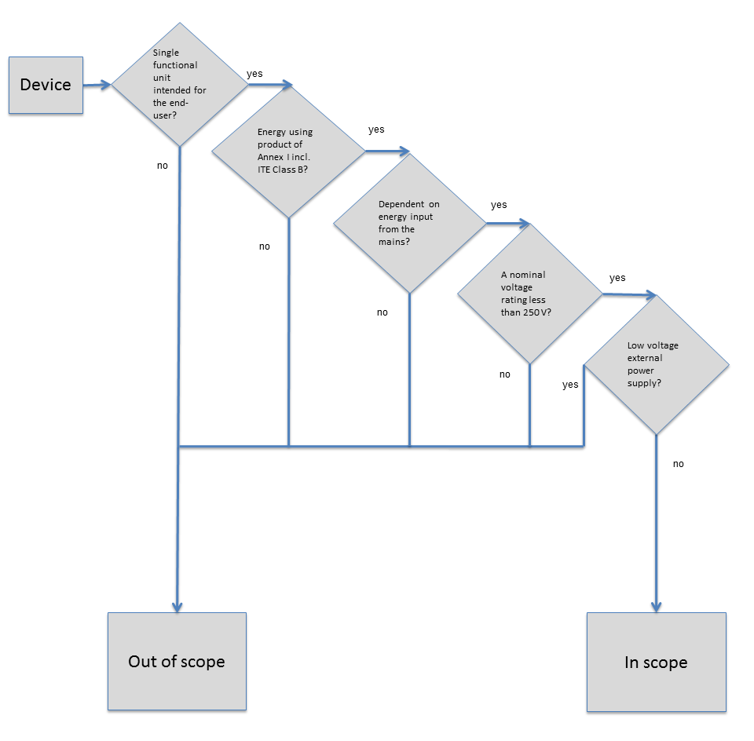

Requirements for televisions
Regulation 801/2013 also amends Regulation 642/2009 for televisions in relation to requirements for networked televisions. The requirements for networked TVs are quite similar to the requirements to networked equipment but were adapted to the specificities and user patterns of televisions. Even though the guide is prepared with reference to 1275/2008, the text covers most of the topics related to the amended Regulation 642/2009., which is currently under review.
The main differences are:

- The power management function has to power down the TV after a maximum of 4 hours following the last user interaction and/or a channel change and only after display of an alert message
- Televisions can have HiNA functionality but not be HiNA equipment

Definitions

The following section explains and specifies the relevant definitions established in Article 2 of the Regulation with a focus on products being subject to the networked standby requirements.

The numbers below correspond to the numbered list in Article 2. A few additional terms used in the amended text but not included in Article 2 are explained here.

Networked equipment
The manufacturer needs to clarify whether the product is networked equipment according to the definitions in the regulation and thereby should comply with the requirements for networked equipment. If the manufacturer considers that the equipment is not networked equipment, it should comply with the standby/off requirements for all other equipment.

The definition of networked equipment is:
17 ‘networked equipment’ means equipment that has the ability to connect to a network and has one or more network ports;
Equipment can thus only be considered networked equipment when it can connect to a network and has one or more interface ports that qualify as network ports according to the definition in the regulation (see explanations below).

There are different categories of networked equipment: HiNA equipment, equipment with HiNA functionality and equipment without HiNA functionalities (see explanations below).

The equipment will have to comply with the standby/off mode requirements and not with the network standby requirements if essential information as required in Annex II 9.b to identify equipment as networked equipment is missing. This does not apply in the case of HiNA equipment or equipment with HiNA functionality (see more details in Section 9), which is automatically considered networked equipment.

18. ‘networked equipment with high network availability’ (HiNA equipment) means equipment with one or more of the following functionalities but no other, as the main function(s): router, network switch, wireless network access point, hub, modem, VoIP telephone, video phone;

Equipment that is considered "networked equipment with high network availability" (HiNA) as defined in definition 18 is equipment that is typically able to resume functions within short time often milliseconds in order to work as intended.

19. ‘networked equipment with high network availability functionality’ (equipment with HiNA functionality) means equipment with the functionality of a router, network switch, wireless network access point or combination thereof included, but not being HiNA equipment;

Devices which are not genuine HiNA equipment but include a router, switch or wireless access point are defined as equipment with HiNA functionality. An example is a complex set top box, which contains a router and wireless access point.

Note that the functions that qualify a device as ‘equipment with HiNA functionality’ are different from the functions that qualify a device as ‘HiNA equipment’: They only include functions of a router, network switch, wireless network access point but not functions of a hub, modem, VoIP telephone or video phone.

Annex II 9.b also stipulates that the manufacturer needs to specify whether the equipment is HiNA equipment or equipment with HiNA functionalities. If this information is missing, the equipment will automatically not be considered HiNA or equipment with HiNA functionality.

Network
10. ‘network’ means a communication infrastructure with a topology of links, an architecture including the physical components, organisational principles, communication procedures and formats (protocols);

A network is an infrastructure that enables connections between devices. Networks can be local (Local Area Networks (LANs), which themselves can be wired or wireless) and global (Wide Area Networks (WANs). Networks can be digital or analogue.

Examples of technologies and interfaces that can connect devices and form a network:
- For WAN:
  - Wired technologies: Ethernet, ADSL, VDSL, DOCSIS cable, GPON, EPON, FXO, fax, PSTN, ISDN and DVB-C
  - Wireless technologies: WiMAX, 3G, 4G, 5G, EDGE, LTE , DVB-T and DVB-S
- For LAN/in-home networks:
  - Wired technologies: Ethernet, MoCA, HDMI CEC, HDMI TDMS, DVI, USB, Firewire, Thunderbolt, HPNA, Power line, Homeplug, MHL (Mobile High definition Link), RS232, IEEE488, VGA, RF-coax, PictBridge, Infrared and SCART
  - Wireless technologies: Wi-Fi, DECT, ZigBee, Bluetooth

A network is only present when at least two devices or two single functional units are connected to one another. A single functional unit is similar to an apparatus as defined in the EMC directive and is accompanied by a Declaration of Conformity. This means that the network cannot exist only within a single apparatus.

Examples:
- A USB connection capable of exclusively powering or charging a product is not considered as a network.
- A remote control which is shipped with a device does not create a network between the remote control and the device.
- A device which can be controlled by external devices such as smartphone and computer via Bluetooth or other wireless or wired connection does form a network with the external device.
- Both one-way connections (e.g. between computer and monitor) and two-way connections (e.g. between computer and printer) are considered to be networks.
- A wireless speaker to which audio can be streamed over a wired and/or a wireless connection is considered to be networked equipment.

It is the manufacturer who has to declare the equipment as networked equipment and thereby also that the equipment can connect to a network according to the definition of a network.

Network port
13. 'network port' means a wired or wireless physical interface of the network connection located on the equipment through which the equipment is able to be remotely activated;

The regulation has provided a specific definition different than the common industry definition of network port. A network interface is only a network port in the sense of the regulation if the device can be remotely activated via an external signal through this interface. A trigger coming from within the equipment itself is not a remote activation.

A manufacturer has to indicate in the technical documentation which network interfaces are network ports. This can be both, LAN and/or WAN network interfaces.

When a device has multiple physical USB network ports, such as a USB 2.0 and a USB 3.0 network port, these are considered to be different network ports if indicated by the manufacturer as such.

Similarly, a network port that supports 10Base-T Ethernet port is considered to be a different port than a network port that supports 100Base-T or a 1G Ethernet port.

14. 'logical network port' means the network technology running over a physical network port;

15. 'physical network port' means the physical (hardware) medium of a network port. A physical network port can host two or more network technologies;

A physical network port may consist of multiple logical network ports.

For example, a single physical network port consisting of a cable F-connector could be used to concurrently support logical network ports consisting of multiple network technologies such as DOCSIS and MoCA. In this case, the two logical network ports would be the DOCSIS interface and the MoCA interface.

A logical network port is considered ‘logical-disconnected’ when the network technology associated with the logical network port is disabled or switched off via vendor-defined means.

Networked standby
11. ‘networked standby’ means a condition in which the equipment is able to resume a function through a remotely initiated trigger via a network connection;

The definition of networked standby has deliberately been limited to one essential aspect (a condition in which the equipment is able to resume a function by a remotely initiated trigger from network connection) to allow different ways of implementation.

In networked standby, there could be network integrity communication (periodic signals exchanged between the devices to confirm their presence in the network) between devices not considered as trigger for resuming a function. Payload traffic such as a print job being sent or other data transfer related to a main function of the device is considered as a trigger.

In networked standby, the equipment is inactive (not performing a main function) but in a condition allowing it to be reactivated via an external network signal.

The condition under which a technology provides networked standby varies greatly. Some technologies may define a ‘magic packet’ that acts as a remotely initiated trigger. One example of technology utilizing a ‘magic packet’ is Ethernet Wake-on-LAN. Some technologies may instead define a protocol that provides a trigger to place a logical network port into and out of a state that maintains the network connection at a reduced power. Examples of these technologies include Energy Efficient Ethernet (802.11az), ADSL 2+ and DOCSIS 3.0.

The network reactivation trigger is not exclusive and comes if needed in addition to other types of reactivation such as remote control key press, internal timer, etc. The trigger that is used to reactivate the equipment should be described in the technical documentation.

A networked standby condition differs depending on the type of device (HiNA or non-HiNA "other network equipment"), and this is why different categories of networked equipment have different power consumption limits:
"Other network equipment" such as imaging equipment, projectors, complex set top boxes, when not performing a main function, power down significant portions of the device electronics to lower the power while maintaining a network connection for receipt of a remote trigger. In the condition providing networked standby the equipment shall not exceed a power consumption of 6/3/2 Watts (2015/2017/2019).

However, HiNA devices, such as routers, gateways, switches and wireless access points, cannot power down significant portions of the device, due to their main function. HiNA equipment must be prepared to receive and handle packets at any time and may leave the networked standby state immediately, i.e. within milliseconds, when another packet arrives – otherwise they cannot work as intended. Hence they are called High Network Availability equipment. They also must forward remote triggers from other edge devices to their destination. Therefore, the power consumption allowed for HiNA devices is higher than for other networked equipment (12/8 Watts for 2015/2017).

Note that resume time is not part of the requirements of the Amendment - it is up to the manufacturer to consider the requirements of their customers and to specify and implement the appropriate resume time in relation to the functionalities provided by the equipment.
The picture below illustrates how most devices behave with respect to networked standby, depending on their place in the network. For networked standby to be available, they cannot shut down the interface that expects an external trigger. However, a large part of the device can be put ‘to sleep’ when not performing a main function.

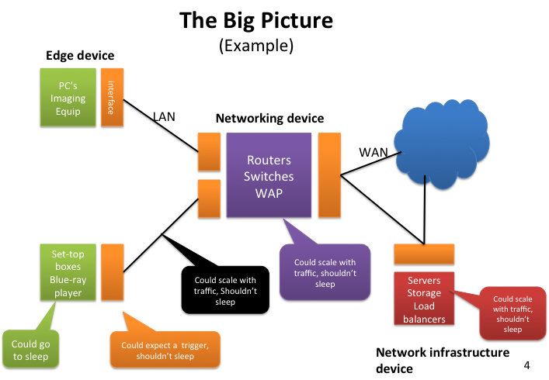

Other terms used
Deactivate: The term ‘deactivate’ as used in the regulation means that a network port can be disabled or switched off via an intended intervention of the user for example via menu or button/switch. Deactivation is possible for wired and wireless network ports

Logical-Disconnect: The term ‘logical-disconnect’ means that the network technology associated with the logical network port is deactivated.

Disconnect: The term ‘disconnect’ as being used in the regulation (without ‘logical’ before it) means that a cable is being disconnected or pulled out of the wired equipment when being tested. Disconnection in this context is only possible for wired network ports. If multiple logical network ports are hosted by a single physical network port, disconnection of the physical network port would disconnect all associated logical network ports.

Reactivation function: For the purposes of this regulation, the term ‘reactivation’ has a meaning which is distinct from the terms deactivation/activation of an interface or network port. The term instead refers to resuming a function within a device. For example a device receives a trigger to resume from a standby mode or from a networked standby condition as defined as defined in the amended Regulation (EC) No 1275/2008.
Remotely activated: In this regulation, "remotely activated" is referring to a function within a device, whereby it is able to resume normal operation from a networked standby state upon receiving an external trigger from the network.

Network connection: A network connection is a port which can form a network. Ports that cannot form a network are not network connections. Example: the IR ports of a remote control and an A/V receiver which are sold together do not create a network and are not network connections.

Wireless network connection: A wireless network connection is a wireless port which can form a network.

Placing on the market: The term ‘placing on the market’ is defined in the Ecodesign directive as making available for the first time on the EU market with a view to its distribution or use within the EU, whether for reward or free of charge and irrespective of the selling technique.

Default condition: Is the state of the equipment as delivered by the manufacturer and made available for the first time in the EU market without the end-user having changed any settings.

Manufacturer: The manufacturer is any natural or legal person who is responsible for designing or manufacturing a product and places it on the market under his own name or trademark. The definition contains two cumulative conditions: the person has to manufacture (or has a product manufactured) and to market the product under his own name or trademark. So, if the product is marketed under another person's name or trademark, this person will be considered as the manufacturer.

The responsibilities of the manufacturer apply also to any natural or legal person who assembles, packs, processes or labels ready-made products and places them on the market under his own name or trademark.

Further, the responsibility of the manufacturer is passed on to any person who changes the intended use of a product in such a way that different essential or other legal requirements will become applicable, or substantially modifies or re-builds a product (thus creating a new product), with a view to placing it on the market.

Networked equipment decision tree
Summarizing the above descriptions, the flowchart below provides a decision tree to determine if a device is networked equipment.

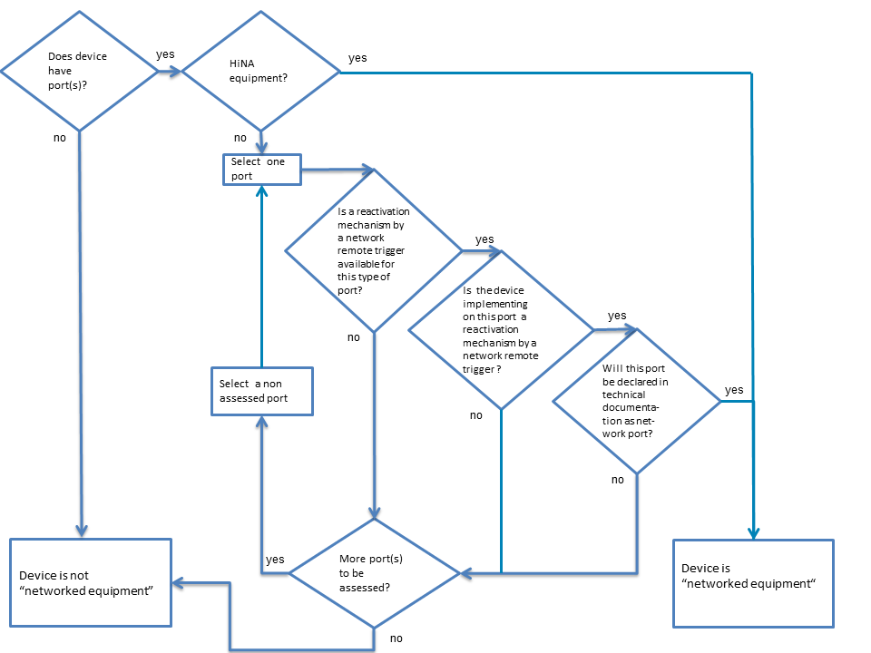

Examples
A webcam has only 1 interface, which is an Ethernet interface. Although Wake-on-LAN (WoL) exists for Ethernet technologies, the manufacturer decided not to implement WoL over Ethernet or other remotely activated trigger. This webcam is not considered networked equipment

A printer has 3 interfaces: Wi-Fi, Ethernet and USB. The manufacturer decided not to implement WoWLAN (Wake-on-Wireless-LAN), but did implement a reactivation mechanism for USB and Ethernet. In the technical documentation, the USB and Ethernet interfaces have been identified as network ports. This printer is considered networked equipment.

A complex set-top box has 4 interfaces: DOCSIS, HDMI, Ethernet and Wi-Fi. The manufacturer did not indicate in the technical documentation that those interfaces are network ports even though some of them might have a working reactivation function. This set-top box is not considered networked equipment.

A router has 2 types of interfaces: Ethernet and Wi-Fi. The manufacturer did not indicate in the technical documentation that those interfaces are network ports In accordance with Annex II 9(b), this router is considered networked equipment anyway, because it provides the functionalities of a router.

A video gateway has 4 interfaces: DOCSIS, Ethernet, MoCA, and Wi-Fi. The manufacturer indicated in the technical documentation that those interfaces are network ports and provided all the necessary information set out in 9(b). This video gateway is considered networked equipment.

Ecodesign requirements for networked equipment

The Ecodesign requirements regarding power consumption and power management are:
- Availability of off and/or standby modes and maximum power levels in off and standby modes. These are the same requirements for networked as for non-networked equipment.
- Power management requiring automatically switching into networked standby after the shortest possible period of time
- Maximum power levels in networked standby
- Possibility of deactivating wireless network connections
- Power management requiring automatically switching into standby or off modes in certain cases

These requirements are detailed in the following with reference to Annex II.

Availability of off and/or standby modes and maximum power levels in off and standby modes

The equipment – both non-networked and networked equipment –shall provide off mode and/or standby mode or a similar condition which does not exceed the corresponding power consumption requirements (Annex II 2(c)). The maximum power levels are 0,5 W in off and standby, or 1,0 W in standby in case an information or status display is available.

The equipment is exempt from the requirement if this is "inappropriate for the intended use". The term inappropriate for the intended use is further described in the Section 6.

Power management for networked standby
The amended Regulation (EC) No 1275/2008 requires in Annex II 3(b) that as from 1 January 2015 equipment shall, unless inappropriate for the intended use, offer a power management function or a similar function.

The power management should be activated as follows: When networked equipment is not providing a main function and other energy-using product(s) are not dependent on its functions, the power management shall switch equipment after the shortest possible period of time appropriate for the intended use of the equipment, automatically into a condition having networked standby. The function is similar to the power management for standby and off.

The Regulation sets a maximum limit on the time to networked standby: The default period of time after which the power management function, or a similar function, switches the equipment automatically into a condition providing networked standby shall not exceed 20 minutes.

Every interface which is indicated in the technical documentation to be a network port according to the definition shall comply with the power management requirement and be able to activate a function of the device upon a remote trigger. Every port type, which is declared a network port must be tested: The power management function, or a similar function, shall be available for all network ports of the networked equipment.

Furthermore: The power management function, or a similar function, shall be activated, unless all network ports are deactivated. In that case the power management function, or a similar function, shall be activated if any of the network ports is activated. The network ports may all be deactivated when the device is placed on the market to save power. However, once a deactivated network port is activated after the equipment has been placed on the market, power management should be activated and the equipment will need to comply with the networked standby requirements.

If the product requires port reactivation for functionality of the system, the network power management function must be activated for those ports upon reactivation.

Thus after 20 minutes of (1) inactivity of a main function and when (2) other devices connected in the network do not depend on the networked equipment, the power management function switches the equipment into a condition of networked standby with the corresponding power limits.

Regarding (1) inactivity of a main function: A device can have several main functions. When performing one of these main functions, the device is considered to be active and does not need to enter the networked standby condition. Examples of such main functions could be: Delivering sound, video or images (via HDMI, USB, Ethernet etc.), performing a scheduled background recording, searching for a network, monitoring health, environment, safety etc., receiving scheduled software updates, downloading software, warming up, charging (via USB, MHL, external power supply etc.).

It is acknowledged in Recital 5 of the Amendment that networked equipment, reactivated by an external trigger, can be in an active mode for a limited period of time independently from its main function(s), e.g. to enable servicing maintenance or downloading of software. Power management should ensure that the product returns to networked standby after having completed the tasks and no other network activity is required.

Regarding (2), other devices connected to the network do not depend on the networked equipment: Equipment does not need to switch into networked standby if that would mean a loss of functionalities of other devices in the network that are dependent on the networked equipment. An example is when a networked device permanently provides energy to others devices such as PoE (Power over Ethernet) devices (e.g. IP phone and videophone), USB device (3G or Wi-Fi Key), etc.

If the power consumption in idle or on modes is below the required power limits, this may be considered a condition of networked standby as long as the equipment is able to resume a function upon receiving an external trigger. Specifically for HiNA equipment, the default time after which power management for networked standby becomes active can be very short as HiNA equipment may enter into a condition providing networked standby immediately after processing the last packet. The trigger that reactivates the HiNA equipment is typically any other new packet.

Power levels
There are two sets of power levels i.e. for HiNA equipment or equipment with HiNA functionality, and for other networked equipment, and 3 tiers i.e. for 2015, 2017 and 2019 - the latter only applying for other networked equipment.
The power levels are provided in Annex II 3.e, 4.c and 5.
Maximum power consumption W in networked standby (max. 20 min.) | Tier 1  (1 Jan 2015) | Tier 2  (1 Jan 2017) | Tier 3  (1 Jan 2019)  Subject to review  in 2016
HiNA equipment and equipment with HiNA functionalities | 12 | 8 | 8
Other equipment | 6 | 3 | 2

Exemptions from the power consumption limits above in Tier 1 exist for:
- Printing equipment with a power supply of a rated power larger than 750 W
- Large format printing equipment
- Tele-presence systems
- Desktop Thin Clients
- Workstations
- Mobile workstations
- Small-scale servers
- Computer servers

In Tier 2 and Tier 3 the exemption list is reduced to:
- Large format printing equipment
- Desktop Thin Clients
- Workstations
- Mobile workstations
- Small-scale servers
- Computer servers

However, these products are still subject to the remaining requirements.

Deactivation of wireless network connections
To ensure that the user can save energy and/or avoid electromagnetic emissions, as of 1 January 2015 equipment needs to offer the possibility for the user to deactivate wireless network connections:

Annex II 3(a): Any networked equipment that can be connected to a wireless network shall offer the user the possibility to deactivate the wireless network connection(s). This requirement does not apply to products which rely on a single wireless network connection for intended use and have no wired network connection.

The requirement concerns all wireless network connections - regardless whether connections are network ports or not - for example via a menu or a physical switch. Wireless connections include Wi-Fi, Bluetooth, infrared, ZigBee, etc. However, as stated already previously, a device which is placed on the market together with a remote control forms a single functional unit together with the remote control and does therefore not have to comply with the requirement on deactivation of the wireless connection. By consequence, the infrared or ZigBee ports of the main device and of the remote control are not network connections unless the intended function is also to connect to other units.

The deactivation of the connection shall be possible either from the device itself (e.g. with a physical switch or via a menu) or from another equipment in the network (e.g. using a computer to manage the device via a web interface or using an app on a smartphone available when having the device). It is the manufacturer that shall decide the best option applicable for the equipment. It should be possible to deactivate the connections in all modes but only after a user action. There is no requirement of automatic deactivation.

Examples:
- On many network devices, the deactivation of wireless functions can be controlled by software settings controlled by the user;
- The wireless network port of a device can be deactivated only by connecting a wired cable in a wired network port;
- A menu or switch deactivates simultaneously the wired and wireless network ports.

The possibility to deactivate the wireless connection is not required if a device relies solely upon the wireless network to perform its intended use. This however needs to be specified in the manufacturers’ documentation.
Examples of such equipment are:
- A wireless speaker system with no wired connection;
- A TV needs the DVB-T wireless antenna connection as it relies on this network connection for intended use;
- A wireless speaker system with Wi-Fi and Bluetooth - where the intended use of the device depends on the Wi-Fi connection;
- A DVD player with a Bluetooth connection to connect to external devices and to the remote control delivered with the player. If the user would be able to disable this Bluetooth connection, the DVD player would not be accessible anymore with the remote control and it would not be possible to perform the intended use.

Specific requirements for standby and off mode for networked equipment
In certain cases, the amended regulation allows or requires the networked equipment to enter standby, off or similar modes with the corresponding power limits (0,50 W or 1,00 W with an information or status display). These cases are detailed in the following.

Annex II 3(b): In a condition providing networked standby, the power management function may switch equipment automatically into standby mode or off mode or another condition which does not exceed the applicable power consumption requirements for standby and/or off mode.

This clause is included to allow the networked equipment to go into standby, off or similar mode.

3(c): Networked equipment that has one or more standby modes shall comply with the requirements for these standby mode(s) when all network ports are deactivated.

The rationale is to make sure that, when networked equipment is no longer logically connected to any network (after deactivating all wired and wireless network ports) and enters standby mode, the power consumption in this mode should not be higher than the required power limits of non-networked equipment for this mode.

Note that there is no requirement to deactivate all network ports, but only a requirement of giving users the possibility to deactivate all wireless connections.

3(d): Networked equipment other than HiNA equipment shall comply with the provisions under 2(d) when all network ports are deactivated.

The reference to 2(d) concerns the power management for all equipment other than networked equipment i.e. for powering down the equipment to standby or off or similar mode not exceeding the power limits.

When all network ports of networked equipment other than HiNA equipment have been deactivated the equipment should power down to standby, off or similar modes after the shortest possible time appropriate for the intended use. The power management function should be activated by default, when the product is placed on the market.
The conditions are:
- All wired and wireless network ports can be and have been deactivated (e.g. via a menu or a switch), and
- the device does not provide the main function, and
- other energy-using product(s) are not dependent on its functions,

It is possible to justify in the technical documentation that it is inappropriate for the intended use to implement this function.

Thus, if equipment other than HiNA equipment has:
- no wired network port,
  - and 1 or more wireless network port which can be deactivated: it shall provide a power management function under 2(d).
  - and only 1 wireless network port which cannot be deactivated: it does not have to provide a power management function under 2(d).
- one or more wired network port and no wireless network ports,
  - and all the wired network ports can be deactivated: it shall provide a power management function under 2(d).
  - and not all wired network port can be deactivated equipment: it does not have to provide a power management function under 2(d).

Examples:
- A complex set-top box with 2 network ports, Ethernet and HomePlug, where the HomePlug port cannot be deactivated: The set-top box does not need to switch into off, standby or any other condition.

- A printer with 2 network ports, USB and Ethernet: When the USB and Ethernet ports have been deactivated, the power management has to power down the printer to a mode below 0,5 W (or 1 W with an information or status display).

- A DVD player has a HDMI CEC network port and has a standby mode: The manufacturer decided that the user cannot deactivate the HDMI port. It is not needed to have a power management function according to 2 (b) and the standby mode does not need to be below 0,5 W.

- A network switch has an off mode, but no standby mode. The switch does not need to have a 0,5 W standby mode.

Changes as of 1 January 2017
The power management requirements are further tightened from 1 January 2017:

4(a): Networked equipment that has one or more standby mode(s) shall comply with the requirements for these standby mode(s) when all wired network ports are disconnected and when all wireless network ports are deactivated.

4(b): Networked equipment other than HiNA equipment shall comply with the provisions under 2(d) when all wired network ports are disconnected and when all wireless network ports are deactivated.

The requirements 4(a) and 4(b) are to be seen as an addition to the requirements 3(c) and 3(d) which continue to be valid. They extend the provisions under 3(c) and 3(d) to situations in which wired network ports are disconnected i.e. the cable is unplugged or the port is logical-disconnected.

The rationale behind 4(a) and 4(b) is to make sure that, when a networked equipment other than HiNA equipment is no longer logically connected to any network (after deactivating or disconnecting all wired and wireless network ports), the power management of the networked equipment should function as power management of non-networked equipment and thus power down the equipment to standby, off or similar modes after the shortest possible time appropriate for the intended use. The power management function should be activated by default, when the product is put on the market.

Most cables can be disconnected from a wired network port, e.g. Ethernet, but it may not be possible for some ports, e.g. HomePlug.

The methodology to be used to detect the disconnection of a wired interface has not been determines in the regulation. "Disconnection" could refer to a physical or a logical disconnect.

The regulation does not require the equipment to wake up from standby (or networked standby) upon the reconnection of the wired interface; however when possible it could be convenient for the end user if the device did so automatically.

It is possible to justify in the technical documentation that it is inappropriate for the intended use to implement this power management function into off and/or standby mode or another condition.

The power management function must be invoked even when it is not possible to deactivate all wired network ports.

Examples:
- A complex set-top box has 2 network ports, Ethernet and HDMI, where the HDMI port can be disconnected but not deactivated: The set-top box needs to comply with the provisions under 2(d), when both the Ethernet and HDMI cables have been disconnected from their ports.

- A Blu-Ray player has 3 network ports, Wi-Fi, Ethernet and HDMI: When the Wi-Fi port has been deactivated and the Ethernet and HDMI cables have been disconnected, the Blu-Ray player needs to comply with the provisions under 2(d).

- A router i.e. HiNA equipment with Ethernet ports: It does not need to enter standby, when all cables are disconnected, because the requirement is only for networked equipment other than HiNA equipment.

Exemption from requirements considered "inappropriate for the intended use"
As mentioned in the previous section, equipment is capable of being exempted from one, two or all of the following requirements if these can be considered "inappropriate for the intended use":
- Availability of standby/off mode
- Power management requiring automatically switching into standby/off modes;
- Power management requiring automatically switching into networked standby. Consequently, power consumption limits attributed to the condition providing networked standby into which the equipment would be switched by the power management function do not apply.
(Annex II 2(c), 2(d) and 3(b))

The reason for including this clause was to ensure that this horizontal regulation covering all household and office devices not being regulated in a product specific measure, does not result in a loss of essential functionalities for individual products and technologies. One past example has been networked equipment that would have been unable to be reactivated over a network if it had been required to fulfil the normal standby requirements.

Exemptions on the ground of the inappropriateness for the intended use do not imply that products are exempted from the scope of the regulation. Other requirements, such as information and deactivation requirements, continue to apply. Any claim requires a technical justification by the manufacturer to be included in the technical documentation. The justification cannot be a general statement, but it should be a specific technical description of why the equipment cannot be used as intended for a certain requirement. The regulation does not prescribe any additional requirements in respect of the technical documentation.

If equipment is not declared to be networked equipment in the sense of the regulation, it will not be possible anymore for the manufacturer to claim "inappropriateness for the intended use" towards implementing the power management and standby/off mode requirements on the ground that the equipment needs to maintain a network connection:

9(d): The need to maintain one or more network connections or to wait for a remotely initiated trigger is not considered a technical justification for exemption from the requirements set out in 2(d) in the case of equipment that is not defined as networked equipment by the manufacturer.

Decision tree for inappropriate requirements for intended use
The flowchart below provides the decision tree for networked equipment (HiNA equipment and other equipment) to determine what to do when it is:
- inappropriate to have off and/or standby for all equipment;
- inappropriate to have power management into off and/or standby (not applicable to HiNA equipment) and;
- inappropriate to have power management into networked standby (from 1 January 2015).
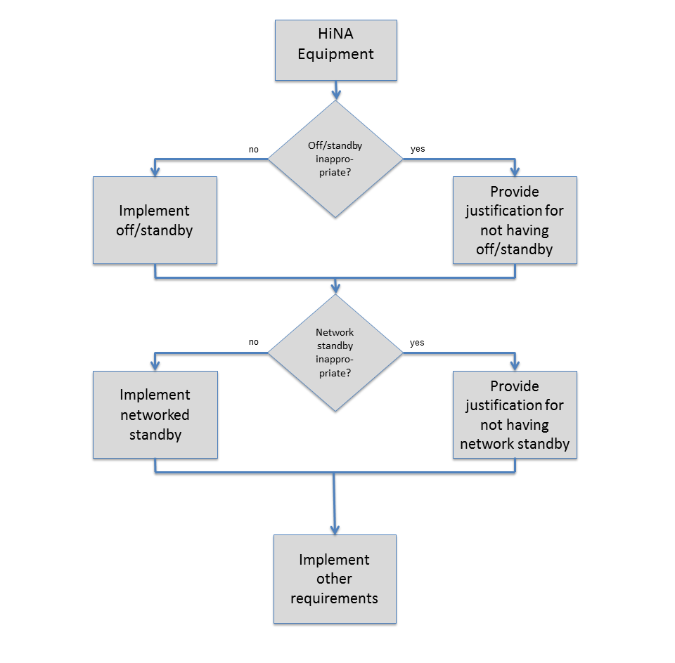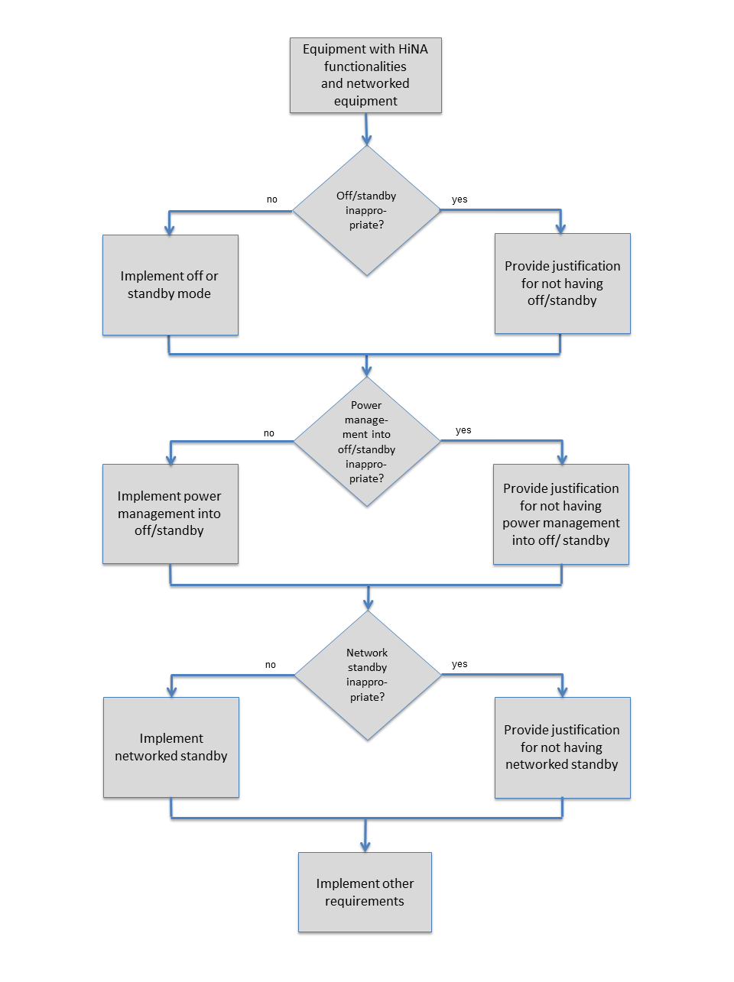

Timing
The requirements in the amended regulation take effect in 5 steps from 2010 to 2019. The Commission shall review the regulation before 7 January 2016, including the level of the requirements for networked standby for 2019.

The specific requirements for networked equipment take effect on 1 January 2015 apart from the requirement on the technical documentation, which took effect in September 2013.

As from 7 January 2010
Equipment needs to comply with point 1 of Annex II regarding availability and power consumption limits for off and standby modes and with point 4 on the technical documentation.

As from 7 January 2013
Equipment needs to comply with point 2 of Annex II regarding availability, Tier 2 power consumption limits for off and standby modes and power management (though not applicable to networked equipment) and with point 4 on the technical documentation.

As from 12 September 2013
On this date the Amending Regulation entered into force. The only additional requirement for networked equipment (before the next step on 1 January 2015) regards the technical documentation, where information on network ports etc. needs to be included.

As from 1 January 2015
Networked equipment needs to comply with Annex II point 3 and point 7:
- Possibility for user to deactivate wireless network ports (3(a))
- Power management for networked equipment (3(b))
- Behaviour of equipment when network ports are deactivated (3(c) and 3(d)):
- Power consumption requirements for networked standby (3(e))
- Information requirements (7)

As from 1 January 2017
Networked equipment needs to comply with Annex II point 4:
- Behaviour of equipment when wireless network ports are deactivated and wired network ports are disconnected (4(a) and 4(b))
- Power consumption requirements for networked standby (4(c))

As from 1 January 2019
Networked equipment needs to comply with Annex II point 5:
- Networked standby power consumption requirements for equipment other than HiNA equipment and equipment with HINA functionality. This requirement will be subject to review in 2016.

Tests for networked standby
The regulation does not describe a specific measurement method that the manufacturers should use for measuring the power consumption. The general requirement is that it should be a reliable, accurate and reproducible measurement procedure, which takes into account the generally recognised state of the art (Annex II point 8), which applies to both standby/off modes and networked standby. All basic parameters have been defined in the harmonised measurement standard EN 50564:2011.

The measurement method used by the manufacturer and the test parameters for the measurement (temperature, voltage, harmonic distortion and set-up of the test) need to be included in the technical documentation. See further description of the technical documentation in the next section.

The regulation describes in Annex III a verification procedure for the Member State authorities to use when they test appliances as part of their market surveillance activities.

The following is a suggested test procedure based on the Regulation:

Step 1: Take a product configured in its default configuration and based on technical product documentation:
- Identify if the product is HiNA equipment, equipment with HiNA functionalities or not;
- Identify the types of technology a network port supports and the number of networked ports including logical network ports (for example, a coax F-connector could support DOCSIS and MOCA at the same time);
- For each network port identify the network trigger to be used to reactivate a function within the product.

Step 2: The unit is placed in the on mode

Step 3: For each type of network port:
- Step 3a: Connect a randomly chosen network port to the appropriate network and activate the port.
- Step 3b: If possible deactivate all other network ports that are not under test
- Step 3c: Ensure that the unit does not perform a main function so that it is able to go into the networked standby mode. For HiNA equipment, this would mean that no traffic is sent. After 20 minutes measure average power consumption over a period not less than 5 minutes and record the power value in Watt rounded to the first decimal place.
- Step 3d: Using the appropriate network trigger, check that a function within the equipment is remotely reactivated from networked standby to on mode. E.g. for IP traffic, an ICMP ping could be sent and one could look for a response back
- Step 3e: Disconnect all cables. The unit under test may need to be reset.

Repeat steps 3a to 3e for all other types of network ports.

To be compliant: Every measurement must be below the relevant power target and each network trigger must reactivate the product. For market surveillance purposes, the regulation describes the maximum amount of power by which the limit value could be exceeded and would need retests if the limit value is exceeded.

The test method clearly specifies that the unit should be allowed to go into the condition providing networked standby and the power consumption should then be measured. However, for devices which remain under the targets in an operational mode, there is no need to change modes (i.e. enter networked standby) after 20 minutes of not providing a main function.

HiNA equipment which scales their power consumption with traffic such as routers and switches, go almost immediately into this lower power state.

Information to be provided
The regulation specifies 2 types of information to be provided:
- Public product information for consumers and other interested parties to be displayed on the manufacturers’ website and in the user manual;
- Technical documentation to be used for conformity assessment.

Public product information
The public product information is targeted at consumers, purchasers, consumer organisations, etc. so they will be able to get an overview of the power consumption and other relevant user information for the product.

The manual that contains the information as required in Annex II, point 7 (b) and (c) can be made available in electronic form or as hard copy. It can be stored on EU national websites or on one single corporate website. If the product is listed or advertised on EU national websites, these websites should either contain the manual with the information included and/or the information itself or have at least a link that leads to the corporate web page which includes the information.

The latter applies also to information as stipulated under 7 (a): If the product is listed or advertised on EU national websites, these websites should either contain the information itself or have at least a link that leads to the corporate web page which includes the information.

The product information should contain (Annex II):

- For each standby and/or off mode and each networked standby state:
- Power consumption in Watt
- Time to standby and/or off mode and networked standby state

- Power consumption in networked standby with all wired network ports connected and all wireless network ports activated

- Guidance on how to activate and deactivate wireless network ports

The goal of requirement (b) is to give the user an idea of what the device may consume once installed in the home. It is recognised and permissible that this value may exceed the networked standby limits given in the regulation.

If the connection of a wired network port automatically deactivates wireless network ports then it is not possible to test when all network ports are activated, thus it is not possible to test this configuration. In that case, the configuration with the highest power consumption should be provided.

Of course, if a product does not have wired or wireless network ports, these cannot be connected or activated.

For networked equipment, the time to networked standby would typically be in the range of minutes and maximum 20 minutes. For HiNA equipment, this time is much shorter since those devices scale their power with traffic. The condition providing networked standby may be entered within seconds or even milliseconds after sending the last packet.

Information to be provided in the technical documentation
Annex II point 9 provides a list of the contents of the technical documentation. Please note that the technical documentation is not the user manual or guide but technical information which has to be sent to the market surveillance authorities upon request.

The technical documentation has to include:
- Test report containing the measured values including the test parameters for the measurements; and
- Other information as described in the product information requirements.

The regulation states the following about the requirements:

(a) for each standby and/or off mode:

- the power consumption data in Watt rounded to the first decimal place,
- the measurement method used,
- a description of how the equipment mode was selected or programmed,
- the sequence of events leading to the condition where the equipment automatically changes modes,
- any notes regarding the operation of the equipment, e.g. information on how the user switches the equipment into a condition having networked standby,
- if applicable, the default time after which the power management function, or similar function, has switched the equipment into the applicable low power mode or condition;

(b) for networked equipment:

- the number and type of network ports and, with the exception of wireless network ports, where these ports are located on the equipment; in particular it shall be declared if the same physical network port accommodates two or more types of network ports,
- whether all network ports are deactivated before delivery,
- whether the equipment qualifies as HiNA equipment or equipment with HiNa functionality; where no information is provided, this is considered not to be the case;

and for each type of network port:

- the default time after which the power management function, or a similar function, switches the equipment into a condition providing networked standby,
- the trigger that is used to reactivate the equipment,
- the (maximum) performance specifications,
- ‘the (maximum) power consumption of the equipment in a condition providing networked standby into which the power management function, or a similar function, will switch the equipment, if only this port is used for remote activation,
- the communication protocol used by the equipment;

If no information is provided, the equipment is considered not to be networked equipment unless it provides the functionalities of a router, network switch, wireless network access point (not being a terminal), hub, modem, VoIP telephone, video phone.

It is important to note that if the information in item (b) is not included in the technical documentation, the equipment is considered not to be networked equipment unless it provides the functionalities of a router, network switch, wireless network access point, hub, modem, VoIP telephone, video phone.

The "(maximum) performance specifications" refers to the maximum speed that a network port supports."

(c) test parameters for measurements:

- ambient temperature,
- test voltage in V and frequency in Hz,
- total harmonic distortion of the electricity supply system,
- information and documentation on the instrumentation, set-up and circuits used for electrical testing;

The information on the test parameters can be provided in the test report.

(d) the equipment characteristics relevant for assessing conformity with the requirements set out in point 1(c), or the requirements set out in points 2(c) and/or 2(d) and/or 3(b), as applicable, including the time taken to automatically reach standby, or off mode, or another condition which does not exceed the applicable power consumption requirements for off mode and/or standby mode.

In particular, if applicable, a technical justification shall be provided that the requirements set out in point 1(c), or the requirements set out in points 2(c) and/or 2(d) and/or 3(b), are inappropriate for the intended use of equipment. The need to maintain one or more network connections or to wait for a remotely initiated trigger is not considered a technical justification for exemption from the requirements set out in 2(d) in the case of equipment that is not defined as networked equipment by the manufacturer.

Declaration of Conformity
The declaration of conformity should be stated against 1275/2008 because Regulation 801/2013 amends the existing 1275/2008 regulation.

Low voltage external power supply is an external power supply with a nameplate output voltage of less than 6 volts and a nameplate output current greater than or equal to 550 milli-amperes).
EN 50564:2011 Electrical and electronic household and office equipment - Measurement of low power consumption

