Possible requirements for electric motors and variable speed drives

EXPLANATORY NOTES

Table on Contents
1. Context of the proposal 2
1.1. Grounds for and objectives of the proposal 2
1.2. Market significance 3
1.3. Environmental significance 4
1.4. Currently covered products 6
1.5. International legislation 6
1.6. Availability of standards 7
2. Proposed measures 9
2.1. M1. Small single phase motors (120 W – 750 W) - IE2 9
2.2. M2. Small three phase motors (120 W – 750 W) - IE2 10
2.3. M3. Large low voltage motors (375 – 1 000 kW) - IE3 10
2.4. M4. Large medium voltage motors (375 – 1 000 kW) – IE3 10
2.5. M5. Removal of option to use an IE2 motor where a VSD is used 12
2.6. M6. Explosion proof and brake motors in the scope of the Regulation 14
2.7. M7. Medium motors (750 W – 1 000 kW) - IE4 15
2.8. M8. VSDs - IE1 15
2.9. M9. Mandatory information requirements 15
2.10. Exclusions 16
3. Possible overlap with other Ecodesign measures 17
4. Review of Regulation 640/2009 18
5. Form of implementing measures 19
6. Measurements and calculations 19
7. Conformity assessment 20
8. Benchmarks 21

Context of the proposal

Grounds for and objectives of the proposal
The Ecodesign Directive 2009/125/EC establishes a framework for the setting of ecodesign requirements for energy-related products. It is a key instrument of the Union policy for improving the energy and other environmental aspects of products placed on the market or put into service in the European Economic Area (EEA). It is an important instrument for achieving the objective of 20 % energy savings compared with projections for 2020, and its implementation is one of the priorities in the Commission's Communication on Energy 2020 and Energy Efficiency Plan 2011. Furthermore, implementation of the Directive 2009/125/EC will contribute to the EU's target of reducing greenhouse gases by at least 20 % by 2020, or 30 % if there is an international agreement that commits other developed countries to comparable emissions reductions. The proposed Regulation is a concrete contribution to this process and is in line with the Commission Action Plan on Sustainable Consumption and Production and Sustainable Industrial Policy.
Electric motor systems were already identified as relevant back in 2005 and they were listed on Article 16 of Directive 2005/32/EC. Therefore, it has been recognised since the beginning of the Ecodesign activities that motor systems, widely used in the European Union, are a priority product group to be considered for implementing measures.
In 2009, with the aim of improving the penetration of high-efficiency electric motors in the European market, Regulation 640/2009 with regard to ecodesign requirements for electric motors was published. This Regulation sets minimum energy efficiency requirements for induction motors with a rated output between 750 W and 375 kW.
The minimum requirements established by this Regulation are as follows:
- from 16 June 2011: motors shall not be less efficient than the IE2 efficiency level
- from 1 January 2015: motors with a rated output of 7.5 – 375 kW shall not be less efficient than the IE3 efficiency level, or meet the IE2 efficiency level and be equipped with a VSD.
- from 1 January 2017: all motors with a rated output of 0.75 – 375 kW shall not be less efficient than the IE3 efficiency level, or meet the IE2 efficiency level and be equipped with a VSD.
The efficiency levels were taken from the international standard IEC 60034-30:2009, which at the time of drafting of the Regulation covered motors in the 0,75 – 375 kW power range.
Nevertheless, the scope of the existing Regulation only covers part of the electric motors placed on the market. In order to evaluate the adequacy of covering motors in a different power range or using other technologies, a preparatory study (Lot 30) was launched in 2012. This preparatory study has also covered the energy efficiency of VSDs. It has shown that:
- Motors and VSDs not covered by the current Regulation are placed in significant quantities on the internal market.
- The main environmental impacts in the life cycle of these products are the energy consumption (electricity) during the use-phase. These impacts are considered significant.
- Technically cost-effective solutions exist that could lead to significant improvements as regards their environmental performance.
Under Article 15 of Directive 2009/125/EC, these products should therefore be covered by an ecodesign implementing measure.

Market significance
The global stock of electric motors is estimated at 2.2 billion. Small motors, under 750 W, account for 90% of the electric motors population (approximately 2 billion) but use only 9% of the overall electricity consumption. There are around 230 million medium motors, in the 0.75 kW to 375 kW power range, about 9% of the installed motors, which are responsible for 67% of the electricity consumed by motor systems. Large motors, with powers over 375 kW represent the smallest number, with only 0.6 million motors installed globally but, nevertheless, they are responsible for 24% of the energy use.
The preparatory study has also identified the sales of electric motors and VSDs in the EU.
Table 1 EU sales of electric motors within scope of proposed regulation
Power range |  | Thousands of units sold
≤ 750 W | Single-phase | 67 000
 | Poly-phase | 7 300
> 0.75 kW but ≤ 375 kW | Single-phase | 6 379
 | Poly-phase | 8 100
> 375 kW but ≤ 1000 kW | Voltage | 10
 | Medium Voltage | 3
Total |  | 88 792

Table 2 Sales of VSDs within scope of proposed regulation
Power range | Thousands of units sold
≤ 750 W | 1 130
> 0.75 kW but ≤ 375 kW | 2 890
> 375 kW but ≤ 1000 kW | 7
Total | 4 027

The total energy use of electric motors has been estimated at 1300 TWh, considering that around 30% of the motor systems incorporate a VSD their total energy use can be estimated at 400 TWh. Motors are used in different economic sectors; Figure 1 provides an overview of the energy used in electric motors per sector in Europe. Not surprisingly, most of the energy used in electric motors is used by the industrial sector, followed by the commercial and residential sectors.
Figure 1: Energy use in motor drives systems per sector in the European Union [TWh 2009]
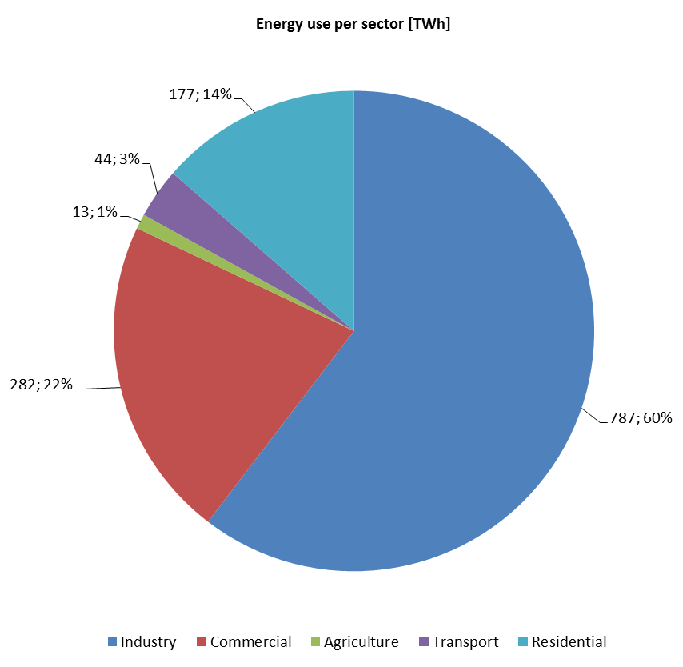

Environmental significance
For all types of motor, the energy consumption (in use phase) dominates in almost all types of environmental impact. This indicates that reducing the energy consumption should be the priority option for reducing the environmental impact of motors.
The total environmental impact of VSDs is only modest, partly because they are inherently very efficient at mid to high load, and there are many motors which are not equipped with them.
The distinction between motor energy consumption and losses is important, as motors are almost unique (in the context of ErP studies) in that most of the energy consumed is used to drive another product – it is only the internal losses that are of concern.
Table 3 Breakdown of energy use and losses, by product.
Description | Power Range | Energy Use [TWhpa] | Energy Losses [TWhpa]
Small induction motor - 1 phase | 0.12 - 0.75 kW | 110 | 35
Small induction motor - 3 phase | 0.12 - 0.75 kW | 71 | 23
Medium induction motor (S) | 0.75 - 7.5 kW | 71 | 14
Medium induction motor (M) | 7.5 - 75kW | 173 | 18
Medium induction motor (L) | 75 - 375kW | 372 | 21
Large induction motor - LV | 375 - 1,000kW | 369 | 18
Large induction motor - MV | 375 - 1,000kW | 135 | 5
VSD - Very Small | 0.15 - 0.75 kW | 400 | 7.5
VSD - Small | 0.15 - 7.5kW |  | 6.2
VSD - Medium | 7.5 - 75kW |  | 3.2
VSD - Large | 75 - 375kW |  | 2.2
VSD - Very Large | 375 - 750kW |  | 12
Total |  | 1300 | 146

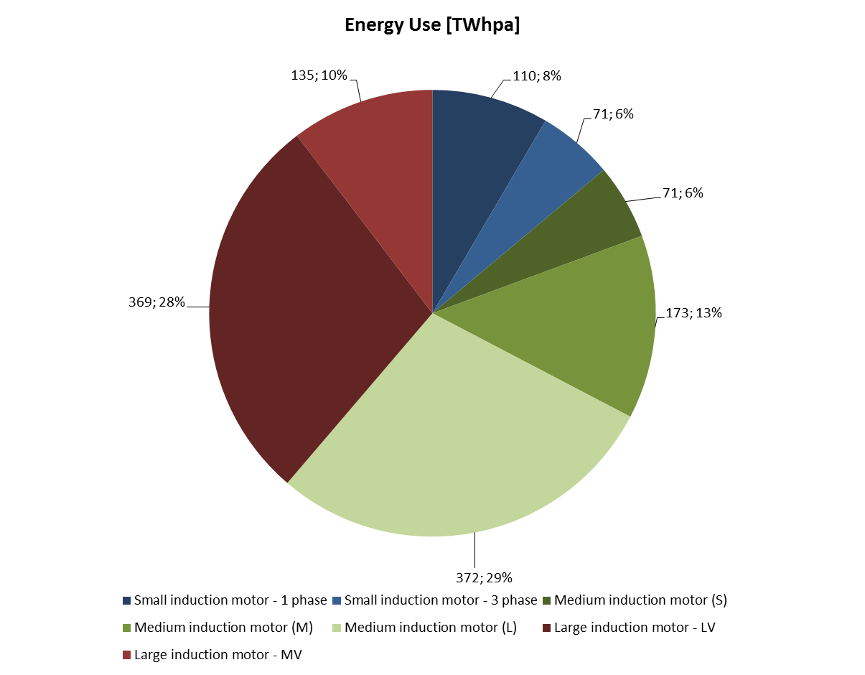
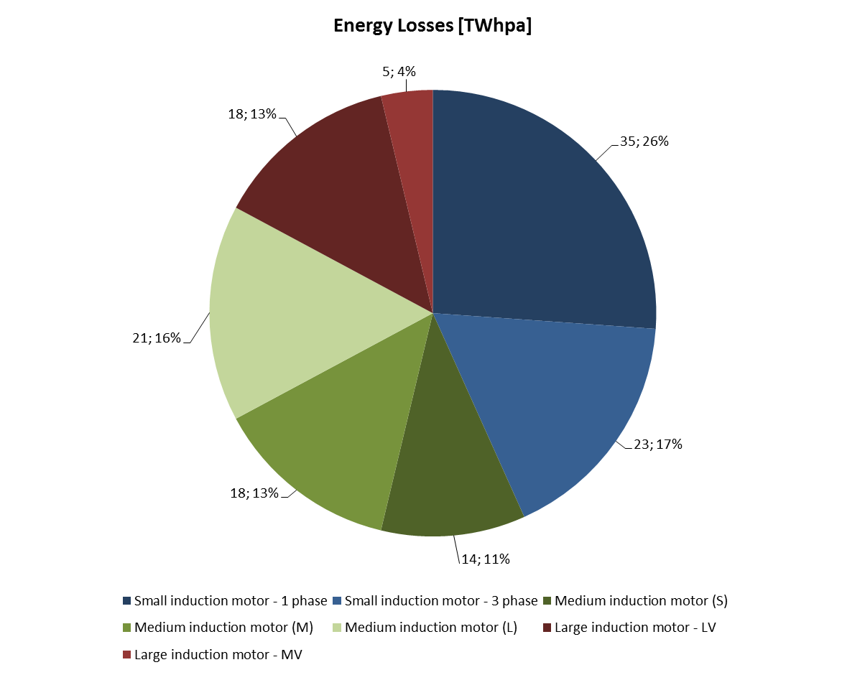
Figure 2: Breakdonw of energy use and losses, by product (motors)
The table and figure above provide a breakdown of the energy use and energy losses of electric motors and VSDs in the European market per year. Medium size motors, in green, are already covered by Regulation 640/2009 and represent 48% of the total market in terms of energy use.
Nevertheless, 60% of the losses on electric motors between 120 W and 1 MW have not yet been addressed, much of these losses occur in small motors (43%), while remaining 17% takes place in motors with a rated output between 375 kW and 1 MW.
With a total estimated energy use of 1 300 TWh and energy losses of 146 TWh the environmental significance of electric motors in terms of energy use is obvious. The preparatory study has identified energy consumption during the use phase as the main environmental impact of electric motors.

Currently covered products
The current requirements apply to three-phase, single speed, induction motors having 2, 4 and 6 poles with a rated output between 750 W and 375 kW and with a rated nominal voltage up to 1000 V. Only motors rated on the basis of continuous duty operation are covered by the existing Regulation.
The following types of motor are excluded:
- motors designed to operate wholly immersed in a liquid;
- motors completely integrated into a product (e.g. pump or fan) where the motor’s energy performance cannot be tested independently from the product;
- motors specifically designed to operate:
  - at altitudes exceeding 4 000 metres above sea-level;
  - where ambient air temperatures exceed 60°C;
  - in maximum operating temperatures above 400°C;
  - where ambient air temperatures are less than −30 °C for any motor or less than 0 °C for a motor with water cooling;
  - where the water coolant temperature at the inlet to a product is less than 0 °C or exceeding 32 °C;
  - in potentially explosive atmospheres as defined in Directive 94/9/EC;
- brake motors.
It is to be noted that the criteria for exclusion from application of the Regulation were amended through Regulation 4/2014 in order to close unintended loopholes that were exploited in the past.

International legislation
Most major economies have set or are in the process of setting minimum energy performance requirements for electric motors. Motors are a globally traded product for which international standards are available, and the convergence, or at least comparability, of minimum requirements should be promoted.

Figure 3: Overview of MEPS for electric motors in the world
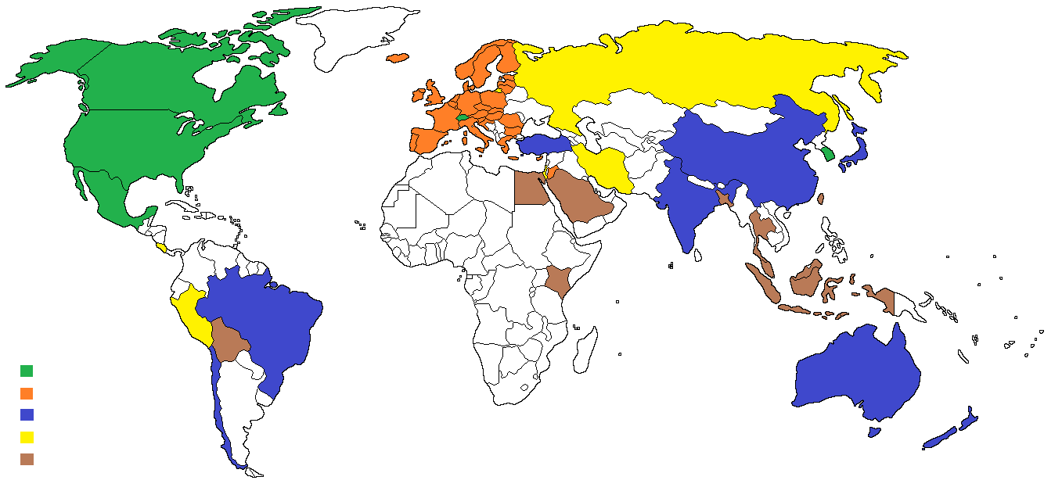
IE3
IE3 / IE2 + VSD
IE2
IE1
Under development
Some countries such as the United States, Canada and México have set IE3 as the minimum requirement for motors placed in their market. The same level of requirements will come into force in South Korea from 2015. Switzerland has also decided to set IE3 as minimum requirement in their market. Preliminary information indicates that Australia, New Zealand, Taiwan and China are considering establishing IE3 as the minimum requirements in their markets in the future.
From the 1st of January 2015, the European Economic Area will be the only market where the minimum requirements can be met by using two different approaches, the use of an IE3 motor or the use of an IE2 motor but equipped with a VSD.
Other major economies such as Brazil, India or China have IE2 as minimum requirement.
China has decided to set minimum requirements also for medium and high voltage motors while the US applies minimum requirements on a voluntary basis.

Availability of standards
Standards for measuring the energy efficiency of electric motors have been available for a long time and recent revisions have extended its scope to previously not covered motors. The main standards covering electric motors that will support the proposed Regulation are:
- IEC 60034-2-1:2007 – Rotating electrical machines — Part 2-1: Standard methods for determining losses and efficiency from tests (excluding machines for traction vehicles).
- IEC 60034-30-1:2014 – Efficiency classes of line operated AC motors (IE code).
The recently published new version of IEC 60034-30-1:2014 has extended its scope to motors with a rated power output between 120 W and 1 MW, in consequence, it is now possible to determine the energy efficiency class of motors in this power range.
Figure 4: IE class for 50 Hz 4-pole motors according to IEC 60034-30-1:2014
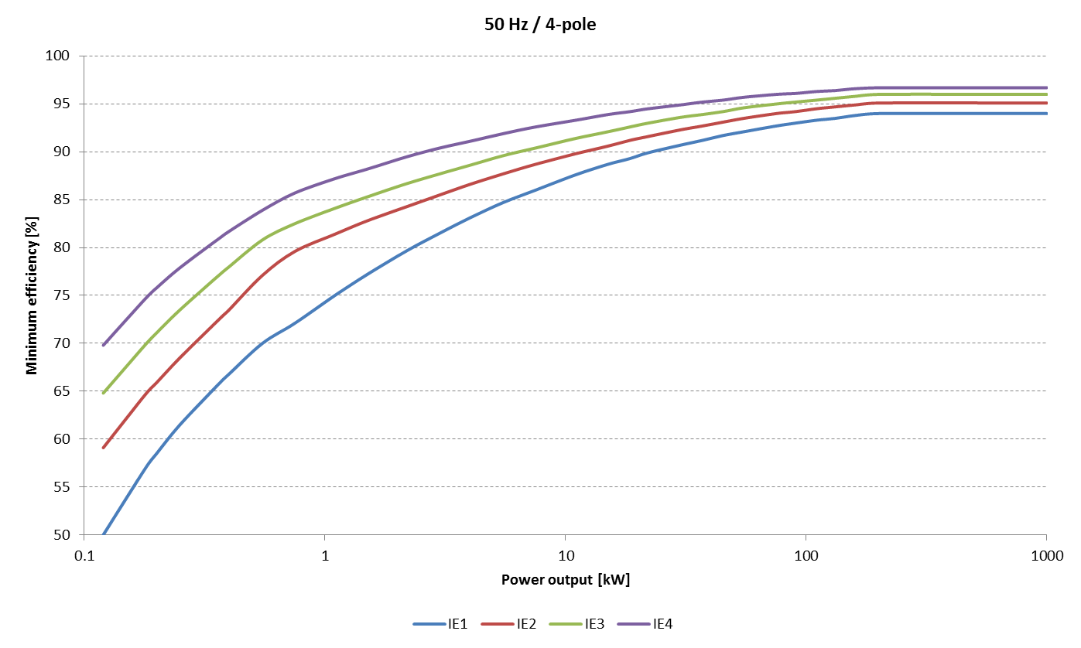
In the case of medium and high voltage motors, the measurement method for the energy efficiency are also ready; nevertheless, the classification provided in IEC 60034-30-1:2014 is only applicable to motors with a rated voltage up to 1 kV.
Regarding VSDs and the combination of motors with them, a mandate was issued in December 2010 asking for standards in the field. As a consequence of such mandate, three standards are in the latest steps of its development:
- prEN 50598-1 – Ecodesign for power drive systems, motor starters, power electronics & their driven applications – Part 1: General requirements for setting energy efficiency standards for power driven equipment using the extended product approach (EPA), and semi analytic model (SAM).

- prEN 50598-2 – Ecodesign for power drive systems, motor starters, power electronics & their driven applications – Part 2: Energy efficiency indicators for power drive systems and motor starters”, are well placed in order to give support to any proposal regarding the minimum energy efficiency of variable speed drives.

- prEN 50598-3 – Ecodesign for power drive systems, motor starters, power electronics & their driven applications – Part 3: Quantitative ecodesign approach through life cycle assessment including product category rules and the content of environmental declarations.
prEN 50598-2 provides a classification regarding the energy efficiency of VSDs and the combination of VSDs with electric motors.

Proposed measures
The preparatory study has shown that significant energy savings can be achieved by implementing a number of policy options which are explained in this chapter. An overview of the projected savings can be found below:
Table 4 Projected energy savings, by Policy Option.
Possible measures | Energy Saving  [TWhpa 2030] | Proposed date of coming into force
M1.Small single phase motors (120 W – 750 W) - IE2 | 4.6 | 01/01/2018
M2. Small three phase motors (120 W – 750 W) - IE2 | 9.9 | 01/01/2018
M3. Large low voltage motors (375 kW – 1 000kW) - IE3 | 3.1 | 01/01/2018
M4. Large medium voltage motors (375 kW – 1 000kW) - IE3 | 1.1 | 01/01/2020  Standard to be developed
M5. Removal of option to use an IE2 motor where a VSD is used | 2.7 | 01/01/2020  Subject to review
M6. Explosion proof and brake motors in the scope of the Regulation | 0.9 | 01/01/2018
M7. Medium motors (750 W – 375 kW) - IE4 | 6.7 | To be re-evaluated in the future
M8. VSDs - IE1 | < 1 | 01/01/2018
M9. Mandatory information requirements | Not Applicable | 01/01/2018

M1. Small single phase motors (120 W – 750 W) - IE2
The energy savings for this option are estimated at 4.6 TWh/year in 2030

It is proposed that this measure comes into force on 1 January 2018.
IE2 would be the minimum requirement for single phase motors with a rated power output between 120 W and 750 W.
The preparatory study has identified an important cost effective energy saving potential on these motors, even while considering that 70% of the sales are motors that integrated into products that are already covered by other Regulations.
It is proposed to cover all motors, even if integrated into other energy related products in order to avoid loopholes and keep a coherent approach with all previous Ecodesign Regulations.
The Regulation shall apply to induction (including shaded pole) motors. Mechanically commutated motors, such as universal motors, have too low running hours to justify being in the scope of the Regulation (the brush gear has a limited lifetime). This exclusion would not lead to a loophole, as this limited lifetime means that it would not be practical to use universal motors in applications that currently use induction motors.
Further exclusions described in point 2.10 apply to small single phase motors.

M2. Small three phase motors (120 W – 750 W) - IE2
The energy savings for this option are estimated at 9.9 TWh/year in 2030

It is proposed that this measure comes into force on 1 January 2018.
IE2 would be the minimum requirement for three phase motors with a rated power output between 120 W and 750 W.
Of all the possible measures evaluated, this leads to the highest energy savings. The preparatory study has identified IE2 level as cost effective and widely available efficiency level for these motors.

M3. Large low voltage motors (375 – 1 000 kW) - IE3
The energy savings for this option are estimated at 3.1 TWh/year in 2030

It is proposed that this measure comes into force on 1 January 2018.
IE3 would be the minimum requirement for large low voltage motors with a rated power input between 375 kW and 1 000 kW and a rated nominal voltage below 1 000 V.
Even if a relatively small numbers of motors between 375 kW and 1 000 kW are placed on the EEA market each year, their number of use hours and high rated power makes them an important energy consumer. Removing the least efficient motors from the market would have important impacts.

M4. Large medium voltage motors (375 – 1 000 kW) – IE3
The energy savings for this option are estimated at 1.1 TWh/year in 2030
It is proposed to apply this measure after the development of the necessary standard.
Ambitious requirements would be set for medium voltage motors with a rated power input between 375 kW and 1 000 kW and a rated nominal voltage below 6 600 V.
It is to be noted that standards exist in order to measure the energy efficiency of medium voltage motors, namely IEC 60034-2-1:2007 and IEC 60034-2-2:2010. Nevertheless the efficiency scale provided by IEC 60034-30-1:2014 is not yet defined to such motors.
Medium voltage motors have specific technical characteristics that in some cases make it impossible to achieve the same energy efficiency level than for low voltage motors:
- The higher amount of insulation material that needs to be used leads to a lower cross sectional area of utilizable copper.

- The short circuit capability of the local grid needs to be considered.

- Limitations related to the inrush current.

- Large variety of cooling methods.
As indicated before, China has already put in place minimum requirements for medium and high voltage motors.
The Chinese standards identifies 3 different levels of efficiency, the mandatory one being the least stringent, while the second is recommended and it’s the minimum level for receiving public financial support.
In the USA there is a voluntary energy efficiency standard for motors with a nominal voltage up to 5 000 V and a rated output power up to 2 500 hp ( 1 875 kW).
According to industry, the level of efficiency of the medium voltage motors placed in the European market is usually in the range of the most efficient grade identified in China (CN-1).
It is also to be noted that the minimum requirements set in China vary depending on the cooling method of the motor.
Figure 5: Efficiency comparison example for 4-pole motor according to GB 30254-2013, IEC 60034-30-1:2014 and ANSI/NEMA MG 1-2011.
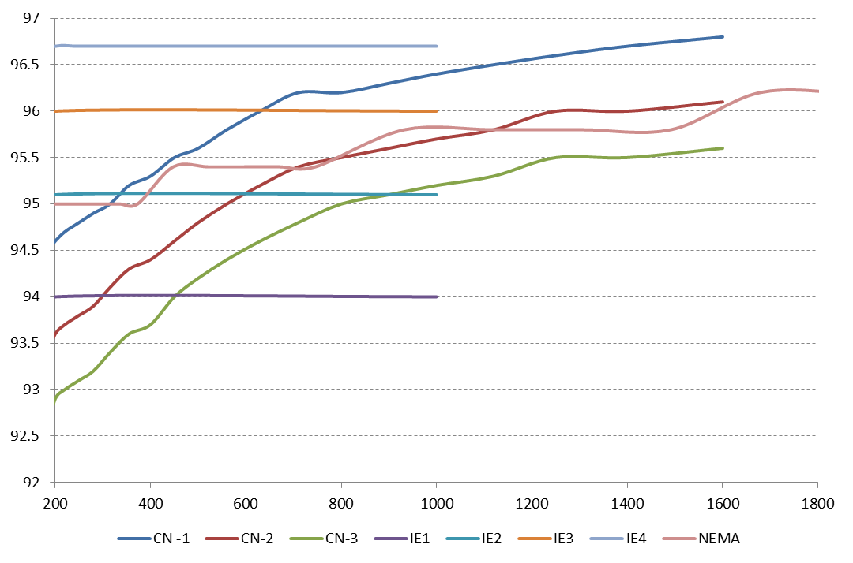
Due to the important uncertainty existing the classification of medium voltage motors, it is proposed to include in the review clause of the Regulation that the Commission should assess the adequacy of setting minimum requirements for medium voltage motors before 2018 and at the same time issuing a mandate to CENELEC in order to extend the existing standards to these motors.
It is to be noted that even if the nominal efficiency of medium voltage motors might be lower than the efficiency of low voltage motors for the same rated power output, this does not necessarily mean that they are a less efficient solution, as in some cases a transformer and additional cabling is needed for using a low voltage motor. The table below provides a specific example for a 750 kW 4-pole motor connected to a 20 kV grid via a transformer and with a cable length of 300 metres.
Table 5: Overall efficiency of MV and LV motor system
Motor | Motor efficiency | Transformer losses | Cabling losses | Efficiency
LV: 690 V | 96.9% | 18.7 kW | 16 kW | 92.7%
MV: 6000 V | 96.5% | 17 kW | 2 kW | 94.2%

M5. Removal of option to use an IE2 motor where a VSD is used
The energy savings for this option are estimated at 2.7 TWh/year in 2030

It is proposed that this measure comes into force on 1 January 2020.
Regulation 640/2009 allows for two alternatives for meeting the minimum requirements, the first one being the use of an IE3 motor while the second one is the use of an IE2 motor combined with a VSD. This option is to remove the “IE2+VSD” alternative.
It is recognized that where variable loads exist, the use of a VSD leads to savings far greater than the savings that can be achieved by the improvement of the efficiency of the motor alone.
It is also a fact that under normal conditions, the combination of an IE3 motor with a VSD is more efficient than the combination of an IE2 motor with the same VSD.
In addition, the Commission services issued M476 were CENELEC was asked to develop standards in the field that would allow evaluating the energy efficiency of VSDs and of the combination of motors with them.
From an economic point of view, the combination of an IE2 motor and a VSD is more expensive than an IE3 motor, so, economic operators faced with fixed loads, the choice on an IE3 motor should be obvious.
The economics of these two options vary with size, nevertheless an specific example for an 11kW motor the price difference is shown in Table 6.
Table 6: Net price of motor purchase options under regulation 640/2009 (example)
11kW Motor options | Motor Price (Euros) | VSD Price (Euros) | Total Price (Euros)
IE3 Motor | 690 |  | 690
IE2 Motor + VSD | 600 | 1,130 | 1,730
Price Difference |  |  | 1,040

Figure 6: Motor efficiency and total losses at full load, with and without VSD, for several 7.5 kW motors
It is not known what proportion of installations will take advantage of this encouragement to purchase a VSD where they would otherwise not have done so.
The current Regulation indicates that IE2 motors placed on the market after the date of coming into force of the requirements should incorporate information about the necessity of equipping such motor with a VSD in a visible place both in the technical documentation and on the rating plate of the motor.
From the point of view of market surveillance the IE2+VSD approach is challenging, as it can only be enforced when the product is put into service, which is already foreseen by Regulation 640/2009.
On the other hand, if correctly implemented, this possibility will lead to the very important energy savings foreseen by Regulation 640/2009, as it will increase the penetration of VSDs on variable load applications.
According to industry estimations, the penetration of VSDs in Europe will continue increasing in the coming years, from 20% in 2012 to more than 40% in 2020.

Figure 7: Expected line fed / converted fed ratio in Europe
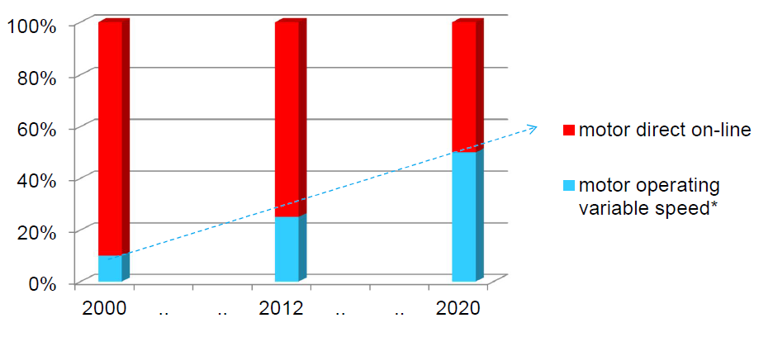
It is proposed to include a requirement from 2020 onwards to remove the possibility of using an IE2+VSD combination instead of an IE3 motor.
The savings calculated for this measure only include the shift on the market from IE2 to IE3 without considering any difference on the penetration of VSDs for different applications.
It is to be noted, that main trade partners, such as Canada, Mexico, Switzerland and the USA have set minimum energy performance requirements at the level of IE3 and the EEA is the only market having such approach.

M6. Explosion proof and brake motors in the scope of the Regulation
The energy savings for this option are estimated at 0.9 TWh/year in 2030

It is proposed that this measure comes into force on 1 January 2018.
The current regulation specifically excludes several types of motors. The energy efficiency of motors working in potentially explosive atmospheres and brake motors does not differ from the efficiency of other motors. The latest version of IEC 60034-30-1:2014 already indicates that these motors are covered.
According to the preparatory study there is no technical or commercial reason why the exemption would need to be maintained.
It has been suggested that brake motors are used in applications with frequent stop-starts and so the inertia will lead to greater startup losses. Motors for intermittent duty applications are not covered by the proposed regulation.
In cases were the brake is an integral part of the motor, that cannot be separated for the purposes of testing, the motor would also not be covered by the Regulation.
In practice, brake motors are usually standard duty motors with a brake added for additional speed of response. This is therefore considered not to be an adequate reason for exclusion.
Motors of these two types exist in the market with IE3 (and above) efficiency levels:
Increased safety motors have technical specificities, such as larger clearances, that do not enable them to reach high efficiency levels and should be specifically excluded.

M7. Medium motors (750 W – 1 000 kW) - IE4
The energy savings for this option are estimated at 5.6 TWh/year in 2030

Based on the flatness of the LCC curve, it can be justified to consider making IE4 the MEPS for all motors within scope of the current regulation in the power range 750 W to 1 000 kW.
However, the sensitivity analysis presented in the preparatory study should be reviewed in order to understand the cost effectiveness of this measure under a range of operating conditions. IE4 induction motors are already available over a wide power range, although so far with limited manufacturer availability and very low sales. In addition there are practical considerations that will need to be taken into account, including the need to use non-standard frame sizes. So while it is true that it is technically challenging, especially in the small sizes, it is clearly possible to overcome these problems and produce commercial products.
If the IE4 market develops well in the next years IE4 could become the most adequate minimum requirement, the savings derived from such measure could be important, but its applicability should be re-evaluated in the future.

M8. VSDs - IE1
The energy savings for this option are estimated at <1 TWh/year in 2030

It is proposed that this measure comes into force on 1 January 2018.
Measures are proposed for VSDs. The VSD market is dominated by models with IE1 performance (as defined in prEN 50598-2 standard) or above this level. The preparatory study has shown that it is not cost effective to require the introduction of MEPS for VSDs at a higher level than the current base-case models assumed, however it would be beneficial to remove from the market VSDs with performance below IE1 in order to ensure that the worst performing models are removed from the market.
No measures relating to soft starters are suggested as these are only used during the start of the motor and are later by-passed being their energy consumption very limited.

M9. Mandatory information requirements
There are no direct savings from this measure
Information requirements under the existing Regulation 640/2009 can reasonably be extended to all types of motor within the proposed extended scope of this Regulation.

The existing product information requirements within Regulation 640/2009 should be extended to include all motors under the extended power range of 0.12 kW to 1000 kW.

In addition, if a motor is more efficient than IE3 (i.e. IE4 or IE5) it should also be allowed to be shown in the technical documentation, rating plate or any relevant documentation.
Information requirements will also apply to VSDs. In addition, if a VSD is more efficient than IE1 level (i.e. IE2) it should be allowed to show it in the relevant documents and on its rating plate.

Exclusions
The proposed Regulation would extend the scope of the existing Regulation to motors rated for operation on a sinusoidal voltage supply (direct-on-line), that:
- have a rated power P_{N} from 0.12 kW to 1000 kW;
- have a rated voltage U_{N} above 50 V up to 1000 V;
- are single-phase.
- have 8 poles.
Brake motors and explosion proof motors, which were previously excluded, are included in the proposed Regulation.
Excluded would be:
- Motors with mechanical commutators (such as DC-motors);
Mechanically commutated motors (e.g. DC and Universal motors) have a very low operating time limited by the lifetime of the commutators. The preparatory study has shown that they have a low environmental impact.
- Increased safety motors;
Increased safety motors have technical features (such as increased air-gap, reduced starting current, enhanced sealing) that make it very difficult for them to achieve high-efficiency levels, nevertheless they are necessary in applications where explosive atmospheres are present and should therefore remain available in the market.
- Motors in cordless or battery operated equipment (off-grid applications);
In cordless or battery operated equipment efficiency is, typically, a major concern at the design stage to extend battery use time. In addition, these motors have a low operating time and their environmental impact is low. The current available standard does not cover these motors.
- Motors in hand-held equipment whose weight is supported by hand during operation.
High efficiency motors typically employ more active materials, having as a result extra-weight of the motor and, therefore, of the equipment it is included in. Hand-held equipment typically has a low number of operating hours per year.
- Motors completely integrated into a machine (for example pump, fan and compressor) that cannot be practically tested separately from the machine even with provision of a temporary end-shield and drive-end bearing.
This means the motor must share common components (apart from connectors such as bolts) with the driven unit (for example, a shaft or housing) and not be designed in such a way as to enable the motor to be separated from the driven unit as an entire motor that can operate independently of the driven unit. That is, for a motor to be excluded from this Regulation, the process of separation must render the motor inoperative. These motors are excluded from the scope of IEC 60034-30-1:2014.
The remaining definitions and exclusions remain unchanged from the previous Regulation.
Relevant information requirements should apply to these motors.

Possible overlap with other Ecodesign measures
Electric motors are products used as part of other equipment which is sometimes regulated as a whole. This is the case with:
- Commission Regulation (EC) No 641/2009 with regard to ecodesign requirements for glandless standalone circulators and glandless circulators integrated in products.

- Commission Regulation (EU) No 1015/2010 with regard to ecodesign requirements for household washing machines.

- Commission Regulation (EU) No 1016/2010 with regard to ecodesign requirements for household dishwashers.

- Commission Regulation (EU) No 327/2011 with regard to ecodesign requirements for fans driven by motors with an electric input power between 125 W and 500 kW.

- Commission Regulation (EU) No 547/2012 with regard to ecodesign requirements for water pumps.

- Commission Regulation (EU) No 932/2012 with regard to ecodesign requirements for household tumble driers.

- Commission Regulation (EU) No 666/2013 with regard to ecodesign requirements for vacuum cleaners.

- Commission Regulation (EU) No 66/2014 with regard to ecodesign requirements for domestic ovens, hobs and range hoods.
The preparatory study has not differentiated between motors sold integrated into other equipment and those that are sold alone. Nevertheless, the savings calculation has been amended to take into account the effect on motors of the already existing legislation. In the preparatory study these motors were not included in the calculation of savings. For small motors (which are the majority of motors included in regulated equipment) only 30% of the total motors sold were considered to be not covered by exiting regulation.
In addition, a study in order to account the savings achieved by different Ecodesign measures is being carried out. This study has introduced a double counting factor for products integrated into other products, for example, motors that are part of a fan, which in turn is used in an air conditioning unit. The factor assumed for motors is 0.5.
This factor is based on the preparatory studies covering motors and the electricity consumption of the applications already included in the accounting.
The previous motor Regulation applied to motors, also when integrated into other products, it is proposed to continue with this approach.

Review of Regulation 640/2009
According to article 7 of Regulation 640/2009 it shall be reviewed in the light of technological progress on both motors and drives no later than August 2016. The review shall include:
- Resource efficiency, re-use and recycling.

- The level of measurement uncertainty.
Lot 30 preparatory study has covered motors in the scope of Regulation 640/2009 and has found that the main environmental impact of the product occurs during its use-phase. The preparatory study has found that given the high value of the materials used in electric motors these tend to be naturally recycled.
The verification tolerances are in line with the uncertainty of the measurement stated in IEC 60034-1:2010. It is to be noted that the values correspond to a percentage of the losses (1 – η) which is 15% for motors with a rated output equal or below 150 kW and 10% for bigger products.
Taking into account the minimum requirements and the IE classification, the real maximum deviations from the minimum requirement are shown in the graph below.
Figure 8: Maximum deviations in terms of efficiency according to IEC 60034-1:2010
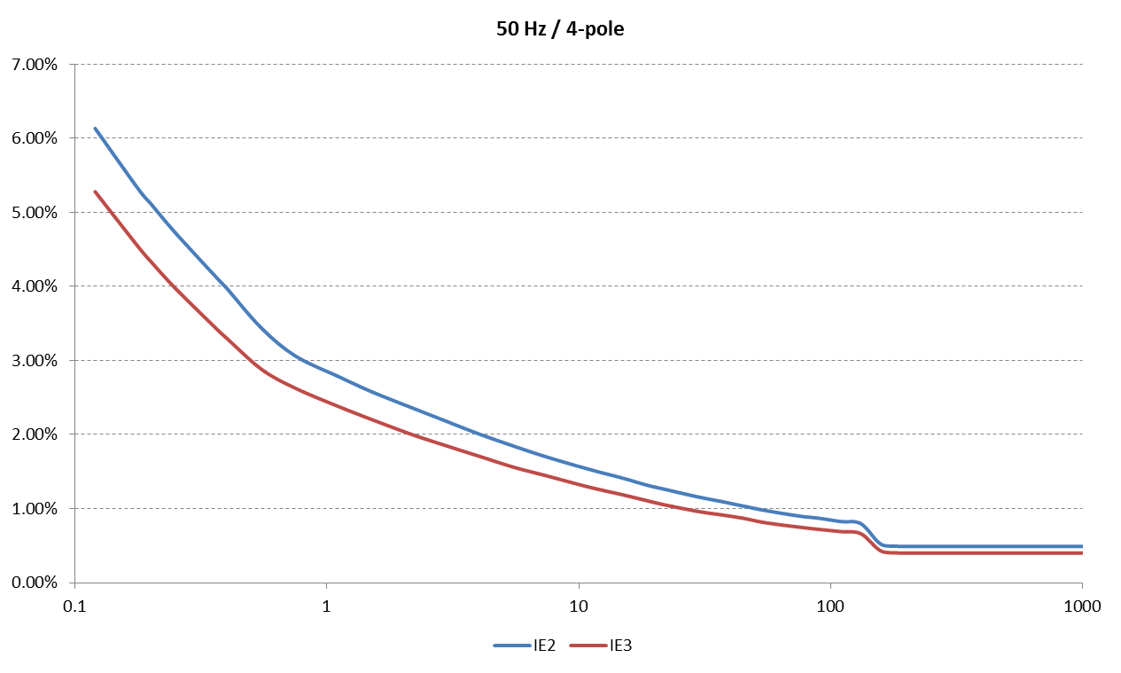
It should be noted that the maximum deviations are below 3% for motors with a rated power above 1 kW and below 1% for motors 50 kW.
As the preliminary data does not point in the direction of urgency for these works, it is proposed to re-evaluate these aspects together with other aspects included in the review clause of the Regulation.

Form of implementing measures
The implementing measure will take the form of a Regulation setting minimum ecodesign requirements directly applicable in all Member States.
The ecodesign requirements relate to the energy efficiency of the products within the scope of the Regulation. In addition there are ecodesign requirements relating to the provision of supplementary product information.
A delegated Commission Regulation for energy labelling of the products within scope is considered to be inappropriate as an energy classification and marking scheme (IE rating) is already in place and mandatory for motors with purchasers being fully aware of the existing scheme. In addition, this energy classification is used worldwide, and motors being an internationally traded product it is not advisable to set an additional classification applicable only in the European Economic Area.

Measurements and calculations
For the purposes of compliance and verification of compliance with the requirements of this Regulation, measurements and calculations shall be made using a reliable, accurate and reproducible method, which takes into account the generally recognised state-of-the-art methods, and whose results are deemed to be of low uncertainty, including methods set out in documents the reference numbers of which have been published for that purpose in the Official Journal of the European Union. They shall fulfil all of the following technical parameters.
Standards are already available on in an advanced process of development as a result of mandates M470 and M476 issued in 2010.
The standards to be used include:
- EN 60034-2-1:2007 Rotating electrical machines — Part 2-1: Standard methods for determining losses and efficiency from tests (excluding machines for traction vehicles).

- IEC 60034-30-1:2014 Efficiency classes of line operated AC motors (IE code).

- prEN 50598-2:2013 Ecodesign for power driven systems, motor starters, power electronics & their driven applications – Part 2: Energy efficiency indicators for power drive systems and motor starters

Conformity assessment
The proposed conformity assessment is:
When performing the market surveillance checks referred to in Article 3 (2) of Directive 2009/125/EC, the authorities of the Member States shall apply the following verification procedure for the requirements set out in Annex I.
For motors with a rated output of equal or above 120 and equal or below 375 kW:
1. If the values in the technical documentation do not comply with the requirements set out in Annex I the model shall be considered not to comply with this Regulation.
2. The authorities of the Member State shall test one single unit.
3. The model shall be considered to comply with the provisions set out in this Regulation, if in the nominal motor efficiency (η), the losses (1-η) do not vary from the values set out in Annex I by more than 15% for motors with on power range equal or above 120 W and below 150 kW and 10% on power range above 150 kW and equal or below 1 000 kW.
4. If the result referred to in point 3 is not achieved the market surveillance authority shall randomly test three additional units, except for motors that are produced in lower quantities than five per year.
5. The same model shall be considered to comply with the provisions set out in this Regulation, if in the average of the nominal efficiency (η), the losses (1-η) of the three units referred to in point 4 do not vary from the values set out in Annex I by more than 15% for motors with on power range equal or above 120 W and below 150 kW and 10% on power range above 150 kW and equal or below 1 000 kW.
6. For motors that are produced in lower quantities than five per year, if the results referred to in point 3 are not achieved, the model shall be considered not to comply with this Regulation.
7. For motors that are produced in quantities of five or more per year, if the results referred to in point 5 are not achieved, the model shall be considered not to comply with this Regulation.
For variable speed drives:
1. If the values in the technical documentation do not comply with the requirements set out in Annex I the model shall be considered not to comply with this Regulation.
2. The authorities of the Member State shall test one single unit.
3. The model shall be considered to comply with the provisions set out in this Regulation, if the power losses do not vary from the values set out in Annex I by more than 5%.
4. If the result referred to in point 3 is not achieved the market surveillance authority shall randomly test three additional units, except for variable speed drives that are produced in lower quantities than five per year.
5. The same model shall be considered to comply with the provisions set out in this Regulation, if the average power losses of the three units referred to in point 4 do not vary from the values set out in Annex I by more than 5%.
6. For variable speed drives that are produced in lower quantities than five per year, if the results referred to in point 3 are not achieved, the model shall be considered not to comply with this Regulation.
7. For variable speed drives that are produced in quantities of five or more per year, if the results referred to in point 5 are not achieved, the model shall be considered not to comply with this Regulation.
Member States authorities shall use the measurement methods and calculation methods set out in Annex II.
Given the weight and size limitations in the transportation of electric motors and variable speed drives with a rated output of 375 – 1 000 kW, Member States authorities may decide to undertake the verification procedure at the premises of manufacturers, before they are put into service in their final destination.
The verification tolerances set out in this Annex relate only to the verification of the measured parameters by Member States authorities and shall not be used by the manufacturer or importer as an allowed tolerance to establish the values in the technical documentation.

Benchmarks
The best available technology on the market for motors was identified as the IE4 level, and an IE2 variable speed drive.
IE5 motors start to be advertised in the market by several manufacturers, although their number is still very low.

OJ L 285, 31.10.2009, p. 10.
OJ L 191, 22.7.2005, p. 29.
OJ L 191, 23.7.2009, p. 26.
Variable Speed Drive.
“Energy efficiency policy opportunities for electric motor systems” P. Waide, C. Brunner. IEA, 2011.
“Walking the torque. Proposed work plan for energy-efficiency policy opportunities for electric motor-driven systems” H. Falkner, S. Holt. IEA 2011.
OJ L 2, 7.1.2014, p. 1.
10 CFR Part 431. Energy Conservation Program: Energy Conservation Standards for Commercial and Industrial Electric Motors; Final Rule. US Department of Energy.
GB 30254-2013. Minimum allowable values of energy efficiency and the energy efficiency grades for cage three-phase high voltage induction motor.
Mandate M/476 on the field of variable speed drives and/or power drive systems
IE3 is indicative of an ambitious level of stringency.
Source: Lot 30 preparatory study. Data provided by: “European Committee of Manufacturers of Electrical Machines and Power Electronics (CEMEP)”.
“Technical and Economical Considerations on Super High-Efficiency Three-Phase Motors”, A. de Almeida, F. Ferreira, A. Quintino. IEEE Transactions on Industry Applications, Volume: 50, NO. 2, page(s): 1-12, 2014
Source: CEMEP
Life Cycle Cost
OJ L 191, 23.7.2009, p. 35.
OJ L 293, 11.11.2010, p. 21.
OJ L 293, 11.11.2010, p. 31.
OJ L 90, 6.4.2011, p. 8.
OJ L 165, 26.6.2013, p. 28.
OJ L 278, 12.10.2012, p. 1.
OJ L 192, 13.7.2013, p. 24.
OJ L 29, 31.1.2013, p. 33.

