EN
 | EUROPEAN COMMISSION
Brussels, XXX
C(2010) YYY final

Draft
COMMISSION DELEGATED REGULATION (EU) No …/..
of […]
implementing Directive 2010/…/EU of the European Parliament and of the Council with regard to energy labelling of televisions
EXPLANATORY MEMORANDUM
1) Context of the proposal
Grounds for and objectives of the proposal
The recast Energy Labelling Directive of the European Parliament and of the Council provides a mandate for the Commission to adopt delegated acts for the indication by labelling and standard product information of the consumption of energy and other resources by energy-related products during use. It requires the Commission to adopt such measures for products which have a significant potential for saving energy, and, where relevant, other resources, and a wide disparity of relevant performance levels of products with equivalent functionality. A technical, environmental and economical analysis on televisions, hereafter called "preparatory study", followed by an impact assessment, has concluded that both conditions are fulfilled. Consequently, televisions should be covered by a delegated act under the recast Energy Labelling Directive.
The environmental impact of televisions in the EU is significant, and it is mainly related to the electricity consumption in the use-phase. Not only the number of televisions increases, but also their average screen size. On the other hand, reliable and easy-to-understand information on the electricity consumption is not available for consumers, resulting in insufficient market transparency and lack of incentives for manufacturers to apply technologies which would lead to reduced energy consumption. The objective of the initiative is therefore to create a harmonised system of energy labelling and standard product information for televisions, which creates market transparency and incentives for innovation. The impact assessment related to measures under the ecodesign and energy labelling policies estimated that energy labelling will save at least 15 TWh electricity annually by 2020, in addition to the savings expected from Commission Regulation (EC) No 642/2009 setting ecodesign requirements for televisions.
General context
The preparatory study showed that the most significant aspect for improving the environmental performance of televisions is their electricity consumption in on-mode, and cost-effective technologies exist on the market, which lead to significant reduction of the electricity consumption of products with equivalent functionality. These technologies are not penetrating the market to a satisfactory extend by market forces alone, because:
- the electricity consumption of televisions has not been a decisive factor for the purchasing decision of consumers;
- no easily accessed and understood information on electricity consumption, related running costs and potential electricity savings is available, and little awareness of these issues exists;
- little incentives exist for manufacturers to optimise the electricity consumption.
As a consequence cost-effective potentials to improve the energy performance of televisions are often not realized.
Existing initiatives on Union and Member State level are not expected to properly correct that market failure. Without taking additional specific measures, the expected electricity consumption of televisions will increase from about 60 TWh in 2005 to 132 TWh by 2020 in EU-27, mainly due to a shift towards larger screen sizes, and an increase of televisions sold and installed in households. It is expected that the ecodesign requirements on on-mode and standby power consumption of televisions alone, as set out in Commission Regulation (EC) No 642/2009, will lead to a reduction of electricity consumption of annually 28 TWh by 2020.
Additional action of the Union is therefore required, and it is estimated that an energy labelling scheme pursuant to the recast Energy labelling Directive will result in additional electricity savings of at least 15 TWh by 2020, and the combined effect of energy labelling and ecodesign requirements set by the current Commission Regulation (EC) No 645/2009 would lead to an annual reduction of at least 43 TWh of electricity consumption by 2020.
Existing provisions in the area of the proposal
In addition to Commission Regulation (EC) No 642/2009 the following measures address the environmental performance of televisions:
- Directive 2002/96/EC of the European Parliament and of the Council of 27 January 2003 on waste electrical and electronic equipment;
- Directive 2002/95/EC of the European Parliament and of the Council of 27 January 2003 on the restriction of the use of certain hazardous substances in electrical and electronic equipment;
- Commission Decision of 12 March 2009 establishing the revised ecological criteria for the award of the Community Eco-label to televisions (2009/300/EC);
- Directive 2006/95/EC of the European Parliament and of the Council of 12 December 2006 on the harmonisation of the laws of Member States relating to electrical equipment designed for use within certain voltage limits.
Consistency with the other policies and objectives of the Union
The recast Energy labelling Directive is an important instrument to achieve the objective of increasing energy efficiency in the Union by 20% by 2020, and its implementation is one of the priorities of the Energy Efficiency Action Plan. Furthermore, implementation of the recast Energy labelling Directive contributes to the Community's targets to attain a reduction of greenhouse gases. The delegated Regulation for energy labelling of televisions is a substantial contribution to this process. It is also consistent with the Sustainable Consumption, Production and Industrial Policy Action Plan. Furthermore, the European Economic Recovery Plan underlines that energy efficiency is one of the key priorities, in particular the promotion of the rapid take-up of products "having as high potential for energy savings" such as televisions.
2) Consultation of interested parties and impact assessment
Consultation of interested parties
Consultation methods, main sectors targeted and general profile of respondents
Experts and stakeholders were consulted from the very beginning of the preparatory study, and, together with ecodesign requirements, energy labelling was discussed in the framework of the "Ecodesign Consultation Forum", which is established by the Ecodesign Framework Directive 2009/125/EC. The Consultation Forum is composed of the experts of the Member States and a balanced representation of stakeholders, namely environmental and consumer NGOs, retailers and manufacturers. During the meeting of the Consultation Forum of 16 October 2008 the Commission staff presented a working document suggesting an energy efficiency ranking for televisions. In March 2009 the Regulatory Committee under the "old" Energy labelling Directive 92/75/EEC endorsed a draft Commission Directive on energy labelling for televisions, which was rejected by the European Parliament in scrutiny on grounds related mainly to the label layout (naming of energy efficiency classes).
Experts were consulted on a draft delegated regulation implementing the recast Energy Labelling Directive during February and March 2010. That draft builds on the draft endorsed by the Regulatory Committee in March 2009, but contains the new elements required by the recast Energy Labelling Directive, including the adaptation of the label layout (naming of energy efficiency classes "better" than energy efficiency class "A"). In addition, it was suggested to shift the energy efficiency ranking up by one class such that e.g. energy efficiency class "A" as suggested in the draft of March 2009 would become energy efficiency class "B".
All relevant working documents were circulated to the experts and stakeholders, and published in the Commission's CIRCA system alongside the stakeholder comments received in writing. In addition, the initiative was discussed on many occasions at meetings of Commission staff with stakeholders and Member States, but also with international partners as e.g. the USA, and in particular California, Japan, Australia and within the IEA 'Implementing Agreement Energy Efficient End Use Equipment'. The draft delegated regulation was notified to the WTO/TBT, to ensure that no barrier to trade is introduced.
Summary of responses and how they have been taken into account
In general an energy labelling scheme for televisions pursuant to the recast Energy labelling Directive is well supported by all stakeholders and by Member States. The following responses on crucial aspects were received during the recent consultation on the draft delegated regulation during February and March 2010:
Energy efficiency ranking:
A large majority of Member States that have provided input, environmental NGOs and consumer NGOs suggested to further upgrade the energy efficiency ranking by one additional class, i.e. an upgrade by two classes compared to the draft endorsed by the Regulatory Committee in March 2009, because the latest available market data shows that two models would already achieve energy efficiency class "A+" according to the ranking suggested in February 2010. Furthermore, the bandwidth of energy efficiency classes "better than A" should be reduced in order to facilitate fast market transformation.
The industry association of television manufacturers pointed out that an upgrade by one class in respect to the draft endorsed by the Regulatory Committee in March 2009 is acceptable, but an upgrade by two classes is too ambitious. In the latter case manufacturers with small production/sales volume fear to have difficulties to procure panels from original equipment manufacturers which would be needed for achieving higher efficiency classes, because state-of-the-art panels could be made available with priority to manufactures which order large quantities of panels. This may result in a market disadvantage for manufacturers with small production/sales volumes. However, this was not considered by the other stakeholders and the representatives of the Member States as a reason not to upgrade by two classes.
The draft delegated regulation follows the suggestion to further upgrade the energy efficiency ranking and reduce the bandwidth for the efficiency classes "better than A", because it is expected that the market, including the OEM panel market, will adapt quickly its production capacities as a response to energy efficiency policies in the Union and further markets such as USA and Australia. As a consequence, at the time of mandatory introduction of the energy labelling scheme, expected for the fourth quarter 2011, no disproportionate adverse impacts on manufacturers are expected.
Size of the label:
It was pointed out by some that the suggested size of the label would be too large for smaller screen sizes, and a smaller label should be foreseen.
On the other hand, the suggested size is the minimum that would allow end-users to recognise the label and read its content. Therefore the size was not changed, but for screen sizes below the size corresponding to a screen diagonal of 32 inch a label with transparent background may be used instead of a white background.
Timing:
Manufacturers and retailers emphasised that a transitory period of at least four months is needed between the first application date of the new label (12 months after publication in the OJ) and the date of mandatory display of the new energy efficiency classes in advertisement and technical promotional material. This transitory period is necessary for them to adapt and publish their promotional material, catalogues or websites. The draft delegated Regulation therefore integrates this time constraint.
Collection and use of expertise
Scientific/expertise domains concerned
The preparatory study provided the relevant analysis needed for setting up an energy labelling scheme. It was carried out by a consortium of external consultants on behalf of the Commission's Directorate General for Energy (DG ENER).
Main organisations/experts consulted
The preparatory study was conducted in an open process that took into account input from relevant stakeholders including manufacturers and manufacturing associations, environmental NGOs, consumer and retail organizations, EU/EEA Member State experts and international organizations such as the International Energy Agency (IEA). The draft measure was notified to the WTO within the TBT agreement.
Summary of advice received and used
The existence of potentially serious risks with irreversible consequences has not been mentioned.
The technical, market and economical analysis carried out in the framework of the preparatory study resulted in recommendations on ecodesign requirements and energy labelling. These recommendations were used as a basis for suggesting possible energy efficiency classes to public consultation.
Means used to make the expert advice publicly available
The preparatory study was given a dedicated website where interim results and further relevant materials were published regularly for timely stakeholder consultation and input. Written submissions from stakeholders are listed in the final reports. The study website was promoted on the websites of the former Transport and Energy DG (now DG ENER) and the Enterprise and Industry DG.
Impact assessment
An assessment of the impacts was carried out, and several options for improving the environmental impact of televisions, in particular their on-mode power consumption, were considered:
Option 1: No EU action
Option 2: Self regulation
Option 3: Energy labelling for TVs only
Option 4: Ecodesign requirements only
Option 5: combination of ecodesign requirements and energy labelling
Options 1 to 4 were discarded, because these options would create market transparency, consumer awareness and incentives for innovations to a limited extent only. Therefore the market failure would persist, and improvements/innovations of energy efficiency would take place at a lower rate as desirable.
Option 5 implies that improvements which can be achieved with currently available cost-effective technology are captured by setting ecodesign requirements, while incentives are created by energy labelling to invest into new energy efficient technologies and their market penetration is fostered, thereby ensuring rapid market transformation.
The analysis of the impacts of the sub-options concludes that the combination of ecodesign requirements and energy labelling implies the following:
- the energy labelling scheme creates market transparency for consumers and provides incentives for manufacturers to invest in energy efficiency innovations;
- the ecodesign requirements realise cost-effective improvement potentials for on-mode power consumption;
- the combined effects lead to market transformation yielding significant annual energy savings of 43 TWh by 2020 related to on-mode power consumption (more than the electricity consumption of Romania), assuming an annual improvement triggered by energy labelling of 4%, corresponding to 17.2 Mt CO2 emissions, compared to a business as usual scenario with an expected on-mode electricity consumption of 130 TWh by 2020;
- a clear legal framework is created which ensures fair competition;
- that no disproportionate burdens and small additional costs for manufacturers are created due to transitional periods which duly take into account re-design cycles, speed of innovation and return of the associated investments.
3) Legal elements of the proposal
Summary of the proposed action
The measure sets out new mandatory information requirements for suppliers placing televisions on the market, and for dealers offering televisions at the point of sale or by distant selling such as via catalogues or the internet. The detailed requirements correspond to the provisions set out in the recast Energy labelling Directive, including the format of the energy label.
In particular, the scope is aligned with the scope of the Commission Regulation (EC) No 642/2009, which covers television sets (display and tuner sold as a unit) and television monitors (display only), while computer monitors are not included.
The energy efficiency ranking is defined in terms of an energy efficiency index, as follows:
Energy Efficiency Class Energy Efficiency Index
A+++ (most efficient) EEI < 0.10
A++ 0.10 ≤ EEI < 0.16
A+ 0.16 ≤ EEI < 0.23
A 0.23 ≤ EEI < 0.30
B 0.30 ≤ EEI < 0.40
C 0.40 ≤ EEI < 0.50
D 0.50 ≤ EEI < 0.64
E 0.64 ≤ EEI < 0.80
F 0.80 ≤ EEI < 1.00
G 1.00 ≤ EEI
The efficiency index is defined as in Commission Regulation (EC) No 642/2009, and mainly depends on the measured on-mode power consumption of a television and its screen area.
The initial compulsory layout of the label uses an "A-G" scale, but if a manufacturer achieves a better ranking, e.g. "A+", this ranking may be shown on the label. The compulsory format is upgraded in three-year intervals starting from 2013, 2016 and 2019, and additional energy efficiency classes "A+, A++, A+++", respectively, have to be added to the label, and the colour code of a particular energy efficiency class is "downgraded". However, the energy efficiency ranking of a particular model remains unchanged.
Measurement methods and the verification procedure for market surveillance purposes are fully aligned with the Commission Regulation (EC) No 642/2009.
Legal basis
The draft delegated Regulation is implementing the recast Energy Labelling Directive, and in particular Article 11 thereof, which is based on Article 194 of the Treaty on the functioning of the European Union.
Subsidiarity principle
The adoption of different energy labelling measures for televisions by individual Member States would lead to obstacles to the free movement of goods within the Community. Such measures must therefore be harmonised. In line with the principle of subsidiarity, it is thus appropriate for the measures in question to be adopted at Union level.
Proportionality principle
In accordance with the principle of proportionality, this measure does not go beyond what is necessary in order to achieve the objective.
Choice of instruments
Proposed instruments: delegated Regulation
The proposed form of action is a Commission delegated Regulation (pursuant to the recast Energy labelling Directive), because the objectives of the action can be achieved most efficiently by fully harmonized requirements, including timely entering into effect, throughout the EU, ensuring free movement of compliant televisions.
4) Legal elements of the proposal
The proposal has no implication for the Community budget
5) Additional information
Review/revision/sunset clause
The proposal includes a review clause.
Trade implications
WTO/TBT was notified to ensure that no barrier to trade is introduced.
European Economic Area
The proposed act concerns an EEA matter and should therefore extend to the European Economic Area.

Draft
COMMISSION DELEGATED REGULATION (EU) No …/..
of […]
implementing Directive 2010/…/EU of the European Parliament and of the Council with regard to energy labelling of televisions
(Text with EEA relevance)
THE EUROPEAN COMMISSION,
Having regard to the Treaty on the Functioning of the European Union,
Having regard to Directive 2010/…/EU of […] of the European Parliament and of the Council on the indication by labelling and standard product information of the consumption of energy and other resources energy-related products, and in particular Article 11 thereof,
Whereas:
(1) Directive 2010/…/EU provides a framework for adopting delegated acts in respect to energy-related products..
(2) The electricity used by televisions accounts for a significant part of total household electricity demand in the European Union, the energy efficiency of televisions can be significantly improved, and televisions with equivalent functionality on the market have a wide disparity in energy efficiency. Televisions should therefore be covered by energy labelling.
(3) Harmonised provisions for indicating the energy efficiency and consumption of televisions by labelling and standard product information should be established in order to provide incentives for manufacturers to improve the energy efficiency of televisions, encourage end-users to purchase energy-efficient models, reduce the electricity consumption of these products, and contribute to the functioning of the internal market.
(4) The combined effect of energy labelling set out in this delegated Regulation and Commission Regulation (EC) No 642/2009 of 22 July 2009 implementing Directive 2009/125/EC of the European Parliament and of the Council with regard to ecodesign requirements for televisions is expected to result in annual electricity savings of 43 TWh by 2020, compared to the situation if no measures are taken.
(5) The information provided on the label should be obtained through reliable, accurate and reproducible measurement procedures, which take into account the recognised state of the art measurement methods including, where available, harmonised standards adopted by the European standardisation bodies, as listed in Annex I to Directive 98/34/EC of the European Parliament and of the Council of 22 June 1998 laying down a procedure for the provision of information in the field of technical standards and regulations and of rules on Information Society services.
(6) This delegated Regulation should specify a uniform design and requirements as to the content of labels for televisions.
(7) In addition, this delegated Regulation should specify requirements as to the technical documentation and the fiche for televisions.
(8) Moreover, this delegated Regulation should specify requirements as to the information to be provided for any form of distance selling, advertisements and technical promotional material of televisions.
(9) It is appropriate to provide for a review of the provisions of this delegated Regulation taking into account technological progress.
(10) Suppliers wishing to place on the market televisions that can meet the requirements for higher energy efficiency classes such as e.g. A++ or A+++ should be allowed to provide labels showing those classes in advance of the date for mandatory display of such classes.

HAS ADOPTED THIS DELEGATED REGULATION:
Article 1
Subject matter
This delegated Regulation establishes requirements for the labelling of televisions and the provision of supplementary product information for televisions [date to be inserted: 12 months after the publication of the delegated regulation in the Official Journal].
Article 2
Definitions
In addition to the definitions set out in Article 2 of Directive 2010/…/EU, the following definitions shall apply:
- "television" means a television set or a television monitor;
- "television set" means a product designed primarily for the display and reception of audiovisual signals which is placed on the market under one model or system designation, and which consists of
(a) a display,
(b) one or more tuner(s)/receiver(s) and optional additional functions for data storage and/or display such as digital versatile disc (DVD), hard disk drive (HDD) or videocassette recorder (VCR), either in a single unit combined with the display, or in one or more separate units.
- "television monitor" means a product designed to display on an integrated screen a video signal from a variety of sources, including television broadcast signals , which optionally controls and reproduces audio signals from an external source device, which is linked through standardised video signal paths including cinch (component, composite), SCART, HDMI, and future wireless standards (but excluding non-standardised video signal paths like DVI and SDI), but cannot receive and process broadcast signals;
- "on-mode" means the condition where the television is connected to the mains power source and produces sound and picture;
- "home-mode" means the television setting which is recommended by the manufacturer for normal home use;
- "standby-mode(s)" means a condition where the equipment is connected to the mains power source, depends on energy input from the mains power source to function properly and offers the following functions only, which may persist for an indefinite time:
(a) reactivation function, or reactivation function and only an indication of enabled reactivation function, and/or
(b) information or status display.
- "off-mode" means a condition in which the equipment is connected to the mains power source and is not providing any function; the following shall also be considered as off-mode:
(a) conditions providing only an indication of off-mode condition,
(b) conditions providing only functionalities intended to ensure electromagnetic compatibility pursuant to Directive 2004/108/EC of the European Parliament and of the Council.
- "reactivation function" means a function facilitating the activation of other modes, including on-mode, by remote switch including remote control, internal sensor, timer to a condition providing additional functions, including on-mode;
- "information or status display" means a continuous function providing information or indicating the status of the equipment on a display, including clocks;
- "forced menu" means a set of television settings, pre-defined by the manufacturer, of which the user of the television must select a particular setting upon initial start-up of the television;
- "full HD resolution" means a screen resolution with physical pixel count of at least 1920 x 1080 pixels;
- "peak luminance ratio" means the ratio of the peak luminance of the home-mode condition or of the on-mode condition of the television as set by the supplier, as applicable, and the peak luminance of the brightest on-mode condition;

- "point of sale" means a location where televisions are displayed or offered for sale, hire or hire purchase;
- "end-user" means a consumer buying or expected to buy a television.
Article 3
Responsibilities of suppliers
1. Suppliers shall ensure that:
(1) each television is supplied with a label stating
(a) the energy efficiency class as set out in Annex I,
(b) the on-mode power consumption, the annual on-mode energy consumption in accordance with the calculation set out in Annex II, and
(c) the screen diagonal;
(2) a product fiche, as set out in Annex III, is made available;
(3) the technical documentation set out in Annex IV is made available on request to the authorities of Member States;
(4) from [date to be inserted: 16 months after publication of this delegated regulation in the Official Journal]:
  - any advertisement for a specific television model contains the energy efficiency class, if the advertisement discloses energy-related or price information; and
  - any technical promotional material concerning a specific television model, which describes its specific technical parameters, includes the energy efficiency class of the model.
2. The energy efficiency classes shall be based on the energy efficiency index calculated in accordance with Annex II.
3. The format of the label shall be as set out in Annex V, which shall be applied according to the following timetable:
(a) For televisions placed on the market from [date to be inserted: 12 months after publication of this delegated regulation in the Official Journal of the European Union] labels for televisions with energy efficiency classes
(i) A, B, C, D, E, F, G shall be in accordance with point 1 or where manufacturers deem appropriate, with point 2 of Annex V;
(ii) A+ shall be in accordance with point 2 of Annex V;
(iii) A++ shall be in accordance with point 3 of Annex V;
(iv) A+++ shall be in accordance with point 4 of Annex V.

(b) For televisions placed on the market from 1 January 2013 labels for televisions with energy efficiency classes A+, A, B, C, D, E, F, shall be in accordance with point 2 or where manufacturers deem appropriate, with point 3 of Annex V.
(c) For televisions placed on the market from 1 January 2016 labels for televisions with energy efficiency classes A++, A+, A, B, C, D, E, shall be in accordance with point 3 of Annex V or where manufacturers deem appropriate, with point 4 of Annex V.
(d) For televisions placed on the market from 1 January 2019 labels for televisions with energy efficiency classes A+++, A++, A+, A, B, C, D shall be in accordance with point 4 of Annex V.

Article 4
Responsibilities of dealers
Dealers shall ensure that:
(1) televisions at the point of sale bear the label provided by suppliers in accordance with Article 3 (1) on the front of the television, in such a way as to be clearly visible;
(2) from [date to be inserted: 16 months after publication of this delegated regulation in the Official Journal]:
(a) televisions offered for sale, hire or hire purchase where the end-user cannot be expected to see the product displayed are marketed with the information provided by suppliers in accordance with Article 3, points (1) and (2), in the format specified in Annex VI.
(b) any advertisement for a specific television model contains the energy efficiency class, if the advertisement discloses energy-related or price information; and
(c) any technical promotional material concerning a specific television model, which describes its specific technical parameters, includes the energy efficiency class of the model.
Article 5
Measurement methods
The information to be provided under Article 3 shall be obtained by reliable, accurate and reproducible measurement procedures, which take into account the recognised state of the art measurement methods, as set out in Annex VII.
Article 6
Verification procedure for market surveillance purposes
When Member States assess the conformity of the declared energy efficiency class they shall apply the procedure laid down in Annex VIII.
Article 7
Revision

The Commission shall review this delegated Regulation in the light of technological progress no later than five years after its entry into force.

Article 8
Transitional provision
Articles 3 and 4 shall not apply to printed advertisement and printed technical promotional material published before [date to be inserted: 16 months after publication of this delegated regulation in the Official Journal].
Article 9
Entry into force

This delegated Regulation shall enter into force on the twentieth day following that of its publication in the Official Journal of the European Union.
This delegated Regulation shall be binding in its entirety and directly applicable in all Member States.
Done at Brussels, […]
For the Commission
[…]
The President

ANNEX I
Energy efficiency class
The energy efficiency class of a television shall be determined in accordance with its Energy Efficiency Index (EEI) as set out in Table 1. The Energy Efficiency Index of a television shall be determined in accordance with Annex II.
Table 1: Energy efficiency class of a television
Energy Efficiency Class | Energy Efficiency Index
A+++ (most efficient) | EEI < 0.10
A++ | 0.10 ≤ EEI < 0.16
A+ | 0.16 ≤ EEI < 0.23
A | 0.23 ≤ EEI < 0.30
B | 0.30 ≤ EEI < 0.40
C | 0.40 ≤ EEI < 0.50
D | 0.50 ≤ EEI < 0.64
E | 0.64 ≤ EEI < 0.80
F | 0.80 ≤ EEI < 1.00
G (least efficient) | 1.00 ≤ EEI
ANNEX II
Method for calculating the Energy Efficiency Index and the annual on-mode energy consumption
1. The Energy Efficiency Index (EEI) is calculated as EEI = P/P_{ref} (A), where:
– P_{ref} (A) = P_{basic} + A ∙ 4.3224 Watts/dm2;
– P_{basic} = 20 Watts for television sets;
– P_{basic} = 15 Watts for television monitors;
– A is the visible screen area expressed in dm²;
– P is the on-mode power consumption of the television in Watts measured in accordance with Annex VII rounded to one decimal place.
2. The annual on-mode energy consumption E in kWh is calculated as E = 1.46 ∙ P.
3. Televisions with automatic brightness control
For the purposes of calculating the Energy Efficiency Index and the annual on-mode energy consumption referred to in points 1. and 2., respectively, the on-mode power consumption as established according to the procedure set out in Annex VII is reduced by 5% if all of the following conditions are fulfilled:
- the luminance of the television in the home-mode or the on-mode condition as set by the supplier, as applicable, is automatically reduced between an ambient light intensity of at least 20 lux and 0 lux,the automatic brightness control is activated in the home-mode condition or the on-mode condition of the television as set by the supplier, as applicable, when the television is placed on the market.
ANNEX III
The fiche
1. The information in the product fiche shall be given in the order specified in points (a) to (g), or given in the description of the television.
  - supplier's name or trade mark;
  - supplier's model identifier; where model identifier means the code, usually alphanumeric, which distinguishes a specific television model from other models of the same trade mark or supplier’s name.
  - the energy efficiency class of the model as defined in Annex I, Table 1; where televisions have been granted a ‘Community Eco-label award’ under Regulation (EC) No 1980/2000, this information may be included;
  - the visible screen diagonal in centimetres and in inches;
  - the on-mode power consumption measured in accordance with the procedure set out in Annex VII;
  - the annual Energy Consumption as set out in Annex II in kWh per year, rounded to the first integer; it shall be described as: ‘Energy consumption XYZ kWh per year, based on the power consumption of the television operating 4 hours per day for 365 days. The actual energy consumption will depend on how the television is used.’;
  - The standby and/or off-mode power consumption measured in accordance with the procedure set out in Annex VII.
  - The screen resolution in physical horizontal and vertical pixel count.
2. One fiche may cover a number of television models supplied by the same supplier.
3. The information contained in the fiche may be given in the form of a copy of the label, either in colour or in black and white. Where this is the case, the information listed in point 1 not already displayed on the label must also be provided.

Annex IV
Technical documentation
The technical documentation referred to in Article 3 (3) shall include:
(a) the name and address of the supplier;
(b) a general description of the television model, sufficient for it to be unequivocally and easily identified;
(c) where appropriate, the references of the harmonised standards applied;
(d) where appropriate, the other technical standards and specifications used;
(e) identification and signature of the person empowered to bind the supplier;
(f) test parameters for measurements
– ambient temperature
– test voltage in V and frequency in Hz
– total harmonic distortion of the electricity supply system
– the input terminal for the audio and video test signals
– information and documentation on the instrumentation, set-up and circuits used for electrical testing
(g) on-mode
– the power consumption data in Watts rounded to the first decimal place for power measurements up to 100 Watts, and to the first integer for power measurements above 100 Watts
– the characteristics of the dynamic broadcast-content video signal representing typical broadcast TV content
– the sequence of steps for achieving a stable condition with respect to power consumption
– for televisions with a forced menu, the ratio of the peak luminance of the home-mode and the peak luminance of the brightest on-mode mode condition provided by the television, expressed as percentage
– for television monitors, a description of the relevant characteristics of the tuner used for measurements
(h) for each standby and/or off-mode
– the power consumption data in Watts rounded to the second decimal place
– the measurement method used
– description of how the mode was selected or programmed
– sequence of events to reach the mode where the television automatically changes modes

ANNEX V
The label
1. LABEL 1
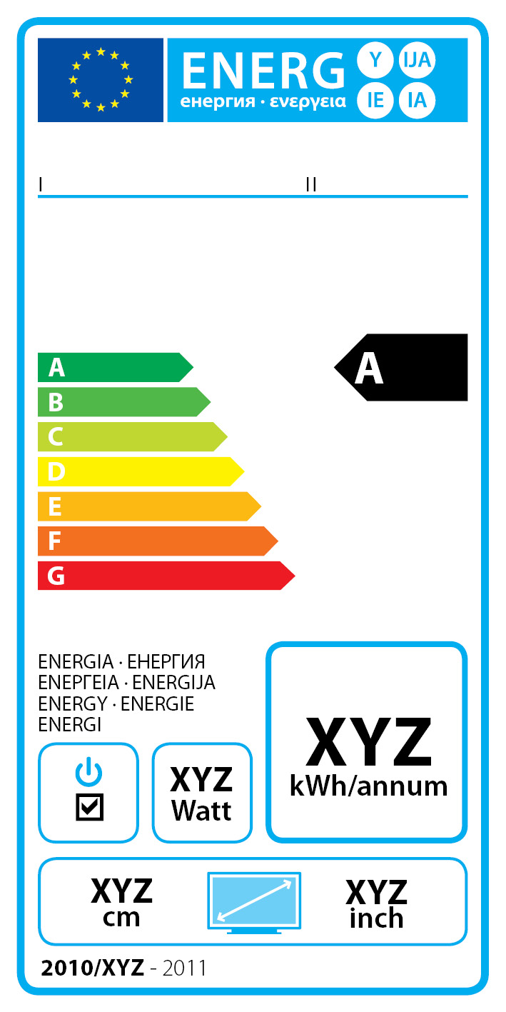 | I, II  III  VII, IV, V  VI

(b) The following information shall be included in the label:
I. supplier's name or trade mark.
II. supplier's model identifier, where model identifier means the code, usually alphanumeric, which distinguishes a specific television model from other models of the same trade mark or supplier’s name.
III. the energy efficiency class of the television, determined in accordance with Annex I. The head of the arrow containing the energy efficiency class of the television shall be placed at the same height as the head of the relevant energy efficiency class.
IV. on-mode power consumption in Watt, rounded to the first integer.
V. annual on-mode energy consumption calculated as described in Annex II, point 2., in kWh, rounded to the first integer.
VI. visible screen diagonal in inches and centimetres.
(c) The design aspects of the label shall be in accordance with point 5. By way of derogation:
VII: for televisions with an easily visible switch, which puts the television in a condition with power consumption not exceeding 0.01 Watts when operated to the off position, the symbol defined in point 8 of point 6 may be added.
Where a model has been granted a ‘European Union eco-label’ under Regulation (EC) No 1980/2000 of the European Parliament and of the Council of 17 July 2000 on a revised Community eco-label award scheme, a copy of the eco-label may be added.

2. LABEL 2
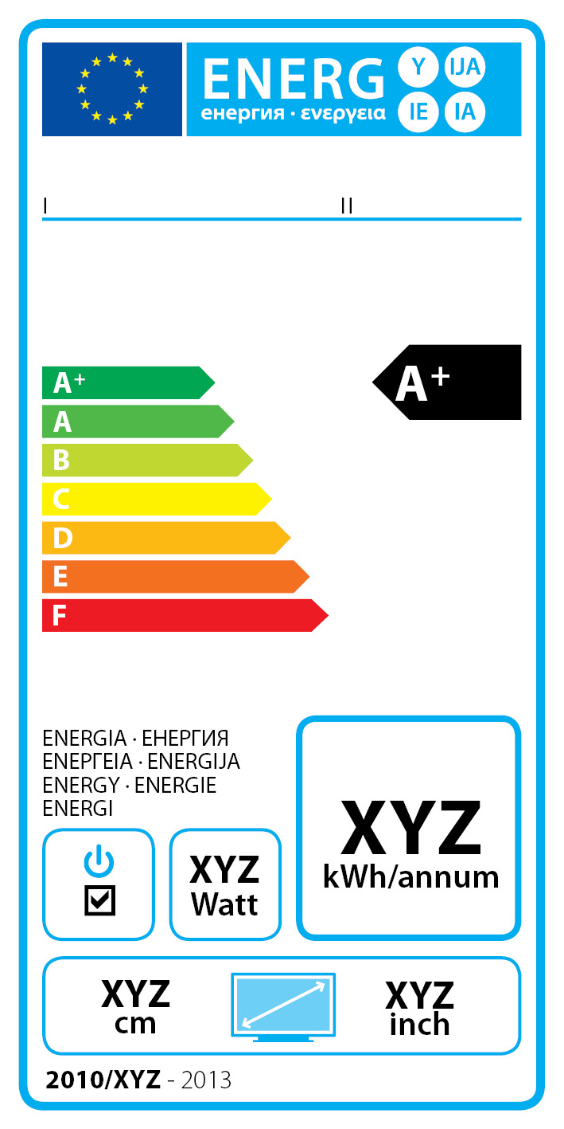 | I, II  III  VII, IV, V  VI

(b) The information listed in point 1.(b) shall be included in the label.
(c) The design aspects of the label shall be in accordance with point 5.

3. LABEL 3
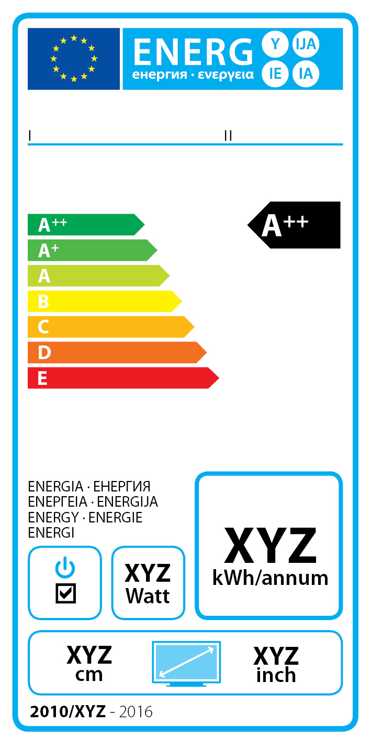 | I, II  III  VII, IV, V  VI

(b) The information listed in point 1. (b) shall be included in the label.
(c) The design aspects of the label shall be in accordance with point 5.

4. LABEL 4
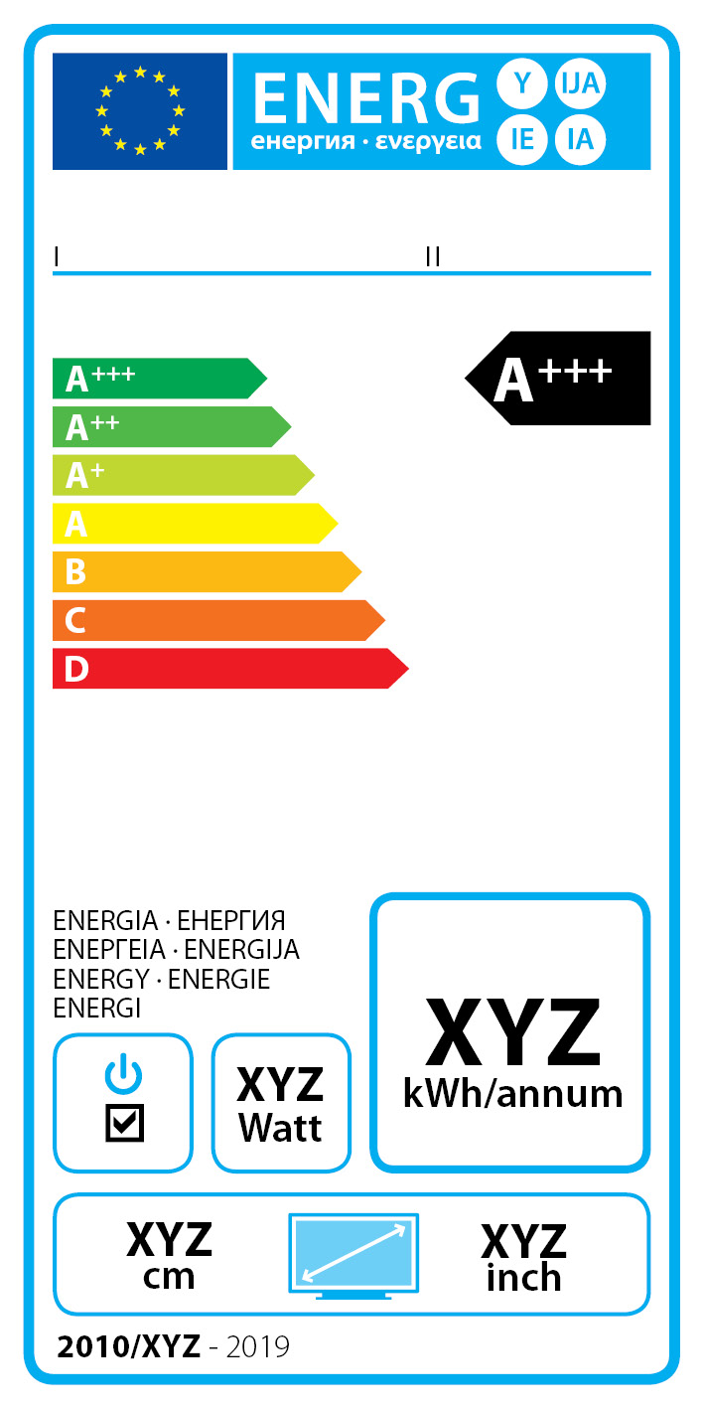 | I, II  III  VII, IV, V  VI

(b) The information listed in point 1(b) shall be included in the label.
(c) The design aspects of the label shall be in accordance with point 5.

5. The design of the label shall be as in the figure below.
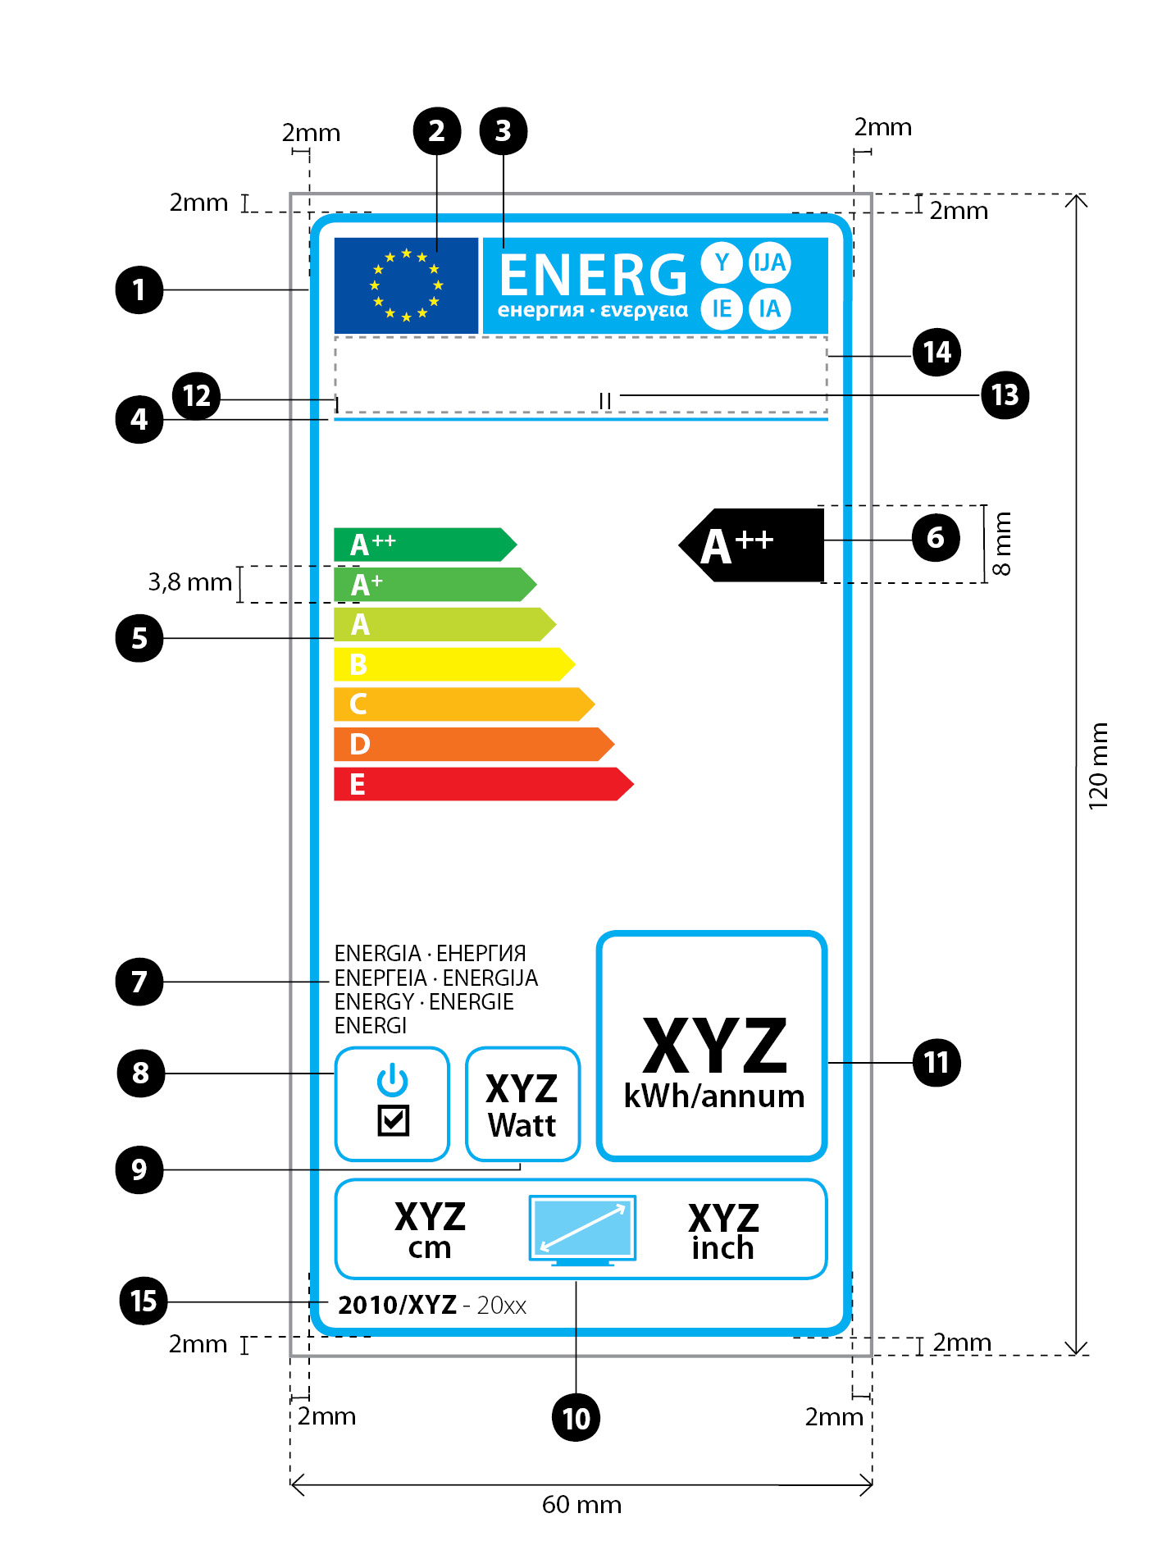
Whereby:
(a) The label shall be at least 60 mm wide and 120 mm high. Where the label is printed in a larger format, its content must nevertheless remain proportionate to the specifications above.
(b) For televisions with screen area above 29 dm2 the background shall be white. For televisions with screen area of 29 dm2 or below the background shall be white or transparent.
(c) Colours are CMYK - cyan, magenta, yellow and black and are given following this example: 00-70-X-00: 0 % cyan, 70 % magenta, 100 % yellow, 0 % black.
(d) The label shall fulfil all of the following requirements (numbers refer to the figure above):
 Border stroke: 3 pt – colour: Cyan 100% – round corners: 3.5 mm.
 EU logo – colours: X-80-00-00 and 00-00-X-00.
 Label logos:
colour: X-00-00-00
Pictogram as depicted; EU logo and label logo (combined): width: 51 mm, height: 9 mm.
 Sub-logos border: 1 pt – colour: Cyan 100% – length : 51 mm.
 A-G scale
- Arrow: height: 3.8 mm, gap: 0.75 mm – colours:
  - Highest class: X-00-X-00,
  - Second class: 70-00-X-00,
  - Third class: 30-00-X-00,
  - Fourth class: 00-00-X-00,
  - Fifth class: 00-30-X-00,
  - Sixth class: 00-70-X-00,
  - Last class(es): 00-X-X-00.
- Text: Myriad Pro Bold 10 pt, capitals, white.

 Energy efficiency class
- Arrow: width: 26 mm, height: 8 mm, 100% black;
- Text: Myriad Pro Bold 15 pt, capitals, white.

 Energy
- Text: Myriad Pro Regular 7/7pt, capitals, black.
 Switch logo:
- Pictogram as depicted, Border: 1 pt – colour: Cyan 100% – round corners: 3.5 mm.
 Text related to on-mode power consumption:
- Border: 1 pt – colour: Cyan 100% – round corners: 3.5 mm.
- Value: Myriad Pro bold 12 pt, 100% black.
- Second line: Myriad Pro regular 10 pt, 100% black.
 Television screen diagonal size:
- Pictogram as depicted
- Border: 1 pt – colour: Cyan 100% – round corners: 3.5 mm.
- Value: Myriad Pro bold 12 pt, 100% black.
Myriad Pro regular 10pt, 100% black.
 Text related to annual energy consumption:
- Border: 2 pt – colour: Cyan 100% – round corners: 3.5 mm.
- Value: Myriad Pro bold 24 pt, 100% black.
- Second line: Myriad Pro regular 10 pt, 100% black.
 Manufacturer’s information
 Model’s information
 The manufacturer and model information should fit in a space of
51x 8 mm.
 Reference period
Text: Myriad Pro Bold 9
Text: Myriad Pro light 9

ANNEX VI
Distance selling and other forms of selling where end-users cannot be expected to see the product displayed
1. Information referred to in Article 4 (2), must be provided in the following order:
  - energy efficiency class of the model as defined in Annex I;
  - on-mode power consumption as referred to in Annex II, point 1;
  - the annual power consumption as defined in Annex II, point 2;
  - the visible screen diagonal.
2. Where other information contained in the product information fiche is also provided, it shall be in the form and order specified in Annex III.
3. The size and font in which all the information referred in this Annex is printed or shown shall be legible.

ANNEX VII
Measurements
(1) Measurements of on-mode power consumption
Measurements of the power consumption referred to in Annex II shall fulfil all of the following conditions.
a) Measurements shall be made using a reliable, accurate and reproducible measurement procedure, which takes into account the generally recognised state of the art measurement methods.
b) Conditions for measuring the on-mode power consumption of televisions
- television sets without forced menu: The power consumption shall be measured in the on-mode condition of the television as delivered by the manufacturer, that is, the brightness controls of the television shall be in the position adjusted by the manufacturer for the end user.
- television sets with forced menu: the power consumption shall be measured in the "home-mode" condition.
- television monitors without forced menu: The television monitor shall be connected to an appropriate tuner. The power consumption shall be measured in the on-mode condition of the television as delivered by the manufacturer, that is, the brightness controls of the television monitor shall be in the position adjusted by the manufacturer for the end user. The power consumption of the tuner is not relevant for the measurements of on-mode power consumption of the television monitor.
- television monitors with forced menu: The television monitor shall be connected to an appropriate tuner. The power consumption shall be measured in the "home-mode" condition.
(b) General conditions
- measurements shall be made at an ambient temperature of 23° C +/- 5° C.
- measurements shall be made using a dynamic broadcast-content video signal representing typical broadcast TV content. The measurement shall be the average power consumed over ten consecutive minutes.
- measurements shall be made after the television has been in the off-mode for a minimum of one hour immediately followed by a minimum of one hour in the on-mode and shall be completed before a maximum of three hours in on-mode. The relevant video signal shall be displayed during the entire on-mode duration. For televisions that are known to stabilize within one hour, these durations may be reduced if the resulting measurement can be shown to be within 2 % of the results that would otherwise be achieved using the durations described here.
- measurements shall be made with an uncertainty of less than or equal to 2% at the 95% confidence level.
- Measurements shall be made with the Automatic Brightness Control function, if such a function exists, made inactive. If the Automatic Brightness Control function exitsts and cannot be made inactive, then the measurements shall be performed with the light entering directly into the ambient light sensor at a level of 300 lux, or more.
(2) Measurements of standby/off-mode power consumption
Measurements of the power consumption referred to in Annex III, point g shall fulfil all of the following conditions.
(a) The power consumption shall be measured by a reliable, accurate and reproducible measurement procedure, which takes into account the generally recognised state of the art measurement methods.
(b) Measurements of power of 0.50 Watts or greater shall be made with an uncertainty of less than or equal to 2% at the 95% confidence level. Measurements of power of less than 0.50 Watts shall be made with an uncertainty of less than or equal to 0.01 Watts at the 95% confidence level.
(3) Measurements of peak luminance
Measurements of the peak luminance referred to in Annex VIII shall fulfil all of the following conditions.
(a) Measurements shall be made using a reliable, accurate and reproducible measurement procedure, which takes into account the generally recognised state of the art measurement methods.
(b) Measurements of peak luminance shall be made with a luminance meter, detecting that portion of the screen exhibiting a full (100%) white image, which is part of a "full screen test" test pattern that does not exceed the average picture level (APL) point where any power limiting occurs in the display luminance drive system.
(c) Measurements of luminance ratio shall be made without disturbing the luminance meter's detection point on the display whilst switching between the home-mode condition or the on-mode condition of the television as set by the supplier, as applicable, and the brightest on-mode condition.
ANNEX VIII
Verification procedure for market surveillance purposes
For the purposes of checking conformity with the requirements laid down in Articles 3 and 4, , the authorities of the Member States shall apply the following verification procedure for the on-mode power consumption referred to in Annex II and the standby/off-mode power consumption referred to in Annex III, point g.
(1) Authorities of the Member State shall test one single unit.
(2) The model shall be considered to comply with the declared value of the on-mode power consumption referred to in Annex II and the values for standby and/or off-mode power consumption referred to in Annex III, point g, if:
(a) the result for on-mode power consumption does not exceed the applicable power consumption value referred to in Annex III by more than 7 %; and
(b) the results for standby/off-mode conditions, as applicable, do not exceed the values declared under Annex III, point g by more than 0.10 Watts; and
(c) the result for the peak luminance ratio is above 60%.
(3) If the results referred to in point (2) (a) or (b) or (c) are not achieved, three additional units of the same model shall be tested.
(4) After three additional units of the same model have been tested, the model shall be considered to comply with the declared value of the on-mode power consumption referred to in Annex II and the values for standby and/or off-mode power consumption referred to in Annex III, point g, if:
(a) the average of the results for the latter three units for on-mode power consumption does not exceed the applicable power consumption value referred to in Annex III by more than 7 %; and
(b) the average of the results for the latter three units for standby/off-mode conditions, as applicable, do not exceed the values declared under Annex III, point g by more than 0.10 Watts; and
(c) the average of the results for the latter three units for the peak luminance ratio set out is above 60%.
(5) If the results referred to in point (4) (a) or (b) or (c) are not achieved, the model shall be considered not to comply with the requirements.
(6) For the purposes of checking conformity with the requirements, the authorities of the Member States shall use the procedure set out in Annex VII and reliable, accurate and reproducible measurement procedures, which take into account the generally recognised state of the art measurement methods, including methods set in documents the reference numbers of which have been published for that purpose in the Official Journal of the European Union.

OJ L …
Available on http://www.ecotelevision.org
SEC(2009) 1011, available on http://ec.europa.eu/energy/efficiency/ecodesign/legislation_en.htm
OJ L 191, 23.7.2009, p. 42.
of which 130 TWh are related to on-mode, and 2 TWh standby/off-mode
OJ L 37, 13.2.2003, p.24.
OJ L 37, 13.2.2003, p. 19.
OJ L 82, 28.3.2009, p. 3.
OJ L 374, 27.12.2006, p. 10.
COM(2006) 545
COM(2008) 800
OJ L 285,31.10.2009, p. 10.
OJ L […], […], p. […].
OJ L 191, 23.7.2009, p. 42.
OJ L 204, 21.7.1998, p. 37.
OJ C 321, 31.12.2003, p. 1.
OJ L 390 of 31.12.2004, p. 24.
OJ L 237, 21.9.2000, p. 1.

