**WORKING DOCUMENT**

**Explanatory Notes**

**Review of Regulation 327/2011**

**Table on Contents**

1. Context of the proposal 3

1.1. Grounds for and objectives of the proposal 3

1.2. Market significance 4

1.3. Environmental significance 4

1.4. Currently covered products 5

1.5. International legislation 7

1.6. Availability of standards 8

2. Proposed measures 9

2.1. New tier 9

2.2. Jet fans 12

2.3. Mandatory information requirements 13

2.4. Exemptions 13

2.5. Allowances 15

3. Possible overlap with other Ecodesign measures 16

4. Form of implementing measures 17

5. Measurements and calculations 18

6. Conformity assessment 18

7. Market surveillance 18

8. Benchmarks 19

# Context of the proposal

## Grounds for and objectives of the proposal

The Ecodesign Directive 2009/125/EC[1] establishes a framework for the setting of ecodesign requirements for energy-related products. It is a key instrument of the Union policy for improving the energy and other environmental aspects of products placed on the market or put into service in the European Economic Area (EEA). It is an important instrument for achieving the energy saving objectives for 2020 and 2030, and its implementation is one of the priorities in the Commission's Communication on Energy 2020 and Energy Efficiency Plan 2011. Furthermore, implementation of the Directive 2009/125/EC will contribute to the EU's target of reducing greenhouse gases by at least 20 % by 2020 and by 40% by 2030.

The proposed Regulation is a concrete contribution to this process and is in line with the Commission Action Plan on Sustainable Consumption and Production and Sustainable Industrial Policy.

Industrial fans, which are widely used in the European Union, were already identified as a priority product group to be considered for implementing measures in 2005 when they were listed on Article 16 of Directive 2005/32/EC[2]. .

In 2011, with the aim of improving the penetration of high-efficiency industrial fans in the European market, Regulation (EU) No. 327/2011 with regard to ecodesign requirements industrial fans[3] was published. This Regulation sets minimum energy efficiency requirements for industrial fans with a rated electric power input between 125 W and 500 kW.

The minimum requirements established by this Regulation applied from 1 January 2013 in a first step and from 1 January 2015 in a second step. The curves for the minimum efficiency standard were taken from the international standard ISO 12579:2010. Tests are based on the applicable test standard ISO 5801:2007.

The minimum efficiency grades (‘N’ in the table) were decided upon by the Ecodesign Regulatory Committee and subsequently the Regulation was submitted to the European Parliament and Council for scrutiny. As required, the Regulation was developed including extensive stakeholder consultation, preparatory study, impact assessment, inter-service consultation and World Trade Organisation notification.

The review clause of Regulation (EU) No. 327/2011 (Art. 7) states:

*"The Commission shall review this Regulation no later than 4 years after its entry into force and present the result of this review to the Ecodesign Consultation Forum. The review shall in particular assess the feasibility of reducing the number of fan types in order to reinforce competition on grounds of energy efficiency for fans which can fulfil a comparable function. The review shall also assess whether the scope of exemptions can be reduced, including allowances for dual use fans".*

To address the issues included in the review article and update the energy efficiency requirements, a preparatory review study was launched in April 2014, resulting in a final report published in March 2015[4]. The study included a questionnaire, a discussion document, two stakeholder meetings (that took place on 25 September 2015 and 22 January 2015) and two interim reports by the study team. It resulted in close to 80 stakeholder position papers (>500 pages) from individual stakeholders and 11 associations.

## Market significance

Sales of industrial fans are estimated at 7.4 million units in 2010, representing a revenue of almost 2 billion euros. According to the Ecodesign WP 2 background study[5] roughly half of the volume of smaller fans comes from extra-EU imports; for larger fans the EU producers hold a strong position.

The EU stock of industrial fans is estimated at close to 0.1 billion units, with an accumulated static gas power[6] output of 109 TWh/year, of which 52 TWh/year from axial fans, the same output from backward-curved (and mixed flow) centrifugal fans and 5 TWh/year from forward-curved centrifugal fans. The share of cross-flow fans >125 W is negligible.

In 2020 the sales are expected to increase to 9 million units and the stock will be approximately 0.12 billion units. In 2030 the unit sales are expected to rise to 9.2 million units and the stock to 0.135 billion units.

## Environmental significance

For all types of industrial fans, the energy consumption (in use phase) dominates in almost all environmental impact categories. This indicates that reducing energy consumption during use should be the priority option for reducing the environmental impact of fans.

The electricity consumption of industrial fans in 2010 is estimated at 262 TWh. Without Ecodesign Regulation (EU) 327/2011 it was expected to grow to 336 TWh in 2020 and 384 TWh in 2030. With Ecodesign measures the projection is 308 TWh in 2020 and 332 TWh in 2030. This means an energy saving of 28 TWh in 2020 and, at full stock change since Tier 2 of the regulation[7], a saving of 52 TWh in 2030[8].

Greenhouse gas emissions from electricity generation and distributions were 108 Mt CO2 in 2010. The projection of greenhouse gas emissions in 2020 without Ecodesign was 128 Mt CO2 and with Ecodesign measures 116 Mt CO2, saving 12 Mt CO2. In 2030 the projections were 130 Mt CO2 without measures and 112 Mt CO2 with measures, saving 18 Mt CO2.

In terms of recycling, industrial fans are relatively unproblematic. Medium and large fans are usually fully made of metals (copper & iron for the motor, aluminium or steel for the impeller and stator) with high recycling rates. Smaller fans may have a plastic impeller and stator, which at end of life can be recycled, e.g. the impeller and stator are usually easily dismounted, or used for heat recovery.

The possible exception is the use of Rare Earth Elements (REE) in Electronically Commutating (EC) motors which are used in fans. These motors are expected to be become a noticeable part of the waste stream. Most types contain permanent magnets[9] with on average 18% Neodymium and smaller fractions of other REE. As these REE are regarded as ‘critical raw materials’ due to their ever increasing prices and dependence on supply from a single country[10] it may be useful to indicated the weight of the magnets on the nameplate of the fan.

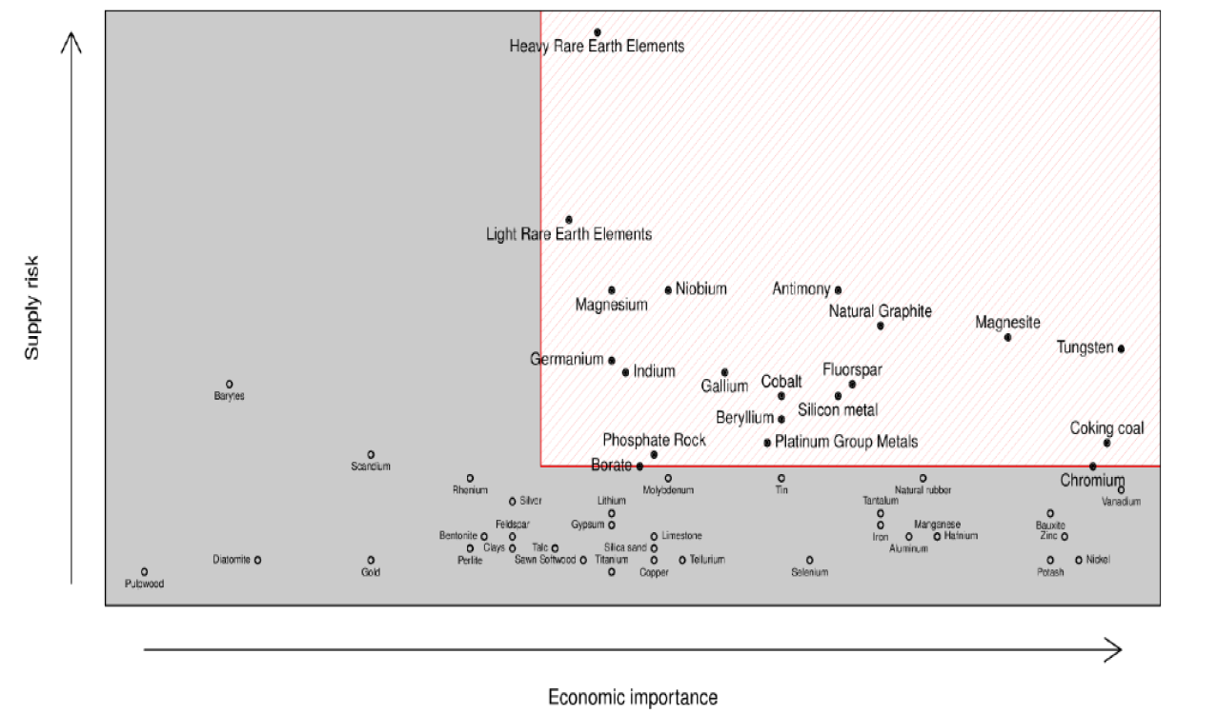

**Critically assessment for the EU**

## Currently covered products

Regulation (EU) No. 327/2011 covers axial, mixed-flow, cross flow and centrifugal fans, with the latter containing the categories ‘forward-curved & radial’, ‘backward-curved with housing’ and ‘backward-curved without housing’ as shown below**[11]**

.

|  |  |  |  |
| --- | --- | --- | --- |
|  |  | |  |
| **ropeller’ (axial)** | **Tube-axial** | | **Vane-axial** |
|  |  | |  |
| **Centrifugal Forward-curved** | **Centrifugal Radial-shrouded** | | **Centrifugal Radial-tipped** |
|  |  | |  |
| **Centrifugal Backward-curved** | **Centrifugal Backward-inclined** | | **Centrifugal Backward aerofoil** |
|  | | | |
| **Mixed-flow** | | | |
|  | |  | |
| **Cross-flow** | | **Cross-flow (section view)** | |

The top row shows types of axial fans, such as the propeller-type (a.k.a. ‘sirocco’) which is without stator, the tube-axial fan which is with housing and the vane-axial fan with housing and also stationary inlet and/or outlet vanes that ‘straighten’ the swirling flow. There are variations of axial fans, not shown, with variable pitch blades and/or vanes and there are more exotic types with contra-rotating axial fans. Axial fan blades come in all forms and sizes: From rectangular to complex scythe contours, from single-thickness to airfoil sections, from radial to skewed attachments to the hub, from diameters (in the scope) of 10 centimeter up to 12 meters.

The second row shows the forward curved and radial centrifugal fans. The forward-curved fan is typically a ‘squirrel-cage’ type with many (up to 60) short blades that in fact ‘kick’ the gas out of the rotor. The air in an FC-fan has to make twice a 90° turn, first coming in through the center of the rotor moving towards the periphery and second when being ‘kicked’ out by the blade into the housing’s diffuser. This is aerodynamically difficult to achieve and costs a lot of power, but with a relatively small rotor and relatively low tip speed (lower noise) it can generate a relatively large flow rate. The housing (or ‘scroll’ and especially the diffuser (or ‘volute’) of an FC-fan is critical for a proper functionality. There are some variations on the ‘squirrel cage’ rotor such as rotors that have longer full blades with shorter ‘semi-blades’ in between.

Radial fans also have a low efficiency. They are typically used either as conveyer fan (to avoid the high dust load to clog up the fan) or when the fan has to be reversible (able to rotate in both direct directions, e.g. for a dual use fan).

The third row shows various BC-fans: a standard backward-curved with single thickness blades, a backward-inclined fan with straight blades to avoid clogging in case of high dust loads that is also easier to make in a one-off production and a more sophisticated BC airfoil bladed fan. The gas in a BC-fan is not ‘kicked’ out, but rather are guided smoothly along the blade before they are ‘swung’ out by the centrifugal force. It means that the fan is aerodynamically more efficient, but –for the same pressure/flow operating point—it is bigger than the FC fan. And (thus) the tip speed is higher, resulting in higher sound power. The housing is less critical and mainly an envelope that ensures that the air goes out in the right direction. But if the direction is irrelevant –e.g. in a plenum fan- a properly designed BC-fan also works –and even more efficiently—without a housing. For larger flow-rates also double entry fans are used, both BC and FC, which means that the air enters the rotor from both sides.

## International legislation

Most measures listed in the CLASP online[12] database or the AMCA overview[13] relate to comfort/ceiling fans, residential ventilation units (sometimes referred to as ‘fans’), residential furnace blowers, etc. but not to industrial fans. Also, they relate often to voluntary endorsement labels or are linked to building codes. A common denominator for most measures seems to be the use of fan performance test standard ISO 5801:2007, also the reference in the EU. The same cannot be said for ISO 12759:2010[14], the standard for calculating the current EU minimum requirements.

Only China has a mandatory minimum energy efficiency performance standard (MEPS) since 2009[15] that is comparable in product scope to the Regulation (EU) No. 327/2011. The US Department of Energy (DoE) is in the process of preparing MEPS, but will probably take at least until 2016[16]. Turkey and Jordan appear to be in the process of incorporating the EU regulation 327/2011 format into their legislation.

The Chinese MEPS, introduced in 2009, uses a metric that is based on look-up tables. Their table for centrifugal fans has 3 tiers (only tier 3 is mandatory), three classes of (impeller) sizes, 10 classes of a relative tip-speed parameter, each subdivided in 1 to 3 subclasses of a parameter for the relative impeller speed that determine the minimum shaft efficiency (not including the motor). The minimum total shaft efficiency values range from 55% to 81% in Tier 3. For the most ambitious Tier 1, voluntary and used for extra incentives, the values range from 64% to 89%.

The axial fan table is also based, on the three classes of (impeller) sizes and, vertically 4 classes of hub-to-impeller diameter ratio (d/D) to indicate the shaft efficiency. The minimum Tier 3 values range from 60 to 73%. The Tier 1 values range from 69 to 83%.

The US DoE is looking at several approaches for the metric:

* Evaluating fan efficiency as a function of size similar to the method described in AMCA 205 using available data (from catalogues or other sources). To better represent differences in performance across fan types, DoE would derive FEG limits (Fan Efficiency Grades, so also excluding the motor) separately for each fan equipment class.
* In addition to fan size, exploring other parameters that show a correlation to efficiency. DoE may consider expanding the FEG approach to incorporate operational conditions of a fan. The approach to expand FEG would include evaluating combinations of size and operational parameters such as flow, pressure, flow coefficient, pressure coefficient, and specific speed as well as any other suitable parameters. Different combinations of parameters may be considered for each equipment class (i.e., hub-tip ratio parameter for axial fans). For each equipment class, the available data would be plotted in a three-dimensional space that includes efficiency and the other two considered parameters. A 3-D plane would be generated from the data to represent the fan average efficiency over the range of operating conditions.

The US DoE is at the beginning of its rulemaking process and is at the stage of seeking stakeholder feedback.

## Availability of standards

The test standard used as basis for the current Regulation is ISO 5801:2007 ‘Industrial fans - Performance testing using standardized airways’, which in the meanwhile has entered a process of revision by ISO TC117, with ISO/DIS 5801:2014 being the latest draft. The revision is largely identical to ISO 5801:2007 for the items relevant for the Regulation. The currently applicable standard is still EN ISO 5801:2008, i.e. the European version of ISO 5801:2007.

For procedural reasons[17], CEN TC156 WG17 started working on mandate M/500 only in June 2014. While since then rapid progress has been made, the first draft EN (prEN) standard is not expected before the beginning of March 2015. Given the time required for voting, the final EN standard is expected in 2016. A harmonised version, i.e. the reference of which is published in the Official Journal, is not expected before late 2016 or early 2017.

Mandate M/500 could be updated to ask for a new metric for measuring the efficiency of fans.

As regards performance testing of jet fans, draft ISO/DIS 13350:2014 ‘Fans — Performance testing of jet fans’ is now available, drawn up by ISO TC117 WG 13, a working group incorporating experts from all four major EU manufacturers. The standard is at final stages of voting. The next step is the conversion to an EN standard and subsequent harmonisation, presumable also in 2016/2017.

The FprEN ISO 12759 Fans – efficiency classification for fans (ISO 12759:2010 + A1:2013) is still ‘under approval’. ISO 12759:2010 specifies requirements for classification of fan efficiency for all fan types driven by motors with an electrical input power range from 0,125 kW to 500 kW. It is applicable to (bare shaft and driven) fans, as well as fans integrated into products. Fans integrated into products are measured as stand-alone fans.

# Proposed measures

## New tier

Over the past four years, while the industry was busy transforming large parts of its catalogue to meet the requirements of the Regulation, there have been no major developments in the metric underlying that Regulation. The ‘extended product approach’ for part load testing, which is part of several other Ecodesign-regulated products[18], has hardly been explored by the sector. The change from the geometry-based categories to a functional pressure/volume flow approach is still in its infancy. A universal way to work noise requirements into the efficiency metric has not progressed.

Given the lack of progress in developing new metrics, the possibilities for updating the requirements under the current metric were explored. Following stakeholder consultation the following approach is proposed:

* One new tier per 1.1.2020 (respecting the design cycle);
* Combining BC-fans with and without housing into one category;
* Keep separate FC and radial fan limits up to 5 kW;
* Over 5 kW all centrifugal fans have the same minimum requirements;
* Axial fans as well as the separate FC and radial categories will follow the slope of centrifugal fans, which means a simplification of the regulation and makes that the new limits will be relatively more lenient for smaller axial and FC-fans;
* For axial fans the maximum difference between the new static and total minimum efficiency is 0,14;
* Mixed-flow fan static pressure limits will be between those of axial and centrifugal fans on a sliding scale determined by the flow angle, to avoid a loophole;
* Keep the 2015 cross-flow fan limits, which effectively means a phase out of cross-flow fans >125W.

New efficiency values are proposed as indicated in the table below.

|  |  |  |  |  |  |  |
| --- | --- | --- | --- | --- | --- | --- |
| **Proposal new efficiency limits per 1.1.2020** | | | |  | **Comparison with current regulation** | |
| **Fan type** | **Measurement category** | **Pressure** | **Efficiency grade N per 1.1.2020** |  | **Compare: N per 1.1.2015** | **Increase N** |
| Axial* | A, C | static | 0,50 |  | 0,40 | 0,10 (+20%) |
| B, D | total | 0,64 |  | 0,58 | 0,06 (+10%) |
| Centrifugal forward-curved and radial <5kW* | A, C | static | 0,52 |  | 0,44 | 0,08 (+18%) |
| B, D | total | 0,57 |  | 0,49 | 0,08 (+16%) |
| Centrifugal >5kW and centrifugal backward-curved and radial ≥5 kW | A, C | static | 0,64 |  | 0,61/0,62*** | 0,02 (+4%) |
| B, D | total | 0,67 |  | 0,64 | 0,03 (+5%) |
| Mixed flow | A, C | static | 0,57+0,07∙(α −45)/25 |  | 0,50 | 0,07 (+14%) |
| B, D | total | 0,67 |  | 0,62 | 0,05 (+8%) |
| Cross flow | B, D | total | 0,21 |  | 0,21 | 0 |
| *= with new curve, now the same as for all types: ηmin= 0,0456*LN(Pe)-0,105+N when Pe≤10 kW and ηmin= 0.011*LN(Pe)-0.026+N when Pe>10 kW | | | | | | |
| **= α is the flow angle of the impeller, between 20° (close to axial) and 70° (close to centrifugal) | | | | | | |
| ***= 0,61 for BC with housing, 0,62 for BC without housing | | | | | | |

As shown in the following scatter-diagrams[19] the new limits would phase out approximately 15-20% of the 2015 product range <10 kW.

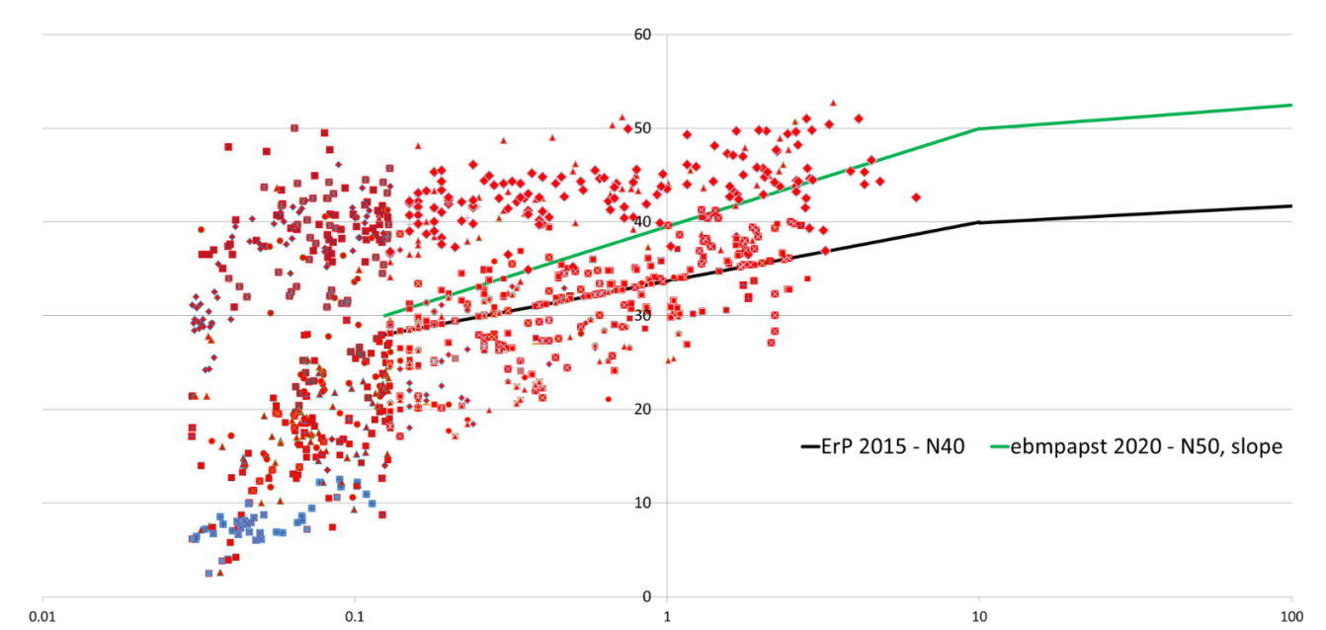

**Limit lines in scatter-diagram of past and present production of axial fans <10 kW**

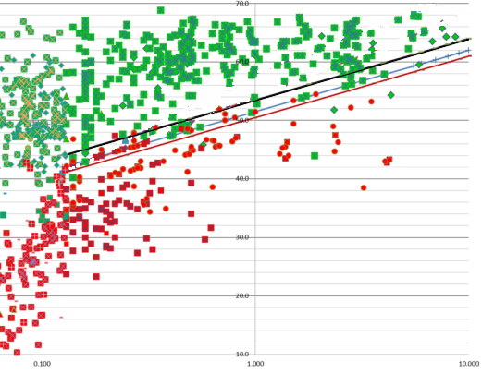

**Limit lines in scatter-diagram of past and present production of Centrifugal Backward-Curved fans <10 kW**

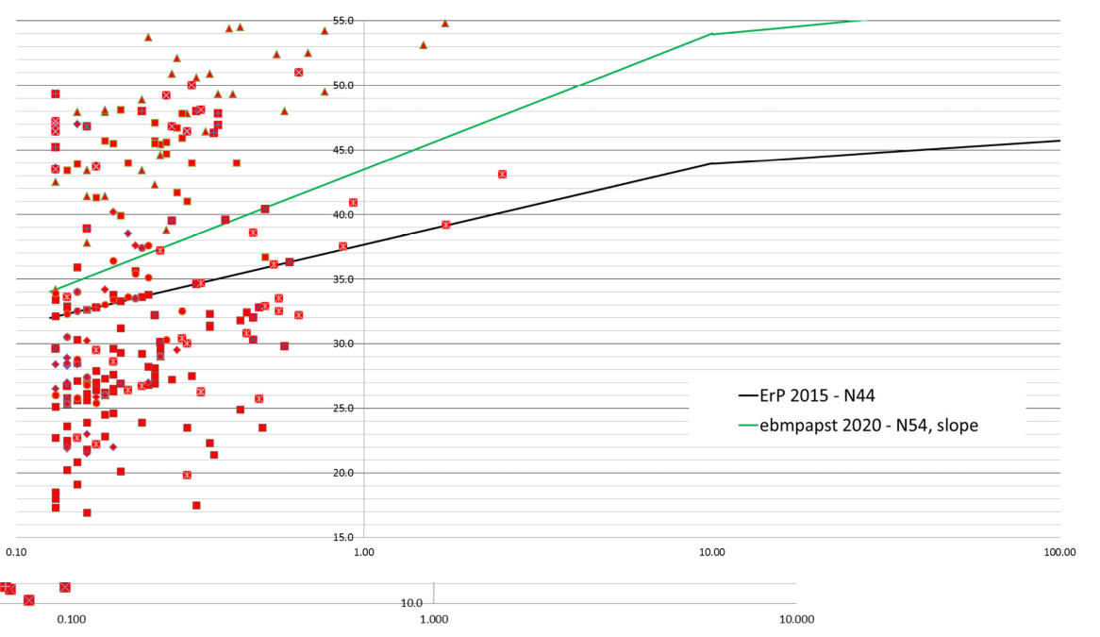**Limit lines in scatter-diagram of past and present production of Centrifugal Forward-Curved fans <10 kW**

Data that the study team received from manufacturers confirm this general picture. In some cases, this data was considered confidential by manufacturers. Nonetheless, especially for manufacturers of specialty process fans and bespoke fans these new limit values were defined as very challenging, especially when there are noise constraints.

On average the proposed efficiency limits are 12% more stringent for static pressure efficiency and 8% more stringent for total pressure efficiency compared to the 2nd tier of the current regulation.

Preliminary estimates indicate that the new tier will add an extra saving of 10-15 TWh/year in 2030.

## Jet fans

Jet fans are used in tunnels and parking garages to deliver a maximum amount of thrust, i.e. the ability to drive forward an air mass in a two-way open envelope. Jet fans are not defined by their blade geometry, i.e. they can be axial (most) or centrifugal (rare). Apart from their performance to convert electric input power to thrust –which is in fact their ‘efficiency’ defined in ISO/DIS 13350—it is not possible to define a jet fan through any other measurable parameter.

The graph below gives the shaft efficiency of 169 models of jet fans currently on the EU-market[20]. The trend-line in this scatter diagram is very flat, meaning that there is little difference with using a flat minimum efficiency number to define a ‘jet fan’.

If, for instance, a minimum efficiency would be set at 50%, 49 of 169 models (23%) would be need to be replaced by more efficient models and the average efficiency of the remaining population of 120 models would become 54.9% compared to 52.8% for the original population.



**Figure 5. Reversible jet fans, input power versus fan impeller efficiency according to ISO/DIS 133560.**

The preparatory review study estimated the maximum EU electricity consumption of jet fans at 6.8 TWh/year. Even with a measure at an unlikely cut-off rate of 50%[21] the saving at full stock change would be no more than 5%, i.e. 0.34 TWh/year at full stock change (in 2030 and beyond).

## Mandatory information requirements

The product information requirements in the current regulation are largely adequate. New elements are

* the shaft efficiency for jet fans (*ηr* according to ISO/DIS 13350);
* the mass of permanent magnets in (some) EC motors on the nameplate as an indication for future recyclers whether it is worthwhile to follow a disassembly route to recover these magnets that contain on average 18% Neodymium and smaller fractions of other Rare Earth Elements.

## Exemptions

As there is no new metric for fan efficiency there is little scope for reducing exemptions. Instead, in the preparatory review study a considerable effort has been made to clarify the existing exemptions so that they can be verifiable in case of a dispute or court case. Also there are some additions to the exemptions in order to align them with the forthcoming Regulation on electric motors (review of Regulation 640/2009)**.**

The definition of emergency fans was updated (referring to the new regulation for fire safety) and – to avoid loopholes - refers only to fire safety classes of F300 (300°C at 60 minutes) and above. This means that F200 fans are not exempted.

The temperature values were aligned with those in the draft motor regulation. Furthermore, it is proposed to relate the exemption to the gases (or abrasive substances) being handled;

* to Regulation 1272/2008 on classification, labelling and packaging of substances and mixtures[22] and its adaptations[23] as a comprehensive (1353 pages) reference to what gases are considered toxic, highly corrosive, flammable and in what concentrations;
* to the bio-hazardous substances of risk groups 2, 3 and 4 as set out in Directive 2000/54/EC on the protection of workers from risks related to exposure to biological agents at work[24] and its adaptations;
* to carcinogen and mutagen substances as set out in Directive 2004/37/EC on the protection of workers from risks related to exposure to carcinogens or mutagens at work[25] and its adaptations;
* to the technical limit values for abrasive substances (hardness≥5 Mohs, concentration ≥100 mg/m³ ) as defined in the Commission Fan FAQ document;
* To the technical limit values in the EVIA guidance document as to the characteristics of solids in conveying fans (currently in Art. 3.4), i.e. a maximum concentration of 200 mg/m³ and/or a maximum average diameter of 1 mm.

Furthermore, in order to align with the draft motor regulation, exemptions have been added for ‘cordless and battery operated equipment’, ‘hand-held equipment whose weight is supported by hand’ and fans in ‘nuclear installations as defined in Article 3 of Directive 2009/71/EURATOM’[26]. In that latter clause, exemptions were also added for fans in military establishments (bunkers) and civil defence establishments (bomb-shelters) for reasons of avoiding significant negative impact on safety (cf. Art. 15, e. of the Ecodesign Regulation). Also an exemption is added for fans in wind-turbines on the grounds of a possible significant negative impact on functionality[27].

During the consultation, and following the discussion regarding the review of the motor regulation, it was investigated whether the exemptions for ATEX-fans (for explosive environments) should not be lifted and instead an allowance for these fans should be given. However, even if the motor regulation would follow such a route, it was deemed that for fans the risks for a significant negative impact on safety are too large. Hence, the exemption in article 1.3 a) is proposed to be kept.

There was great concern with stakeholders over the fact that for the period starting from 1.1.2015 there is no provision in the current regulation for spare parts to replace phased-out fans. It was pointed out, inter alia, that:

* Commercial contracts require the delivery of spare parts for a long time;
* The dimensions, electrical connections and controls of new fans typically prohibits their use as a replacement for phased-out fans;
* For nuclear power plants it is a requirement that identical parts shall be delivered during the full life of the power plant (40-50 years);
* Directive 2011/65/EU on the restriction of the use of certain hazardous substances in electrical and electronic equipment[28] (RoHS Directive) allows an unlimited production of spare parts;
* The lack of spare parts would lead to early end-of-life for many products or prohibitive costs for stocking replacement fans by the suppliers/manufacturers;
* While for large industrial components it may be established practice to repair/replace just one piece of the product (e.g. the motor or the rotor), for small and medium-sized fans (say <10 kW) this is not customary and/or very expensive;
* Spare parts are currently only 1-2% of the total fans placed on the market (confirmed by the study team for one manufacturer).

On the other hand, spare part provisions have been up to now more the exception than the rule. Such a spare part provision, where it is enough for the manufacturer to write ‘spare part for product XX[29]’ on the nameplate to be able to sell an incompliant fan, creates a potentially large loophole and thus a provision, if unavoidable to avoid a significant negative impact of the measure, should be restricted in time as much as possible.

Taking into account the approach taken in other Ecodesign regulations, it is proposed to fix a period of 5 years, starting from the data the tier is applicable.

## Allowances

In Article 3 of the current regulation a 10% allowance (factor 0.90 times the minimum efficiency values) was given for dual use fans from 1 January 2013, this value was reduced to 5% (factor 0.95) from 1 January 2015.

All stakeholders insisted that for dual use fans this is impossible and the 10% allowance is appropriate. The technical study of standards and guidelines confirmed this with most of the efficiency losses coming from the larger tip clearance. Furthermore, the preparatory review study found that, if the emergency fan definition in Art. 1.3 b) is limited to class F300 and above (see exemptions section), there is little risk of loopholes. The dual use fan needs to be certified (as do emergency fans) and their price is 2 to 3 times higher than a ‘normal’ fan.

Most dual use fans are reversible, i.e. the direction of the flow can be reversed to extract smoke and create oxygen-poor conditions for the fire. But there are differences in the quality of reversibility. Simply reversing the rotation-direction of the impeller of most fans will already have some effect, which may or may not be enough in some situations. For true reversibility it is required that the reverse flow is at least 80% of the design-flow. This means that compromises have to be made in the fan geometry, both in the impeller-design and the in/outlet conditions, which have to be more symmetrical than would be optimal for a non-reversible fan. Furthermore, for some applications[30] it was mentioned that reversibility is required even without dual use certification.

In summary, it is proposed to give a 10% allowance (factor 0.9) for dual use fans and a non-accumulative 15% allowance (factor 0.85) for reversible fans, dual use or not.

# Possible overlap with other Ecodesign measures

Industrial fans are a B2B-product supplied to manufacturers of products regulated under ecodesign such as ventilation units, (room) air conditioners, etc. and they make use, amongst others, of 'ecodesign regulated' industrial motors.

The Ecodesign Impact Accounting (EIA) study[31] based on the 2008 stakeholder study[32] and the 2011 impact assessment[33], projects electricity savings of 28 TWh/year in 2020 from the Industrial Fans regulation (EU) 327/2011. Industry confirms that it is well underway of achieving this target and that –despite the lack of surveillance—the regulation is having a significant savings effect.

The EIA study also indicates an overlap of 50%, i.e. around 14 TWh/year, from savings claimed by other products with Ecodesign measures. This 14 TWh/year saving can be split on the demand side between 5 TWh for ventilation units, <1 TWh for combustion fans in boilers, <1 TWh for room air conditioners, 2 TWh for future measures on larger air heating/cooling units and perhaps 1 TWh for future measures on commercial and professional refrigeration.

On the supply side the motor regulation may have an overlap of 5 TWh. The impact of the motor regulation is relatively modest, mostly limited to medium-sized fan motors (5-10 kW), because both in the smaller fans (50% with EC motors) and in the bigger fans (mostly with IE3 motors or better) the minimum efficiency values of the motor regulation will have limited impact. Furthermore, even in the medium-sized motors the motor efficiency influences only a fraction (typically less than half) of the fan & motor efficiency grade that is being regulated through the Regulation 327/2011.

Specifically in the case of fans, some associations proposed to make an exemption for all fans that are used in products that are already regulated by other Ecodesign Regulations. Under this reasoning, fans are considered an auxiliary component and without such an exemption manufacturers may be forced to pay for a more expensive fan, while low-cost options may be available to meet the Ecodesign requirements for their end-products. They claim it is more expensive for the consumer, a suboptimal limitation of the design freedom and inefficient for the legislator and market surveillance authorities. The European Union has legislation and harmonised standards that aim to protect the safety, health and general wellbeing of its citizens and the environment. Without such rules at EU level, there would probably be at least 28 national requirements and standards covering the same product groups, resulting in significant additional compliance costs for manufacturers and a fragmentation of the internal market.

Furthermore, companies have to deal with products that are compliant with EU legislation also at component level and are liable in case they would use components that are non-compliant. In theory this means that the number of tests and test standards to which the final product has to show compliance is a manifold. To avoid that manufacturers would have to test also every component, the EU created the CE-marking. This allows that the manufacturer of an end-product can rely on the testing for compliance by the component supplier, evidentiated through a CE-mark (and the underlying Document of Conformity) instead of having to re-test every component.

In this context, the main criterion, taking into account all boundary conditions formulated in the Ecodesign Directive, is whether a regulation has added value in reaching EU policy objectives. Whether it is a component or a product is irrelevant.

Specifically, in the case of fans which go into products that are regulated under the Ecodesign directive some industries argue that setting requirements for such fans is detrimental to their business because it prohibits them from buying lower-cost unregulated fans, thereby preventing them to spend this money on improving other components (heat exchangers, etc.) that may have greater effect on the overall efficiency of the final product.

While this may be true in some cases for the Ecodesign Directive this is less of a problem. If there is a level playing field, i.e. all producers are subject to the same requirements as is intended through an EU-wide regulation, there is no negative impact on competition: The increased costs are passed on to the consumer that will recuperate these during the life time of the product. If the analysis shows that the payback for the consumer is positive (the industry does not deny that efficiency goes up through a better fan, only that it is more expensive than other potential design measures) there is no negative economic impact on the consumer.

Moreover, as for most components, the production costs and prices of industrial fans are going down when production volumes (and competition) go up. More specifically for this sector, there is a shortage of affordable motors and lack of know-how and willingness to invest, both at producer and buyer side, in optimal aerodynamics (bell-mouths, guide vanes, etc.) and controls (VSD, sensors, etc.). To turn this situation around, it is imperative that a) there are no loopholes whereby unregulated fans can enter the EU market, and b) there is a minimum market volume. Considering that Ecodesign regulated end-products, containing industrial fans as a component, are projected to make up roughly half of the market volume, there is most certainly an added value in also including these integrated fans in the scope of the fan Regulation.

Given the horizontal nature of the discussion, this item will also be put on the agenda of an horizontal Consultation Forum.

# Form of implementing measures

The reviewed ecodesign measure will continue to have the form of an Implementing Regulation setting minimum ecodesign requirements directly applicable in all Member States.

The ecodesign requirements relate to the energy efficiency of the products within the scope of the Regulation. In addition there are ecodesign requirements relating to the provision of supplementary product information.

# Measurements and calculations

Member States authorities shall use the measurement methods and calculation methods set out in Annex V. These relate to the assessment of the fan flow angle (determining fan category), the centrifugal blade angle (determining the centrifugal subtypes), jet fan (determining the shaft efficiency) and the characteristic noise emission value needed to determine whether a fan >10 kW can qualify as ‘low noise’.

Other than these specific assessments, the testing of energy efficiency performance is left to the appropriate standard(s) such as developed and referenced under Mandate M/500.

# Conformity assessment

The verification tolerances set out in the relevant Annex of the Regulation relate only to the verification of the measured parameters by Member States authorities and shall not be used by the manufacturer or importer as an allowed tolerance to establish the values in the technical documentation.

The preparatory review study explored whether the verification tolerances could be reduced to 7% (factor 0.93 of minimum requirements), like e.g. for ventilation units. In mass-produced products this seemed to be relatively unproblematic, but several manufacturers, especially of bespoke industrial fans (produced one-off or in small series), gave convincing evidence on deviations in tip clearances and rotor-angles that would necessitate to keep the 10% tolerance.

Therefore, it is recommended to keep the 10% tolerance (factor 0.9 of the minimum efficiency value).

The possibility of third party certification (TPC) as a means to streamline conformity assessment was met by large scepticism from the stakeholders. They foresee that the loopholes for e.g. imported fans would continue to exist and for the domestic producers it would result in additional administrative burden. Also the lack of certified laboratories would be a major bottleneck.

# Market surveillance

In as much as it could be assessed in the preparatory review study, the enforcement activities undertaken by the market surveillance authorities (MSAs) of Member States has been limited to document inspection, and no fans have been tested for compliance with regulation (EU) no 327/2011.

An important problem seems to be the confusion over who is responsible for non-compliance. The current EC Blue Guide is not always clear and the existence of the ‘non-final assembly’ in the regulation is considered a major loophole. The latter allows an impeller-manufacturer to test with an efficient motor and then sell this compliant ‘fan’ (impeller) to a client who can use any type of motor or stator.

For these reasons it is proposed to delete the ‘non-final assembly’ option from the regulation and clearly state in Article 2 (definitions) that a ‘fan’ consists of three parts: an impeller, a stator and a drive system (motor and drive). This means that compliance tests always need to include these three elements and that a fan-buyer cannot, within tolerances, use a different stator or drive system other than those used for compliance testing. If this is nevertheless done, the CE-mark/ DoC of the fan supplier is no longer valid and he the fan has to be tested again.

Furthermore, to avoid that fan-buyers and -manufacturers hide behind the argument that the fan cannot be tested because it is fully integrated in the end-product and cannot be tested as an individual item, Art. 2.4 and Annex I are flexible as regards what is a ‘test fan’, allowing tests with facsimile stator geometry, scale model testing (above 1,6 m impeller diameter) and on-site testing[34].

At the moment, the manufacturer indicates compliance of his product, i.e. the DoC/CE-mark, on the basis self-declaration. This can be effective, assuming that there is at least a minimum of compliance testing by MSAs. Apart from the practical problems mentioned above, the MSAs are also faced with budgetary and practical restrictions, including the lack of availability of ‘neutral’ test-facilities. This could in principle be solved for the fan sector where several manufacturers have offered their test-facilities for verification testing – executed or supervised by independent MSA technicians/experts.

Another option, practised in China and possibly in the future in the US is 'self'-certification. A certification organisation gives out certificates, based on self-declarations, and then performs verification testing with spot checks. In case of non-compliance the manufacturer will be asked to withdraw the product from the market or else the MSA will be alerted. At the moment the European manufacturers are not keen to follow this system, not just because of the costs but also - given the vested interests of parties - there is doubt that such a system would work flawlessly. Still, if the lack of compliance testing by MSAs persists because of the problems mentioned above, it may be considered as an alternative.

Finally, there is the option of third-party testing for each product entering the market. Up until a few years ago, at least for electric appliances and products[35], the industry was heavily opposed to this option because of the costs. However, given that countries in Asia and South-America are requiring third party testing, by national laboratories, for every imported electric product and at considerable costs, the European industry is reconsidering its postion. Nevertheless, the concern over the cost of third-party testing still seems to prevail.

# Benchmarks

The table below gives the best estimate of the study team for the benchmarks of industrial fans. The benchmarks are not a single line of fan efficiency depending on electric power input but area range between minimum and maximum values.

The maximum values relate to the achievable efficiency grade N in % (see minimum efficiency formulas) with clean air and no space and/or noise restrictions. The minimum values apply to contaminated air (some dust load) and space, noise and/or other operational restrictions at the limit of what is still in scope according to the exemptions in Article 1.

|  |  |  |
| --- | --- | --- |
|  | **Minimum N in %** | **Maximum N in %** |
| AX static (cat. A,C) | 50 | 75 |
| AX total | 64 | 85 |
| FC<5kW static | 52 | 65 |
| FC<5kW total | 57 | 70 |
| BC & FC>5kW static | 64 | 80 |
| BC & FC>5kW total | 67 | 85 |
| MF static | 57 | 77 |
| MF total | 67 | 85 |
| CF total | 13 | 13 |

An indicative benchmark for jet-fan impeller efficiency is 0,60.

1. OJ L 285, 31.10.2009, p. 10.
2. OJ L 191, 22.7.2005, p. 29.
3. OJ L 90, 8. 6.4.2011.
4. VHK, Ecodesign Fan Review – Review study on Commission Regulation (EU) No 327/2011, Final report, March 2015.
5. Elburg, M. van, et al., Study on Amended Working Plan under the Ecodesign Directive, VHK for the European Commission, 2011.
6. Gas power (static) Pu=Δp ∙ qv. Dimensional analysis: W= Pa ∙ m³/s = N/m² ∙ m³/s = Nm/s = J/s
7. The average fan life is estimated at 15 years, meaning that it takes 15 years before all inefficient fans from before 2015 are replaced by fans complying with the minimum efficiency requirements.
8. Ecodesign Impact Accounting EIA (VHK 2014), based on the 2008 preparatory and 2011 impact assessment studies for industrial fans.
9. But not all. E.g. switched reluctance motors (SRM) do not use permanent magnets.
10. Recovery of Rare Earths from Electronic Wastes: An Opportunity for High-Tech SMEs. Study for the ITRE Committee. European Parliament.
11. Picture source: CEN/TC 156/WG 17 Fans – Working Draft for Harmonised Standard under elaboration, VHK (computer drawings).
12. www.clasponline.org
13. www.amca.org/pdf/AsiaFanRegulations2014.pdf
14. ISO 12759:2010, Efficiency classification for fans.
15. GB 19761-2009, Minimum allowable values of energy efficiency and energy efficiency grades.
16. United States Department of Energy, Energy Conservation Standards Rulemaking Framework for Commercial and Industrial Fans and Blowers, Office of Energy Efficiency and Renewable Energy, Building Technologies Program, January 28, 2013.
17. The mandate M/500 was issued in January 2012. CEN requires a minimum number of Member States to participate in the work on a mandate and did not reach that minimum number in a first round. Hence the WG was not allowed to start before June 2014.
18. e.g. for circulators, covered by Regulation 641/2009 (OJ L 23.7.2009, p. 35), amended by Regulation 622/2012 (OJ L 180, 12.7.2012, p. 4).
19. Data provided by embpapst during the review study.
20. Data provided by Zitron during the review study
21. Meaning a minimum shaft efficiency at 0.142LN(Pr)+0.48
22. OJ L 353, 31.12.2008, p.1.
23. Implying all amendments and recasts. The fan Regulation would not need to be updated every time this reference is updated.
24. OJ L 262, 17.10.2000, p.21.
25. OJ L 229, 29.6.2004, p. 23.
26. OJ L 172, 2.7.2009, p. 18
27. Fans in wind-turbines are used for generator-(oil) cooling in the head of the wind-turbine. In order to minimize a negative impact on aerodynamics (and thus the energy production), the generator housing has very tight space constraints that would not allow the use of diffusers or large bell-mouths to reach the fan-efficiency requirements proposed here for axial fans.
28. OJ L 174, 1.7.2011, p. 88.
29. Insert name of the incompliant fan to be replaced.
30. E.g. drying of wood, extraction of toxic fumes.
31. Kemna, R., Ecodesign Impact Accounting – Part 1, VHK for the European Commission, June 2014.
32. Radgen, P., EuP Lot 11 Final Report, Fraunhofer Institute Systems and Innovation Research, Karlsruhe, Germany, 2008.
33. SEC(2011)384, Impact Assessment Ecodesign Regulation on Industrial Fans, EC, 2011.
34. E.g. following ISO 5802 for on-site testing
35. For fossil-fuel fired products it is different, because historically third party testing was always necessary for safety reasons and the sector has no problems to spend the extra testing costs also for efficiency tests.